1. **Ab Phylline Sr 200mg Tablet : ---**

**Description:**

AB Phylline SR 200 Tablet is used to treat and prevent symptoms of asthma and chronic obstructive pulmonary disorder (a lung disorder in which flow of air to the lung is blocked). It helps in relaxing the muscles of the air passages, thus widening it and making it easier to breathe.

**USES OF AB PHYLLINE TABLET SR**

1. [Asthma](https://www.1mg.com/diseases/asthma-116)
2. [Chronic obstructive pulmonary disease (COPD)](https://www.1mg.com/diseases/chronic-obstructive-pulmonary-disease-copd-172)

**BENEFITS OF AB PHYLLINE TABLET SR**

**In Asthma**

AB Phylline SR 200 Tablet can help prevent the onset of an asthma attack if it is taken before exercise or exposure to some “triggers”. These may include house dust, pollen, pets and cigarette smoke. This medicine will allow you to exercise more freely without worrying about getting symptoms such as wheezing, coughing and shortness of breath. It allows you to live your life more freely without worrying so much about things that set off your symptoms.

**In Chronic obstructive pulmonary disease (COPD)**

AB Phylline SR 200 Tablet helps the airways in your lungs stay open. It relaxes the muscles of these airways. This makes it easier for air to get in and out. It will relieve symptoms such as tightness in your chest, shortness of breath, wheezing and coughing and help you carry out your daily activities more easily. This medicine is safe and effective. It usually starts to work within a few minutes and the effects can last up to several hours. Do not stop using it unless you are advised to by your doctor.

**SIDE EFFECTS OF AB PHYLLINE TABLET SR**

Most side effects do not require any medical attention and disappear as your body adjusts to the medicine. Consult your doctor if they persist or if you’re worried about them

Common side effects of AB Phylline

1. Nausea
2. Headache
3. Vomiting
4. Upset stomach
5. Restlessness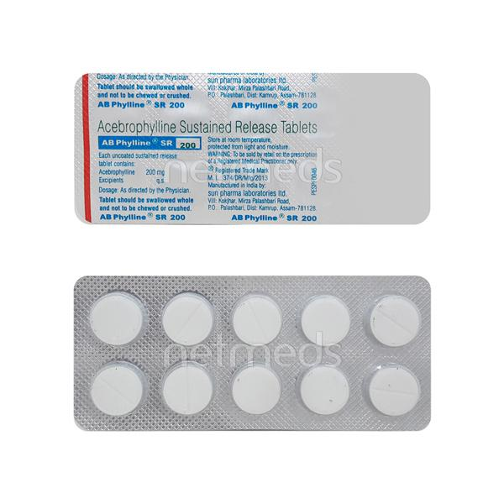
6. **Acitrom 3mg Strip Of 30 Tablets : ---**

**Description**

Acitrom 3 Tablet is an oral anticoagulant that helps prevent harmful blood clots in the legs, lungs, brain, and heart. It is used for deep vein thrombosis, pulmonary embolism, and stroke prevention.  
  
Acitrom 3 Tablet should be taken as advised by the doctor. You may take it with or without food but it is better to take it at a fixed time. This medicine should not be stopped abruptly without consulting the doctor. You should take this medicine regularly to get the most benefit, even if you feel fine. It is preventing future harm.  
  
Use of this medicine may increase your risk of bleeding. Let your doctor know immediately if you see a pinpoint rash or blood in your vomits, urine, or stool. If you are going under any surgery or dental treatment, you may need to stop this medicine for some time but only after consulting with your doctor.  
  
Before taking it, you must inform the doctor if you are suffering from any kidney or liver disease. Also, let your doctor know if you are pregnant or breastfeeding and about all the other medications that you are taking regularly.

**USES OF ACITROM TABLET**

Treatment and prevention of Blood clots

**BENEFITS OF ACITROM TABLET**

In Treatment and prevention of Blood clots

Acitrom 3 Tablet is a type of medicine known as an anticoagulant. Although it does not “dissolve” blood clots, it can prevent them from getting bigger so your body can dissolve them over time. It will also prevent new ones from forming. It works by blocking a substance in the body which is involved in blood clotting. This keeps your blood flowing freely around your body and makes it less likely that a clot will form inside a blood vessel. This can help prevent or reduce damage caused by stroke, clots in your lungs (pulmonary embolism), or other blood vessels (thrombosis). It can also make it less likely that parts of a clot will break off and travel to other parts of the body. You should take it regularly and make appropriate lifestyle changes to help this medicine be effective.

**SIDE EFFECTS OF ACITROM TABLET**

Most side effects do not require any medical attention and disappear as your body adjusts to the medicine. Consult your doctor if they persist or if you’re worried about them

Common side effects of Acitrom

* Bleeding

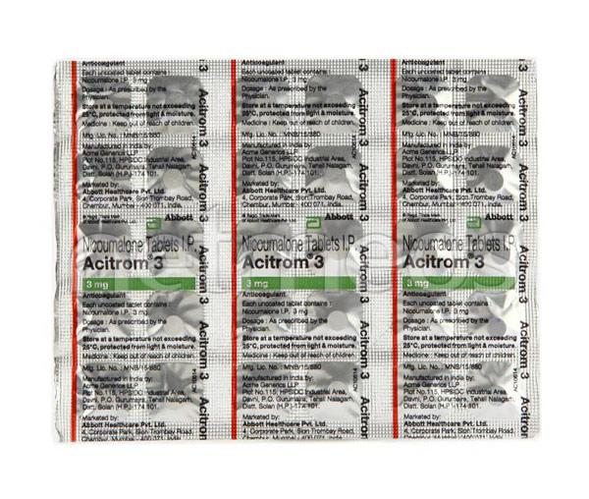

1. Acitrom 2mg Strip Of 30 Tablets :--

Description:

Acitrom 2 Tablet is an oral anticoagulant that helps prevent harmful blood clots in the legs, lungs, brain, and heart. It is used for deep vein thrombosis, pulmonary embolism, and stroke prevention.  
  
Acitrom 2 Tablet should be taken as advised by the doctor. You may take it with or without food but it is better to take it at a fixed time. This medicine should not be stopped abruptly without consulting the doctor. You should take this medicine regularly to get the most benefit, even if you feel fine. It is preventing future harm.  
  
Use of this medicine may increase your risk of bleeding. Let your doctor know immediately if you see a pinpoint rash or blood in your vomits, urine, or stool. If you are going under any surgery or dental treatment, you may need to stop this medicine for some time but only after consulting with your doctor.  
  
Before taking it, you must inform the doctor if you are suffering from any kidney or liver disease. Also, let your doctor know if you are pregnant or breastfeeding and about all the other medications that you are taking regularly.

**USES OF ACITROM TABLET**

Treatment and prevention of Blood clots

**BENEFITS OF ACITROM TABLET**

In Treatment and prevention of Blood clots

Acitrom 2 Tablet is a type of medicine known as an anticoagulant. Although it does not “dissolve” blood clots, it can prevent them from getting bigger so your body can dissolve them over time. It will also prevent new ones from forming. It works by blocking a substance in the body which is involved in blood clotting. This keeps your blood flowing freely around your body and makes it less likely that a clot will form inside a blood vessel. This can help prevent or reduce damage caused by stroke, clots in your lungs (pulmonary embolism), or other blood vessels (thrombosis). It can also make it less likely that parts of a clot will break off and travel to other parts of the body. You should take it regularly and make appropriate lifestyle changes to help this medicine be effective.

**SIDE EFFECTS OF ACITROM TABLET**

Most side effects do not require any medical attention and disappear as your body adjusts to the medicine. Consult your doctor if they persist or if you’re worried about them

Common side effects of Acitrom

* Bleeding

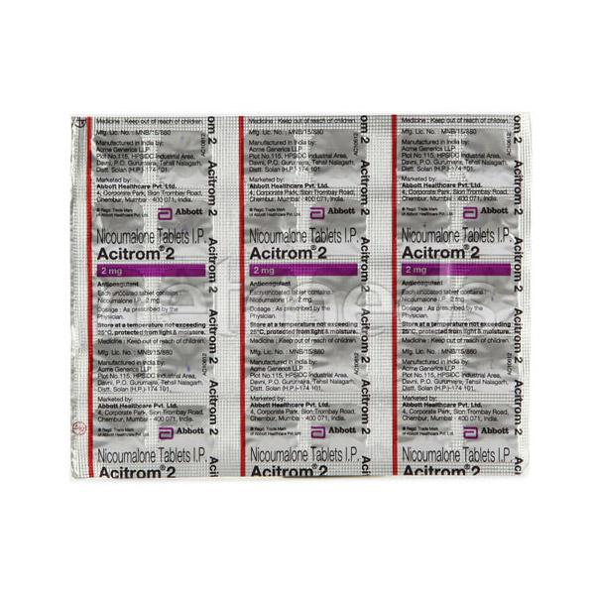

1. **Acitrom 4mg Strip Of 30 Tablets:--**

**Description:**

Acitrom 4 Tablet is an oral anticoagulant that helps prevent harmful blood clots in the legs, lungs, brain, and heart. It is used for deep vein thrombosis, pulmonary embolism, and stroke prevention.  
  
Acitrom 4 Tablet should be taken as advised by the doctor. You may take it with or without food but it is better to take it at a fixed time. This medicine should not be stopped abruptly without consulting the doctor. You should take this medicine regularly to get the most benefit, even if you feel fine. It is preventing future harm.  
  
Use of this medicine may increase your risk of bleeding. Let your doctor know immediately if you see a pinpoint rash or blood in your vomits, urine, or stool. If you are going under any surgery or dental treatment, you may need to stop this medicine for some time but only after consulting with your doctor.  
  
Before taking it, you must inform the doctor if you are suffering from any kidney or liver disease. Also, let your doctor know if you are pregnant or breastfeeding and about all the other medications that you are taking regularly.

**USES OF ACITROM TABLET**

Treatment and prevention of Blood clots

**BENEFITS OF ACITROM TABLET**

In Treatment and prevention of Blood clots

Acitrom 4 Tablet is a type of medicine known as an anticoagulant. Although it does not “dissolve” blood clots, it can prevent them from getting bigger so your body can dissolve them over time. It will also prevent new ones from forming. It works by blocking a substance in the body which is involved in blood clotting. This keeps your blood flowing freely around your body and makes it less likely that a clot will form inside a blood vessel. This can help prevent or reduce damage caused by stroke, clots in your lungs (pulmonary embolism), or other blood vessels (thrombosis). It can also make it less likely that parts of a clot will break off and travel to other parts of the body. You should take it regularly and make appropriate lifestyle changes to help this medicine be effective.

**SIDE EFFECTS OF ACITROM TABLET**

Most side effects do not require any medical attention and disappear as your body adjusts to the medicine. Consult your doctor if they persist or if you’re worried about them

Common side effects of Acitrom

* Bleeding

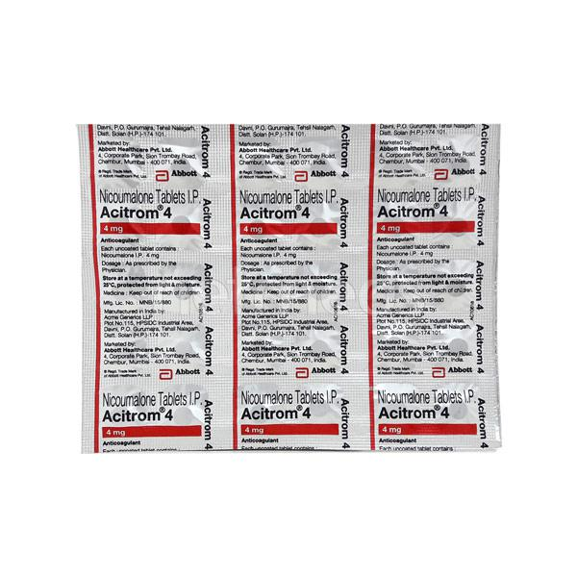

1. **Afoglip M 500mg Strip Of 10 Tablets :---**

**Description**

Afoglip M 500 Tablet ER is a combination of two medicines that control high blood sugar levels in people with type 2 diabetes mellitus. This helps prevent serious complications of diabetes such as kidney damage and blindness and may also reduce your chances of having a heart attack or stroke.  
  
Afoglip M 500 Tablet ER can be prescribed alone or together with other diabetes medications. All diabetes medicines work best when used along with a healthy diet and regular exercise. The dose you are given will depend on your condition, blood sugar levels, and what other medicines you are taking. Taking it with meals helps to reduce the chances of developing an upset stomach.  
  
You should take it regularly, at the same time each day, to get the most benefit and you should not stop unless your doctor recommends it. It is controlling your blood sugar levels and helping to prevent serious complications in the future. It is important to stay on the diet and exercise program recommended by your doctor while taking this medicine. Your lifestyle plays a big part in controlling diabetes.  
  
The most common side effects of taking this medicine include diarrhea, nausea, vomiting, upset stomach, headache, and sore throat. Low blood sugar level (hypoglycemia) is a possible side effect if you are also taking other diabetes medicines like insulin or sulfonylurea, so you need to know how to recognize and deal with it.  
  
This medicine is not suitable for everyone. Before taking it, you should let your doctor know if you have ever had kidney, liver, or heart disease, problems with your pancreas, or if you drink a lot of alcohol. Pregnant or breastfeeding women should also consult their doctor before taking this medicine. Some other medicines can affect this one so tell your doctor about all the medicines you are taking to make sure you are safe. You should try to avoid drinking alcohol as it lowers blood glucose. Your doctor will check your kidney function and blood sugar levels before and during treatment.

**USES OF AFOGLIP M TABLET ER**

[Type 2 diabetes mellitus](https://www.1mg.com/diseases/type-2-diabetes-mellitus-105)

**BENEFITS OF AFOGLIP M TABLET ER**

In Type 2 diabetes mellitus

Afoglip M 500 Tablet ER is a combination of two medicines that work together in different ways to lower your blood glucose levels. Lowering blood glucose levels is an essential part of managing diabetes. If you can control your blood glucose level, your risk of getting any of the serious complications of diabetes such as kidney damage, eye damage, nerve problems, and loss of limbs is also lowered. Additionally, proper control of diabetes can also reduce the risk of heart disease and stroke. Taking this medicine regularly along with proper diet and exercise will help you live a normal, healthy life. You should keep using this medicine for as long as it is prescribed because it is protecting your future health.

**SIDE EFFECTS OF AFOGLIP M TABLET ER**

Most side effects do not require any medical attention and disappear as your body adjusts to the medicine. Consult your doctor if they persist or if you’re worried about them

* Common side effects of Afoglip M
* Diarrhea
* Nausea
* Vomiting
* Upset stomach
* Headache
* Nasal congestion (stuffy nose)
* Sore throat
* Respiratory tract infection
* Hypoglycaemia (low blood sugar level) in combination with insulin or sulphonylurea

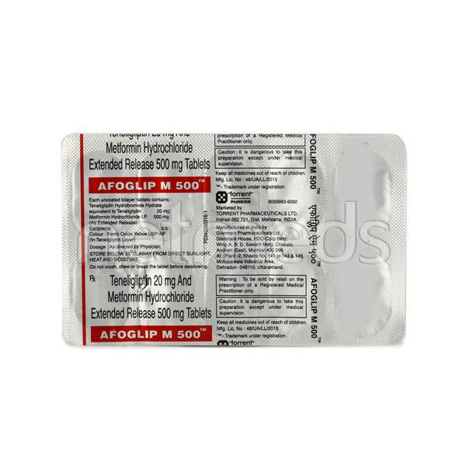

1. **Afoglip 20mg Tablet :---**

**Description**

Afoglip Tablet is a medicine used to treat type 2 diabetes mellitus. It is used together with a healthy diet and regular exercise to control blood sugar levels. This helps to prevent serious complications of diabetes like kidney damage and blindness.  
  
Afoglip Tablet is normally prescribed when diet and exercise alone or other medicines do not prove sufficient to control your blood sugar level. Your doctor may prescribe it alone or in combination with other diabetes medicines. It can be taken with or without food. The dose will depend on your condition and blood sugar levels. Use it strictly as advised by your doctor.  
  
You should take it regularly at the same time each day to get the most benefit from it. Do not stop taking the medicine unless your doctor recommends it. This medicine helps you control your blood sugar levels and prevent serious complications in the future. It is important to stay on the diet and exercise program recommended by your doctor while taking this medicine. Your lifestyle plays a big part in controlling diabetes.  
  
The most common side effects of this medicine are hypoglycemia and constipation. It is important to recognize the symptoms of hypoglycemia (such as lightheadedness, sweating, dizziness, fainting, and dry mouth) and know how to deal with it. You can carry sugar or glucose candy and have them to control your symptoms if you experience any. Contact your doctor if the side effects if they do not go away or worry you.  
  
Before taking this medicine, let your doctor know if you have ever had kidney disease, heart disease, or pancreas problems. Pregnant or breastfeeding women should also consult their doctor before taking it. Some other medicines you are taking may interfere with this medicine's working. So, make sure your doctor knows about all the other medicines you are using. Limit your alcohol intake while taking this medicine because it can increase your risk of developing low blood sugar levels. You may need regular tests such as kidney function and blood glucose levels to check that the medicine is working properly.

**USES OF AFOGLIP TABLET**

[Type 2 diabetes mellitus](https://www.1mg.com/diseases/type-2-diabetes-mellitus-105)

**BENEFITS OF AFOGLIP TABLET**

In Type 2 diabetes mellitus

Afoglip Tablet belongs to a group of medicines called DPP-4 inhibitors (or gliptins). It helps increase the amount of insulin your body produces after a meal and to stop your body from releasing too much glucose (sugar) into your blood. This way it lowers the blood glucose levels in your body. It is usually taken once a day and has relatively few common side effects.  
  
Lowering blood glucose levels is an essential part of managing diabetes. If you can control the level you will reduce the risk of getting any of the serious complications of diabetes such as kidney damage, blindness, and loss of limbs. Proper control of diabetes can also reduce the risk of heart disease and stroke. Taking this medicine regularly along with a proper program of diet and exercise will help you live a normal, healthy life. You should keep using it for as long as it is prescribed.

**SIDE EFFECTS OF AFOGLIP TABLET**

Most side effects do not require any medical attention and disappear as your body adjusts to the medicine. Consult your doctor if they persist or if you’re worried about them

Common side effects of Afoglip

* Hypoglycemia (low blood glucose level)
* Constipation

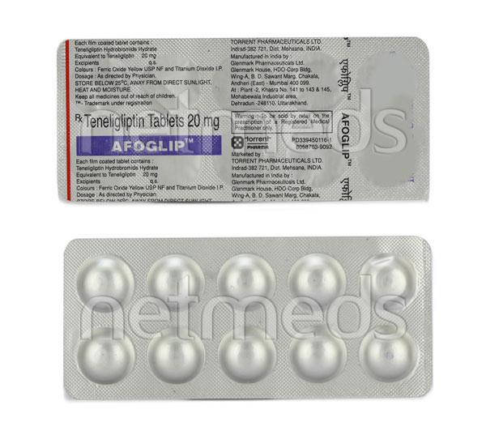

1. **Ajaduo 25/5mg Tab 10's :--**

**Description**

Ajaduo 25mg/5mg Tablet is a combination medicine that helps control blood sugar levels. This medicine is used together with diet and exercise to improve blood sugar control in adults with type 2 diabetes mellitus. It helps in proper utilisation of insulin, thereby lowering the blood sugar level.  
  
Ajaduo 25mg/5mg Tablet can be taken with or without food at any time of day but you should try to take it at the same time every day. The dose will be decided by your doctor. Don’t stop taking it without asking your doctor. If you do, your blood sugar levels may increase and put you at risk of serious complications like kidney damage and blindness. This medicine is only part of a treatment program that should include a healthy diet, regular exercise, and weight reduction as advised by your doctor.  
  
The most common side effects of this medicine include urinary tract infection, nasal congestion, sore throat, and upper respiratory tract infection. Drinking plenty of fluids while using it will help prevent dehydration. Some people may develop fungal infections in the genital area. Maintaining good hygiene can help prevent this.  
  
Before taking this medicine, inform your doctor if you have any kidney or liver problems or a urinary tract infection or if you are on water pills (diuretics). Pregnant or breastfeeding women should also consult their doctor before taking it. Avoid excessive alcohol intake while taking it as this may increase the risk of developing some side effects. Monitor your blood sugar levels regularly while taking this medicine.

**USES OF AJADUO TABLET**

[Type 2 diabetes mellitus](https://www.1mg.com/diseases/type-2-diabetes-mellitus-105)

**BENEFITS OF AJADUO TABLET**

In Type 2 diabetes mellitus

Ajaduo 25mg/5mg Tablet is a medicine that helps to control high blood glucose (sugar) levels. It helps get rid of extra glucose from your body through urine. Lowering blood glucose levels is an essential part of managing diabetes. If you can control the level, you will reduce the risk of getting any of the serious complications of diabetes such as kidney damage, eye damage, nerve problems and loss of limbs. This medicine will reduce the risk of dying from cardiovascular disease if you have type 2 diabetes and already have cardiovascular disease.  
Taking this medicine regularly along with proper diet and exercise will help you live a normal, healthy life. You should keep using it for as long as it is prescribed because it is protecting your future health.

**SIDE EFFECTS OF AJADUO TABLET**

Most side effects do not require any medical attention and disappear as your body adjusts to the medicine. Consult your doctor if they persist or if you’re worried about them

Common side effects of Ajaduo

* Urinary tract infection
* Nasal congestion (stuffy nose)
* Sore throat
* Upper respiratory tract infection

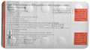

1. **Ajaduo 10mg/5mg Tab 10's :--**

**Description**

Ajaduo 10mg/5mg Tablet is a combination medicine that helps control blood sugar levels. This medicine is used together with diet and exercise to improve blood sugar control in adults with type 2 diabetes mellitus. It helps in proper utilisation of insulin, thereby lowering the blood sugar level.  
  
Ajaduo 10mg/5mg Tablet can be taken with or without food at any time of day but you should try to take it at the same time every day. The dose will be decided by your doctor. Don’t stop taking it without asking your doctor. If you do, your blood sugar levels may increase and put you at risk of serious complications like kidney damage and blindness. This medicine is only part of a treatment program that should include a healthy diet, regular exercise, and weight reduction as advised by your doctor.  
  
The most common side effects of this medicine include urinary tract infection, nasal congestion, sore throat, and upper respiratory tract infection. Drinking plenty of fluids while using it will help prevent dehydration. Some people may develop fungal infections in the genital area. Maintaining good hygiene can help prevent this.  
  
Before taking this medicine, inform your doctor if you have any kidney or liver problems or a urinary tract infection or if you are on water pills (diuretics). Pregnant or breastfeeding women should also consult their doctor before taking it. Avoid excessive alcohol intake while taking it as this may increase the risk of developing some side effects. Monitor your blood sugar levels regularly while taking this medicine.

**USES OF AJADUO TABLET**

[Type 2 diabetes mellitus](https://www.1mg.com/diseases/type-2-diabetes-mellitus-105)

**BENEFITS OF AJADUO TABLET**

In Type 2 diabetes mellitus

Ajaduo 10mg/5mg Tablet is a medicine that helps to control high blood glucose (sugar) levels. It helps get rid of extra glucose from your body through urine. Lowering blood glucose levels is an essential part of managing diabetes. If you can control the level, you will reduce the risk of getting any of the serious complications of diabetes such as kidney damage, eye damage, nerve problems and loss of limbs. This medicine will reduce the risk of dying from cardiovascular disease if you have type 2 diabetes and already have cardiovascular disease.  
Taking this medicine regularly along with proper diet and exercise will help you live a normal, healthy life. You should keep using it for as long as it is prescribed because it is protecting your future health.

**SIDE EFFECTS OF AJADUO TABLET**

Most side effects do not require any medical attention and disappear as your body adjusts to the medicine. Consult your doctor if they persist or if you’re worried about them

Common side effects of Ajaduo

* Urinary tract infection
* Nasal congestion (stuffy nose)
* Sore throat
* Upper respiratory tract infection

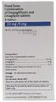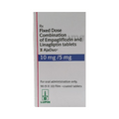

1. **Alfoo 10mg Tab 30`s :---**

**Description**

Alfoo 10mg Tablet PR is an alpha-adrenergic antagonist that is used in the treatment of benign prostatic hyperplasia. It helps to relieve symptoms like difficulty in passing urine. However, it does not decrease the size of the prostate.  
  
Alfoo 10mg Tablet PR is advised to take it in a dose and duration as per prescription. It should be taken with food, but take at the same time regularly. Swallow the medicine as a whole without crushing or chewing it. You should not stop taking the medicine without consulting the doctor as it may lead to the worsening of your symptoms. The course of the treatment should be completed for better efficacy of the medicine.  
  
Some common side effects of this medicine are upper respiratory tract infection, headache, and tiredness. It may also lead to blurry vision or dizziness, so it is advised to avoid driving while on the medication. If any of the side effects persist or bother you, you must consult the doctor without delay.  
  
Simple lifestyle changes can help you manage your symptoms better. Try to urinate as soon as you feel the urge, however, never strain or push to empty your bladder. You should avoid drinking caffeinated or alcoholic drinks at night and a few hours before going to bed or going out.  
  
Before receiving the treatment, inform your doctor if you are on any medication for any other health condition. If you have to undergo eye surgery due to cataracts or glaucoma then inform your eye doctor about the usage of this medicine. Patients with liver or kidney disease must be cautious while receiving the prescription, and they must receive regular follow-ups as per the doctor’s advice.

**USES OF ALFOO TABLET PR**

Treatment of [Benign prostatic hyperplasia](https://www.1mg.com/diseases/benign-prostatic-hyperplasia-91)

**BENEFITS OF ALFOO TABLET PR**

In Treatment of Benign prostatic hyperplasia

When your prostate gland becomes enlarged it can cause urinary problems such as difficulty passing urine and a need to go to the toilet frequently or urgently. It can also cause urine flow to be slower. If not treated, there is a risk that your urine flow will be completely blocked. Alfoo 10mg Tablet PR works by relaxing muscles in the bladder and prostate. So, it can rapidly relieve the symptoms and make it easier for you to urinate. However, it may take up to 6 months to notice the full benefit. Take this medicine exactly as prescribed for maximum benefits.

**SIDE EFFECTS OF ALFOO TABLET PR**

Most side effects do not require any medical attention and disappear as your body adjusts to the medicine. Consult your doctor if they persist or if you’re worried about them

Common side effects of Alfoo

* Upper respiratory tract infection
* Dizziness
* Headache
* Tiredness

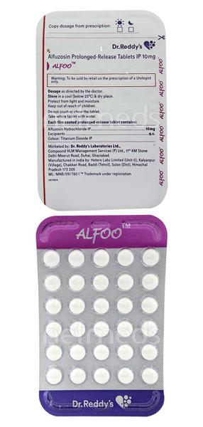

1. **Alfusin D Strip Of 15 Tablets :---**

**Description**

Alfusin D Tablet ER is a combination of two medicines that work in different ways to treat men with an enlarged prostate gland. It helps to relieve symptoms such as difficulty urinating or needing to go to the toilet more often. It is not used to prevent prostate cancer.  
  
Alfusin D Tablet ER should be taken at the same time each day. Take it as a whole, do not break, chew, or crush them. Your doctor will prescribe the dose most suitable for you. To gain the most benefit and treat your symptoms effectively you should not miss doses, even if you feel well. It may take up to 4 weeks to notice an improvement in symptoms but keep taking them regularly. Tell your doctor if your symptoms do not improve after 4 weeks or if they get worse.  
  
The most common side effects of this medicine include decreased libido, inability to get an erection (impotence), and tenderness or enlargement of your breasts. If these effects worry you or do not go away, call your doctor for advice. You may also feel dizzy or drowsy. These risks are higher when you first start taking this drug. Remember, your doctor has given you this medicine because the benefits are greater than the risks of the side effects.  
  
Alfusin D Tablet ER should not be taken by women or children. Before taking it, tell your doctor if you have low blood pressure or liver or kidney disease. This medicine may not be suitable. It can also affect, or be affected by, other drugs so let your doctor know all other medicines you are taking. You may be advised to wear a condom during sex and to have your blood pressure checked frequently. Talk to your healthcare team if you drink alcohol.

**USES OF ALFUSIN D TABLET ER**

Treatment of [Benign prostatic hyperplasia](https://www.1mg.com/diseases/benign-prostatic-hyperplasia-91)

**BENEFITS OF ALFUSIN D TABLET ER**

In Treatment of Benign prostatic hyperplasia

When your prostate gland becomes enlarged it can cause urinary problems such as difficulty passing urine and a need to go to the toilet frequently or urgently. It can also cause urine flow to be slower. If not treated, there is a risk that your urine flow will be completely blocked. Alfusin D Tablet ER is a combination of two medicines that reduces the size of your prostate by blocking the production of a hormone which causes it to grow. Additionally, it relaxes the muscles in the bladder and prostate. Together they can rapidly relieve the symptoms and make it easier for you to urinate. However, it may take up to 6 months to notice the full benefits. Take this medicine exactly as prescribed for maximum benefits.

**SIDE EFFECTS OF ALFUSIN D TABLET ER**

Most side effects do not require any medical attention and disappear as your body adjusts to the medicine. Consult your doctor if they persist or if you’re worried about them

Common side effects of Alfusin D

* Decreased libido
* Impotence
* Breast tenderness
* Breast enlargement

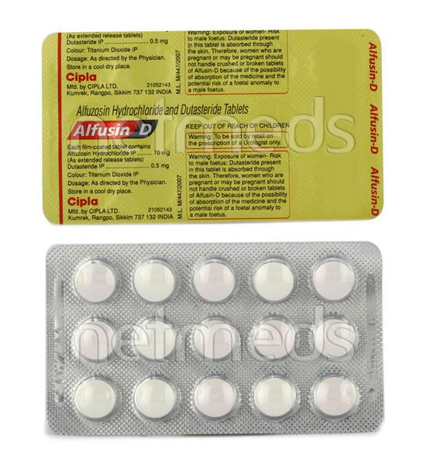

1. **Allegra M Tablet :---**

**Description**

Allegra-M Tablet is a combination medicine used in the treatment of allergy symptoms such as runny nose, stuffy nose, sneezing, watery eyes, and congestion or stuffiness.  
  
Allegra-M Tablet is taken with or without food in a dose and duration as advised by the doctor. The dose you are given will depend on your condition and how you respond to the medicine. You should keep taking this medicine for as long as your doctor recommends. If you stop treatment too early your symptoms may come back and your condition may worsen. Let your healthcare team know about all other medications you are taking as some may affect, or be affected by this medicine.  
  
The most common side effects are nausea, diarrhea, vomiting, skin rash, flu-like symptoms, and headache. Most of these are temporary and usually resolve with time. Contact your doctor straight away if you are at all concerned about any of these side effects. This medicine may cause dizziness and sleepiness, so do not drive or do anything that requires mental focus until you know how this medicine affects you. Avoid drinking alcohol while taking this medicine as it can worsen your sleepiness.  
  
Never support self-medication or recommend your medicine to another person. It is beneficial to have plenty of fluids while taking this medication. Before you start taking this medicine it is important to inform your doctor if you are suffering from liver or kidney disease. You should also tell your doctor if you are pregnant, planning pregnancy or breastfeeding.

**USES OF ALLEGRA-M TABLET**

Treatment of Sneezing and runny nose due to allergies

**BENEFITS OF ALLEGRA-M TABLET**

In Treatment of Sneezing and runny nose due to allergies

Allegra-M Tablet is a combination medicine that provides relief from symptoms such as blocked or runny nose, sneezing and itchy or watery eyes. This will make it easier for you to go about your daily activities. It rarely has any serious side effects and you may only need to take it on days you have symptoms. If you are taking it to prevent getting symptoms you should use it regularly to get the most benefit.

**SIDE EFFECTS OF ALLEGRA-M TABLET**

Most side effects do not require any medical attention and disappear as your body adjusts to the medicine. Consult your doctor if they persist or if you’re worried about them

Common side effects of Allegra-M

* Nausea
* Diarrhea
* Vomiting
* Skin rash
* Flu-like symptoms
* Headache
* Drowsiness
* Dizziness

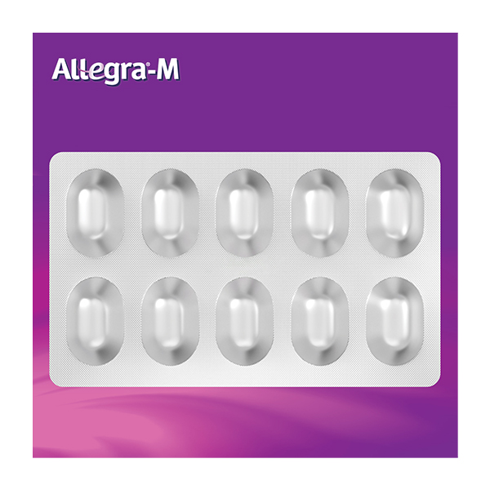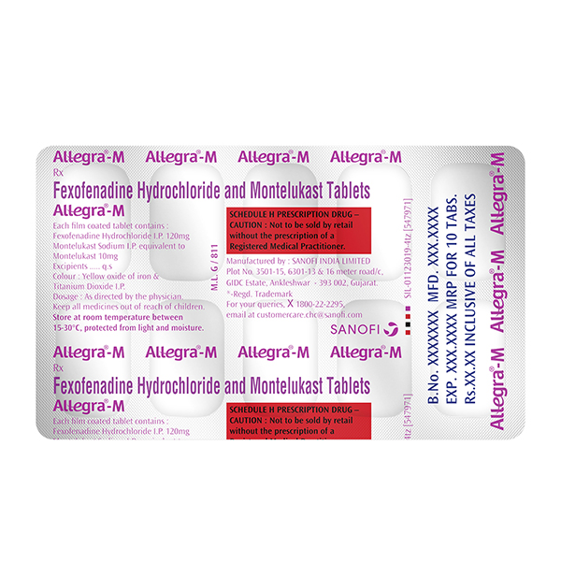

1. **Allegra 120mg Tablet :---**

**Description**

Allegra 120mg Tablet is an anti-allergy medicine used in the treatment of allergic symptoms such as runny nose, congestion or stuffiness, sneezing, itching, swelling, and watery eyes. It also helps treat skin allergies with itching, redness, or swelling.  
  
Allegra 120mg Tablet may be taken with or without food, in the dose and duration as advised by the doctor. The dose you are given will depend on your condition and how you respond to the medicine. You should keep taking this medicine for as long as your doctor recommends. Do not stop taking it without consulting your doctor.  
  
The most common side effects are headache, drowsiness, dizziness, and nausea. Most of these are temporary and usually resolve with time. Please consult your doctor if any of these side effects do not resolve or persist for a longer duration.  
  
Do not self-medicate or recommend your medicine to another person even if you see the similarity in symptoms. Consult your doctor to get the most benefit. Inform your doctor if you are suffering from any problems related to the kidneys, liver, or heart. Pregnant and breastfeeding mothers should not take this medicine without consulting a doctor.

**USES OF ALLEGRA 120MG TABLET**

Treatment of Sneezing and runny nose due to allergies

Treatment of [Allergic skin conditions](https://www.1mg.com/diseases/allergic-skin-conditions-637)

**BENEFITS OF ALLEGRA 120MG TABLET**

In Treatment of Sneezing and runny nose due to allergies

Allegra 120mg Tablet provides relief from symptoms such as sneezing, itching, watery eyes, and runny nose. This will make it easier for you to go about your daily activities. It rarely has any serious side effects and you may only need to take it on days you have symptoms. If you are taking it to prevent getting symptoms you should use it regularly to get the most benefit.

**Show More**

**SIDE EFFECTS OF ALLEGRA 120MG TABLET**

Most side effects do not require any medical attention and disappear as your body adjusts to the medicine. Consult your doctor if they persist or if you’re worried about them

Common side effects of Allegra 120mg Tablet

* Headache
* Drowsiness
* Dizziness
* Nausea

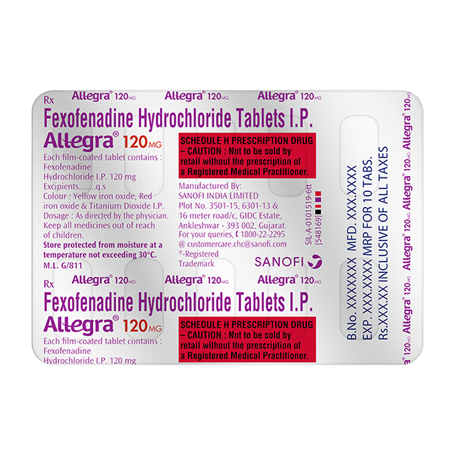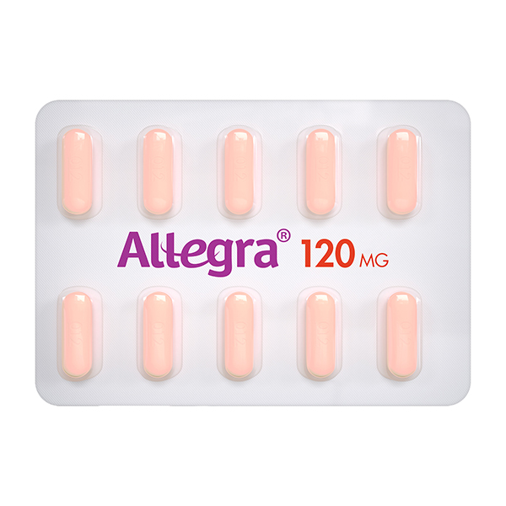

1. **Allegra 180mg Tablet :---**

**Description**

Allegra 180mg Tablet is an anti-allergy medicine used in the treatment of allergic symptoms such as runny nose, congestion or stuffiness, sneezing, itching, swelling, and watery eyes. It also helps treat skin allergies with itching, redness, or swelling.  
  
Allegra 180mg Tablet may be taken with or without food, in the dose and duration as advised by the doctor. The dose you are given will depend on your condition and how you respond to the medicine. You should keep taking this medicine for as long as your doctor recommends. Do not stop taking it without consulting your doctor.  
  
The most common side effects are headache, drowsiness, dizziness, and nausea. Most of these are temporary and usually resolve with time. Please consult your doctor if any of these side effects do not resolve or persist for a longer duration.  
  
Do not self-medicate or recommend your medicine to another person even if you see the similarity in symptoms. Consult your doctor to get the most benefit. Inform your doctor if you are suffering from any problems related to the kidneys, liver, or heart. Pregnant and breastfeeding mothers should not take this medicine without consulting a doctor.

**USES OF ALLEGRA TABLET**

Treatment of [Allergic conditions](https://www.1mg.com/diseases/allergic-conditions-10)

**BENEFITS OF ALLEGRA TABLET**

In Treatment of Allergic conditions

During seasonal allergic conditions, the body releases a chemical substance called histamine. This chemical causes symptoms such as blocked or runny nose, sneezing, and itchy or watery eyes. Allegra 180mg Tablet works to relieve these symptoms by preventing the release of this chemical. It is used to treat seasonal allergic conditions like the common cold, hay fever, sinusitis, conjunctivitis, and skin allergies like urticaria (hives).  
  
The doctor will consider the age, body weight, and how severe the allergic condition is before prescribing the treatment. Do not alter the dose or abruptly stop the medicine by yourself as it may render the treatment ineffective and cause side effects. Along with this medicine following some self-care measures such as avoidance of allergen exposure and hygiene maintenance may help your child recover fast.

**SIDE EFFECTS OF ALLEGRA TABLET**

Most side effects do not require any medical attention and disappear as your body adjusts to the medicine. Consult your doctor if they persist or if you’re worried about them

Common side effects of Allegra

* Headache
* Drowsiness
* Dizziness
* Nausea

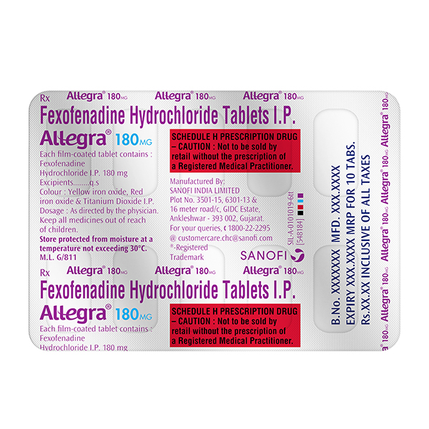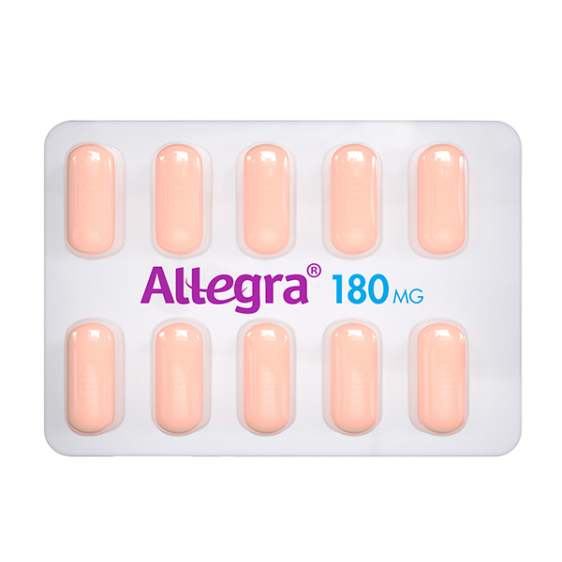

1. **Altraz 1mg Tablet :--**

**Description**

Altraz Tablet is used alone or with other treatments, such as surgery or radiation, to treat early breast cancer in postmenopausal women. It can also be used as the first line treatment of advanced breast cancer that has spread within the breast or to other areas of the body.  
  
Altraz Tablet belong to a class of drug called aromatase inhibitors, which decreases the amount of estrogen in the body. It should be taken with or without food, but take it at the same time every day to get the most benefit. It should be taken as your doctor's advice. The dose and how often you take it depends on what you are taking it for. Your doctor will decide how much you need to improve your symptoms. Swallow the tablets whole with a drink of water. You should take this medicine for as long as it is prescribed for you.  
  
The most common side effects of the medicine include hot flushes, nausea, rashes, joint pain, osteoporosis, and weakness. If these bother you or appear serious, let your doctor know. There may be ways of reducing or preventing them.  
  
Before taking this medicine, tell your doctor if you are not gone through menopause and still having menstrual periods, or you have a problem with the liver or kidney. Your doctor should also know about all other medicines you are taking as many of these may make this medicine less effective or change the way it works. Tell your doctor if you are pregnant or breastfeeding. Your doctor may perform some blood tests to check for vitamin D level or bone density.

**USES OF ALTRAZ TABLET**

[Breast cancer](https://www.1mg.com/diseases/breast-cancer-134)

**BENEFITS OF ALTRAZ TABLET**

In Breast cancer

Altraz Tablet relieves the symptoms of breast cancer such as breast lumps, bloody discharge from nipple or changes in the shape or texture of the breast. It works by altering the production of those hormones in the body that are essential for the growth and spread of breast cancer. It may also interact with other hormones or have a direct effect on the cancer to stop its growth.

**SIDE EFFECTS OF ALTRAZ TABLET**

Most side effects do not require any medical attention and disappear as your body adjusts to the medicine. Consult your doctor if they persist or if you’re worried about them

Common side effects of Altraz

* Hot flashes
* Nausea
* Osteoporosis
* Skin rash
* Weakness

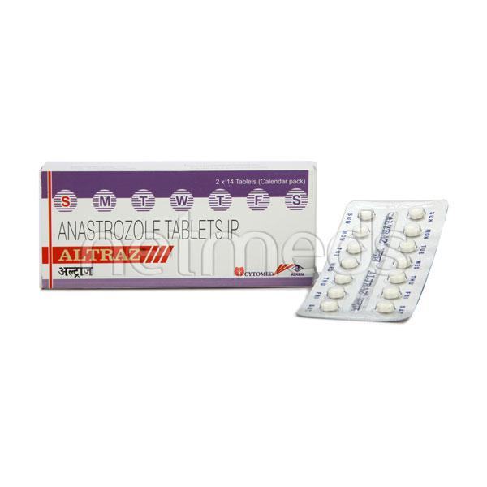

1. **Amantrel Tab 15's :--**

**Description**

Amantrel Tablet is used alone, or with other medicines to treat Parkinson’s disease. It can also be used to treat movement side effects caused by certain drugs (drug-induced movement disorder).  
  
Amantrel Tablet may be taken with or without food. However, take it at the same time each day as this helps to maintain a consistent level of medicine in the body. Take this medicine in the dose and duration as advised by your doctor.  
  
If you have missed a dose, take it as soon as you remember it. You should finish the full course of treatment even if you feel better. It is important that this medication is not stopped suddenly without talking to your doctor. This medicine may put you at a higher risk of having seizures, so it is better to talk to your doctor if you have any history of seizures or taking medication for it.  
  
Some common side effects of Amantrel Tablet include nausea, dryness in the mouth, constipation, blurred vision, insomnia (difficulty sleeping), hallucinations, peripheral edema and balance disorder (loss of balance). It may initially cause dizziness and lowering of blood pressure while standing, so rise slowly and do not drive or do anything that requires mental focus until you know how this medicine affects you.

**USES OF AMANTREL TABLET**

[Parkinson's disease](https://www.1mg.com/diseases/parkinson-s-disease-165)

**BENEFITS OF AMANTREL TABLET**

In Parkinson's disease

Amantrel Tablet is one of the most effective medications to relieve symptoms of Parkinson's disease such as tremors, muscle stiffness and difficulty moving. It increases the amount of a chemical called dopamine in the brain which helps in coordination of body movements. This medicine can therefore enhance the quality of life by improving the ability to carry out daily functions in a better manner.

**SIDE EFFECTS OF AMANTREL TABLET**

Most side effects do not require any medical attention and disappear as your body adjusts to the medicine. Consult your doctor if they persist or if you’re worried about them

Common side effects of Amantrel

* Nausea
* Dryness in mouth
* Constipation
* Dizziness
* Blurred vision
* Insomnia (difficulty in sleeping)
* Hallucination
* Peripheral edema
* Balance disorder (loss of balance)
* Orthostatic hypotension (sudden lowering of blood pressure on standing)

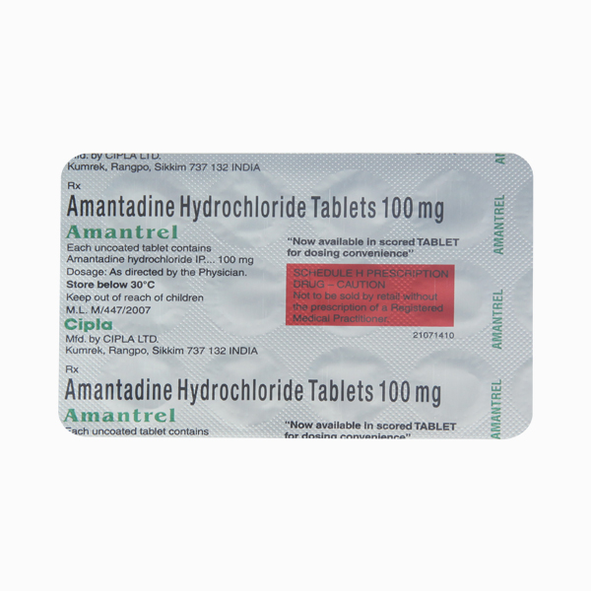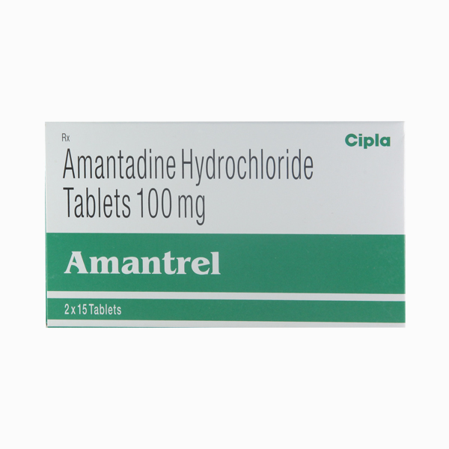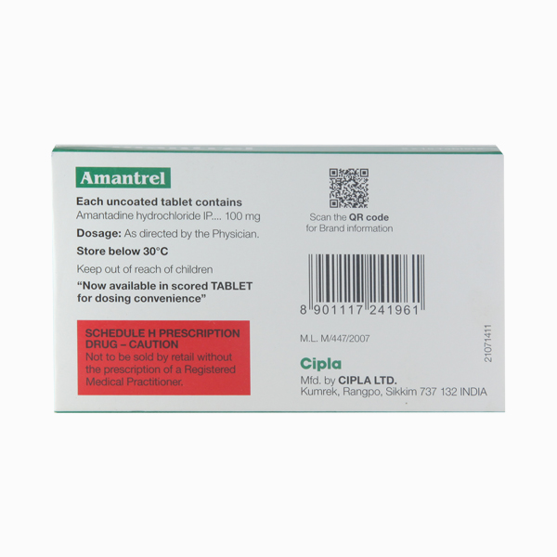

1. **Amaryl 1mg Tab 30`s :---**

**Description**

Amaryl 1mg Tablet belongs to a group of medicines called sulfonylureas and is used to treat type 2 diabetes mellitus in adults. It helps control blood sugar levels in people with diabetes thereby preventing serious complications of diabetes such as kidney damage and blindness.  
  
Amaryl 1mg Tablet may be used alone or along with other medicines. It should be taken just before or with the first meal of the day. Take it regularly at the same time each day to get the maximum benefit. Your doctor will decide what dose is best for you and this may change from time to time according to your blood sugar levels.  
  
Keep taking this medicine, even if you feel well or your blood sugar levels are controlled. If you stop it without consulting your doctor, your blood sugar levels could rise to put you at risk of diabetes complications such as kidney damage, blindness, nerve problems, and loss of limbs. Remember that it is only part of a treatment program that should also include a healthy diet, regular exercise, and weight reduction as advised by your doctor. Your lifestyle plays a big part in controlling diabetes.  
  
The most common side effects of taking this medicine include low blood sugar levels (hypoglycemia), nausea, headache, and dizziness. Make sure you recognize the signs of having low blood sugar levels, such as sweating, dizziness, headache, and shaking, and know how to deal with them. To prevent this, it is important to have regular meals and always carry a fast-acting source of glucose such as sugary food or fruit juice with you. Drinking alcohol can also increase your risk of low blood sugar levels and hence should be avoided. Some people may experience an increase in weight with this medicine.  
  
You should not take it if you have type 1 diabetes mellitus, diabetic ketoacidosis (high levels of acid in your blood), or if you have severe kidney or liver disease. Before taking this medicine, tell your doctor if you have ever had heart disease, thyroid disease, or some hormonal conditions, as it may not be suitable. Pregnant or breastfeeding women should also consult their doctor before taking it. Your blood sugar levels should be checked regularly and your doctor may also advise blood tests to monitor your blood cell counts and liver function.

**USES OF AMARYL TABLET**

Treatment of [Type 2 diabetes mellitus](https://www.1mg.com/diseases/type-2-diabetes-mellitus-105)

**BENEFITS OF AMARYL TABLET**

In Treatment of Type 2 diabetes mellitus

Amaryl 1mg Tablet increases the amount of insulin your body produces (in the pancreas). The insulin then works to lower your blood glucose level. It is usually taken once a day. You should keep taking it for as long as it is prescribed.  
  
Lowering blood glucose levels is an essential part of managing diabetes. If you can control the level you will reduce the risk of getting any of the serious complications of diabetes such as kidney damage, eye damage, nerve problems, and loss of limbs. Taking this medicine regularly along with proper diet and exercise will help you live a normal, healthy life.

**SIDE EFFECTS OF AMARYL TABLET**

Most side effects do not require any medical attention and disappear as your body adjusts to the medicine. Consult your doctor if they persist or if you’re worried about them

Common side effects of Amaryl

* Hypoglycemia (low blood glucose level)
* Headache
* Nausea
* Dizziness

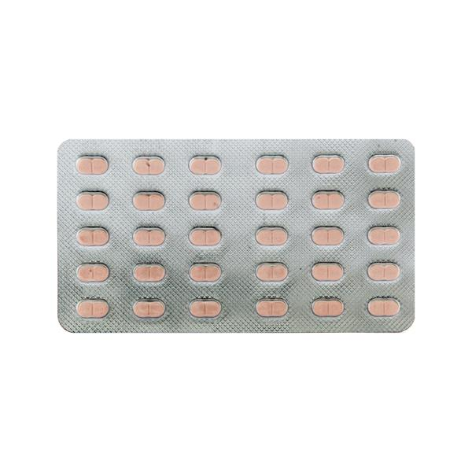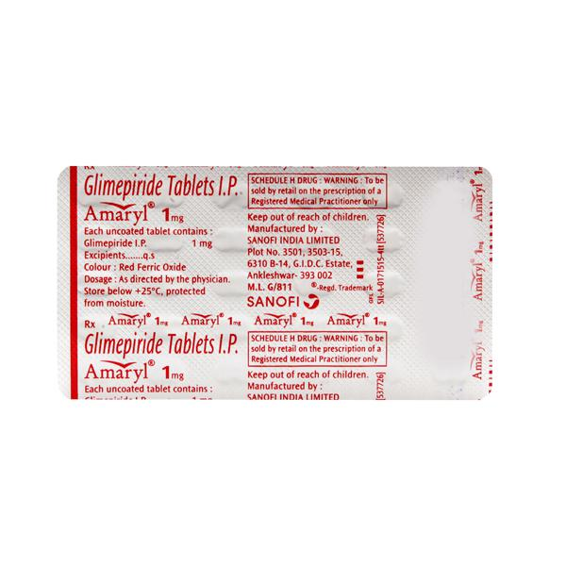

1. **Amaryl 3mg Strip Of 30 Tablets :---**

**Description**

Amaryl 3mg Tablet belongs to a group of medicines called sulfonylureas and is used to treat type 2 diabetes mellitus in adults. It helps control blood sugar levels in people with diabetes thereby preventing serious complications of diabetes such as kidney damage and blindness.  
  
Amaryl 3mg Tablet may be used alone or along with other medicines. It should be taken just before or with the first meal of the day. Take it regularly at the same time each day to get the maximum benefit. Your doctor will decide what dose is best for you and this may change from time to time according to your blood sugar levels.  
  
Keep taking this medicine, even if you feel well or your blood sugar levels are controlled. If you stop it without consulting your doctor, your blood sugar levels could rise to put you at risk of diabetes complications such as kidney damage, blindness, nerve problems, and loss of limbs. Remember that it is only part of a treatment program that should also include a healthy diet, regular exercise, and weight reduction as advised by your doctor. Your lifestyle plays a big part in controlling diabetes.  
  
The most common side effects of taking this medicine include low blood sugar levels (hypoglycemia), nausea, headache, and dizziness. Make sure you recognize the signs of having low blood sugar levels, such as sweating, dizziness, headache, and shaking, and know how to deal with them. To prevent this, it is important to have regular meals and always carry a fast-acting source of glucose such as sugary food or fruit juice with you. Drinking alcohol can also increase your risk of low blood sugar levels and hence should be avoided. Some people may experience an increase in weight with this medicine.  
  
You should not take it if you have type 1 diabetes mellitus, diabetic ketoacidosis (high levels of acid in your blood), or if you have severe kidney or liver disease. Before taking this medicine, tell your doctor if you have ever had heart disease, thyroid disease, or some hormonal conditions, as it may not be suitable. Pregnant or breastfeeding women should also consult their doctor before taking it. Your blood sugar levels should be checked regularly and your doctor may also advise blood tests to monitor your blood cell counts and liver function.

**USES OF AMARYL TABLET**

Treatment of [Type 2 diabetes mellitus](https://www.1mg.com/diseases/type-2-diabetes-mellitus-105)

**BENEFITS OF AMARYL TABLET**

In Treatment of Type 2 diabetes mellitus

Amaryl 3mg Tablet increases the amount of insulin your body produces (in the pancreas). The insulin then works to lower your blood glucose level. It is usually taken once a day. You should keep taking it for as long as it is prescribed.  
  
Lowering blood glucose levels is an essential part of managing diabetes. If you can control the level you will reduce the risk of getting any of the serious complications of diabetes such as kidney damage, eye damage, nerve problems, and loss of limbs. Taking this medicine regularly along with proper diet and exercise will help you live a normal, healthy life.

**SIDE EFFECTS OF AMARYL TABLET**

Most side effects do not require any medical attention and disappear as your body adjusts to the medicine. Consult your doctor if they persist or if you’re worried about them

Common side effects of Amaryl

* Hypoglycemia (low blood glucose level)
* Headache
* Nausea
* Dizziness

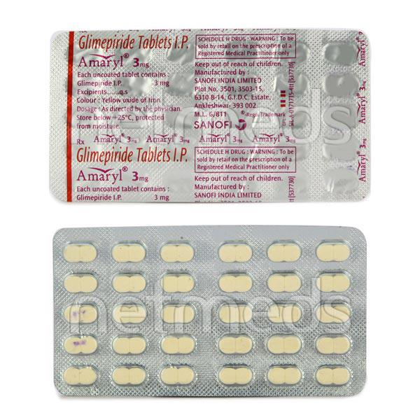

1. **Amaryl 2mg Tab 30's :---**

**Description**

Amaryl 2mg Tablet belongs to a group of medicines called sulfonylureas and is used to treat type 2 diabetes mellitus in adults. It helps control blood sugar levels in people with diabetes thereby preventing serious complications of diabetes such as kidney damage and blindness.  
  
Amaryl 2mg Tablet may be used alone or along with other medicines. It should be taken just before or with the first meal of the day. Take it regularly at the same time each day to get the maximum benefit. Your doctor will decide what dose is best for you and this may change from time to time according to your blood sugar levels.  
  
Keep taking this medicine, even if you feel well or your blood sugar levels are controlled. If you stop it without consulting your doctor, your blood sugar levels could rise to put you at risk of diabetes complications such as kidney damage, blindness, nerve problems, and loss of limbs. Remember that it is only part of a treatment program that should also include a healthy diet, regular exercise, and weight reduction as advised by your doctor. Your lifestyle plays a big part in controlling diabetes.  
  
The most common side effects of taking this medicine include low blood sugar levels (hypoglycemia), nausea, headache, and dizziness. Make sure you recognize the signs of having low blood sugar levels, such as sweating, dizziness, headache, and shaking, and know how to deal with them. To prevent this, it is important to have regular meals and always carry a fast-acting source of glucose such as sugary food or fruit juice with you. Drinking alcohol can also increase your risk of low blood sugar levels and hence should be avoided. Some people may experience an increase in weight with this medicine.  
  
You should not take it if you have type 1 diabetes mellitus, diabetic ketoacidosis (high levels of acid in your blood), or if you have severe kidney or liver disease. Before taking this medicine, tell your doctor if you have ever had heart disease, thyroid disease, or some hormonal conditions, as it may not be suitable. Pregnant or breastfeeding women should also consult their doctor before taking it. Your blood sugar levels should be checked regularly and your doctor may also advise blood tests to monitor your blood cell counts and liver function.

**USES OF AMARYL TABLET**

Treatment of [Type 2 diabetes mellitus](https://www.1mg.com/diseases/type-2-diabetes-mellitus-105)

**BENEFITS OF AMARYL TABLET**

In Treatment of Type 2 diabetes mellitus

Amaryl 2mg Tablet increases the amount of insulin your body produces (in the pancreas). The insulin then works to lower your blood glucose level. It is usually taken once a day. You should keep taking it for as long as it is prescribed.  
  
Lowering blood glucose levels is an essential part of managing diabetes. If you can control the level you will reduce the risk of getting any of the serious complications of diabetes such as kidney damage, eye damage, nerve problems, and loss of limbs. Taking this medicine regularly along with proper diet and exercise will help you live a normal, healthy life.

**SIDE EFFECTS OF AMARYL TABLET**

Most side effects do not require any medical attention and disappear as your body adjusts to the medicine. Consult your doctor if they persist or if you’re worried about them

Common side effects of Amaryl

* Hypoglycemia (low blood glucose level)
* Headache
* Nausea
* Dizziness

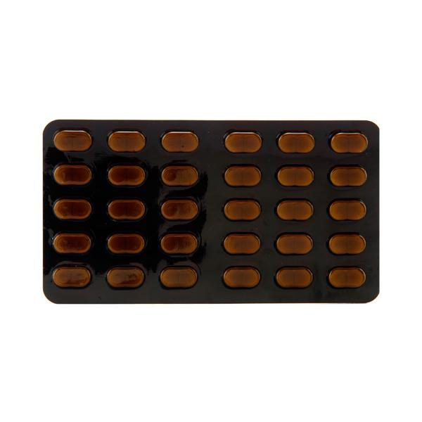1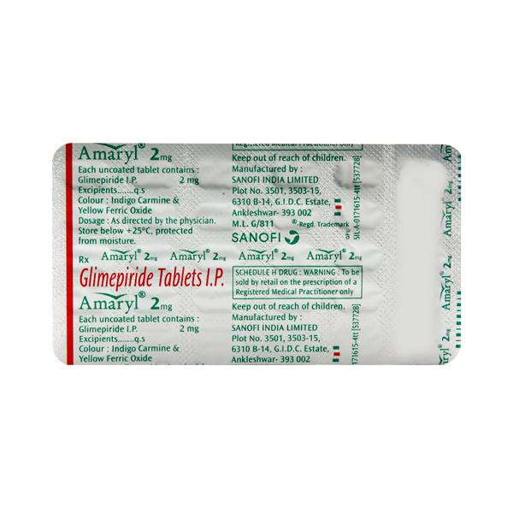

1. **Amaryl M 1mg Strip Of 15 Tablets :--**

**Description**

Amaryl 1mg Tablet belongs to a group of medicines called sulfonylureas and is used to treat type 2 diabetes mellitus in adults. It helps control blood sugar levels in people with diabetes thereby preventing serious complications of diabetes such as kidney damage and blindness.  
  
Amaryl 1mg Tablet may be used alone or along with other medicines. It should be taken just before or with the first meal of the day. Take it regularly at the same time each day to get the maximum benefit. Your doctor will decide what dose is best for you and this may change from time to time according to your blood sugar levels.  
  
Keep taking this medicine, even if you feel well or your blood sugar levels are controlled. If you stop it without consulting your doctor, your blood sugar levels could rise to put you at risk of diabetes complications such as kidney damage, blindness, nerve problems, and loss of limbs. Remember that it is only part of a treatment program that should also include a healthy diet, regular exercise, and weight reduction as advised by your doctor. Your lifestyle plays a big part in controlling diabetes.  
  
The most common side effects of taking this medicine include low blood sugar levels (hypoglycemia), nausea, headache, and dizziness. Make sure you recognize the signs of having low blood sugar levels, such as sweating, dizziness, headache, and shaking, and know how to deal with them. To prevent this, it is important to have regular meals and always carry a fast-acting source of glucose such as sugary food or fruit juice with you. Drinking alcohol can also increase your risk of low blood sugar levels and hence should be avoided. Some people may experience an increase in weight with this medicine.  
  
You should not take it if you have type 1 diabetes mellitus, diabetic ketoacidosis (high levels of acid in your blood), or if you have severe kidney or liver disease. Before taking this medicine, tell your doctor if you have ever had heart disease, thyroid disease, or some hormonal conditions, as it may not be suitable. Pregnant or breastfeeding women should also consult their doctor before taking it. Your blood sugar levels should be checked regularly and your doctor may also advise blood tests to monitor your blood cell counts and liver function.

**USES OF AMARYL TABLET**

Treatment of [Type 2 diabetes mellitus](https://www.1mg.com/diseases/type-2-diabetes-mellitus-105)

**BENEFITS OF AMARYL TABLET**

In Treatment of Type 2 diabetes mellitus

Amaryl 1mg Tablet increases the amount of insulin your body produces (in the pancreas). The insulin then works to lower your blood glucose level. It is usually taken once a day. You should keep taking it for as long as it is prescribed.  
  
Lowering blood glucose levels is an essential part of managing diabetes. If you can control the level you will reduce the risk of getting any of the serious complications of diabetes such as kidney damage, eye damage, nerve problems, and loss of limbs. Taking this medicine regularly along with proper diet and exercise will help you live a normal, healthy life.

**SIDE EFFECTS OF AMARYL TABLET**

Most side effects do not require any medical attention and disappear as your body adjusts to the medicine. Consult your doctor if they persist or if you’re worried about them

Common side effects of Amaryl

* Hypoglycemia (low blood glucose level)
* Headache
* Nausea
* Dizziness

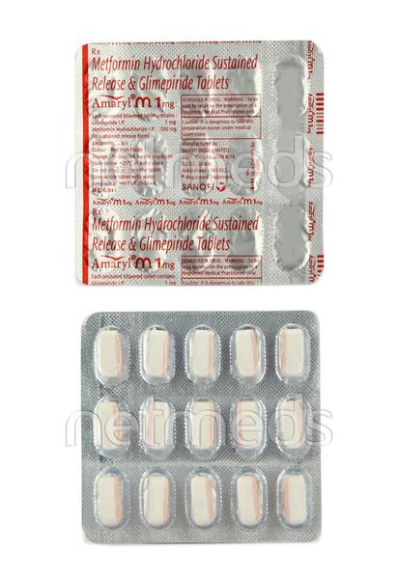

1. **Amaryl M 2mg Strip Of 15 Tablets :---**

**Description**

Amaryl M 2mg Tablet PR belongs to a category of medicines known as anti-diabetic drugs. It is a combination of two medicines used to treat type 2 diabetes mellitus in adults. It helps control blood sugar levels in people with diabetes.  
  
Amaryl M 2mg Tablet PR should be taken with food. Take it regularly at the same time each day to get the most benefit. Your doctor will decide what dose is best for you and this may change from time to time according to how it is working according to your blood sugar levels.  
  
Keep taking this medicine, even if you feel well or your blood sugar levels are controlled. If you stop it without consulting your doctor, your blood sugar levels could rise and put you at risk of kidney damage, blindness, nerve problems, and loss of limbs. Remember that it is only part of a treatment program that should also include a healthy diet, regular exercise, and weight reduction as advised by your doctor. Your lifestyle plays a big part in controlling diabetes.  
  
The most common side effect of Amaryl M 2mg Tablet PR is low blood glucose levels (hypoglycemia). Make sure you recognize the signs of having low blood glucose levels, such as sweating, dizziness, headache, and shaking, and know how to deal with it. To prevent this, it's important to have regular meals and always carry a fast-acting source of glucose such as sugary food or fruit juice with you. Drinking alcohol can also increase your risk of low blood sugar levels and should be avoided. Other side effects that may be seen on taking this medicine include taste changes, nausea, diarrhea, stomach pain, headache, and upper respiratory tract infection. Some people may find that they put on weight with this medicine.  
  
You should not take it if you have type 1 diabetes mellitus, if you have diabetic ketoacidosis (high levels of acid in your blood), or if you have severe kidney or liver disease. Before taking this medicine, tell your doctor if you have ever had heart disease. It may not be suitable. Pregnant or breastfeeding women should also consult their doctor before taking it. Your blood sugar levels should be checked regularly and your doctor may also advise blood tests to monitor your blood cell counts and liver function.

**USES OF AMARYL M TABLET PR**

[Type 2 diabetes mellitus](https://www.1mg.com/diseases/type-2-diabetes-mellitus-105)

**BENEFITS OF AMARYL M TABLET PR**

In Type 2 diabetes mellitus

Amaryl M 2mg Tablet PR is a combination medicine that increases the amount of insulin your body produces (in the pancreas). The insulin then works to lower your blood glucose level. It is usually taken once a day. You should keep taking it for as long as it is prescribed.  
Lowering blood glucose levels is an essential part of managing diabetes. If you can control the level you will reduce the risk of getting any of the serious complications of diabetes such as kidney damage, eye damage, nerve problems, and loss of limbs. Taking this medicine regularly along with proper diet and exercise will help you live a normal, healthy life.

**SIDE EFFECTS OF AMARYL M TABLET PR**

Most side effects do not require any medical attention and disappear as your body adjusts to the medicine. Consult your doctor if they persist or if you’re worried about them

Common side effects of Amaryl M

* Hypoglycemia (low blood glucose level)
* Taste change
* Nausea
* Diarrhea
* Stomach pain
* Headache
* Upper respiratory tract infection

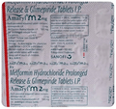

1. **Amaryl Mv 2mg Strip Of 15 Tablets :--**

**Description**

Amaryl MV 2mg Tablet SR belongs to a category of medicines known as anti-diabetic drugs. It is a combination of medicines used to treat type 2 diabetes mellitus in adults. It helps control blood sugar levels in people with diabetes.  
  
Amaryl MV 2mg Tablet SR should be taken with food. Take it regularly at the same time each day to get the most benefit. Your doctor will decide what dose is best for you and this may change from time to time according to how it is working according to your blood sugar levels.  
  
Keep taking this medicine, even if you feel well or your blood sugar levels are controlled. If you stop it without consulting your doctor, your blood sugar levels could rise and put you at risk of kidney damage, blindness, nerve problems and loss of limbs. Remember that it is only part of a treatment program that should also include a healthy diet, regular exercise, and weight reduction as advised by your doctor. Your lifestyle plays a big part in controlling diabetes.  
  
The most common side effect of Amaryl MV 2mg Tablet SR is low blood glucose levels (hypoglycemia). Make sure you recognize the signs of having low blood glucose levels, such as sweating, dizziness, headache, and shaking and know how to deal with it. To prevent this, it's important to have regular meals and always carry a fast-acting source of glucose such as sugary food or fruit juice with you. Drinking alcohol can also increase your risk of low blood sugar levels and should be avoided. Other side effects that may be seen on taking this medicine include taste changes, nausea, diarrhea, stomach pain, headache, edema (swelling), blurred vision, bone fracture, and upper respiratory tract infection. Some people may find that they put on weight with this medicine.  
  
You should not take it if you have type 1 diabetes mellitus, if you have diabetic ketoacidosis (high levels of acid in your blood), or if you have severe kidney or liver disease. Before taking this medicine, tell your doctor if you have ever had heart disease. It may not be suitable. Pregnant or breastfeeding women should also consult their doctor before taking it. Your blood sugar levels should be checked regularly and your doctor may also advise blood tests to monitor your blood cell counts and liver function.

**USES OF AMARYL MV TABLET SR**

[Type 2 diabetes mellitus](https://www.1mg.com/diseases/type-2-diabetes-mellitus-105)

**BENEFITS OF AMARYL MV TABLET SR**

In Type 2 diabetes mellitus

Amaryl MV 2mg Tablet SR is a medicine that helps to control high blood glucose (sugar) levels. It helps to slow down the breaking down of food in our intestine to simple glucose (sugar), thereby decreasing the rise in blood glucose levels after meals. It also helps get rid of extra glucose from your body through urine. Lowering blood glucose levels is an essential part of managing diabetes. If you can control the level, you will reduce the risk of getting any of the serious complications of diabetes such as kidney damage, eye damage, nerve problems and loss of limbs.  
Amaryl MV 2mg Tablet SR will reduce the risk of dying from cardiovascular disease if you have type 2 diabetes and already have cardiovascular disease. Taking this medicine regularly along with proper diet and exercise will help you live a normal, healthy life. You should keep using it for as long as it is prescribed because it is protecting your future health.

**SIDE EFFECTS OF AMARYL MV TABLET SR**

Most side effects do not require any medical attention and disappear as your body adjusts to the medicine. Consult your doctor if they persist or if you’re worried about them

Common side effects of Amaryl MV

* Hypoglycemia (low blood glucose level)
* Nausea
* Diarrhea
* Taste change
* Flatulence
* Stomach pain
* Headache
* Skin rash
* Respiratory tract infection

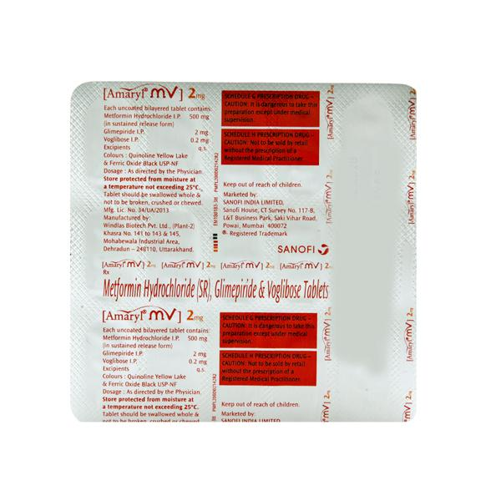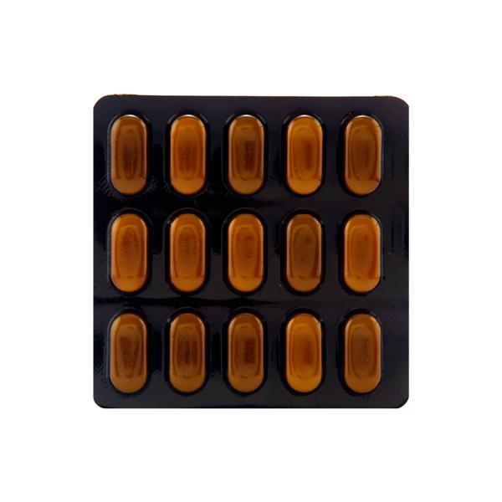

1. **Amaryl M Forte 2mg Tab 15`s :--**

**Description**

Amaryl M Forte 2mg Tablet PR belongs to a category of medicines known as anti-diabetic drugs. It is a combination of two medicines used to treat type 2 diabetes mellitus in adults. It helps control blood sugar levels in people with diabetes.  
  
Amaryl M Forte 2mg Tablet PR should be taken with food. Take it regularly at the same time each day to get the most benefit. Your doctor will decide what dose is best for you and this may change from time to time according to how it is working according to your blood sugar levels.  
  
Keep taking this medicine, even if you feel well or your blood sugar levels are controlled. If you stop it without consulting your doctor, your blood sugar levels could rise and put you at risk of kidney damage, blindness, nerve problems, and loss of limbs. Remember that it is only part of a treatment program that should also include a healthy diet, regular exercise, and weight reduction as advised by your doctor. Your lifestyle plays a big part in controlling diabetes.  
  
The most common side effect of Amaryl M Forte 2mg Tablet PR is low blood glucose levels (hypoglycemia). Make sure you recognize the signs of having low blood glucose levels, such as sweating, dizziness, headache, and shaking, and know how to deal with it. To prevent this, it's important to have regular meals and always carry a fast-acting source of glucose such as sugary food or fruit juice with you. Drinking alcohol can also increase your risk of low blood sugar levels and should be avoided. Other side effects that may be seen on taking this medicine include taste changes, nausea, diarrhea, stomach pain, headache, and upper respiratory tract infection. Some people may find that they put on weight with this medicine.  
  
You should not take it if you have type 1 diabetes mellitus, if you have diabetic ketoacidosis (high levels of acid in your blood), or if you have severe kidney or liver disease. Before taking this medicine, tell your doctor if you have ever had heart disease. It may not be suitable. Pregnant or breastfeeding women should also consult their doctor before taking it. Your blood sugar levels should be checked regularly and your doctor may also advise blood tests to monitor your blood cell counts and liver function.

**USES OF AMARYL M FORTE TABLET PR**

[Type 2 diabetes mellitus](https://www.1mg.com/diseases/type-2-diabetes-mellitus-105)

**BENEFITS OF AMARYL M FORTE TABLET PR**

In Type 2 diabetes mellitus

Amaryl M Forte 2mg Tablet PR is a combination medicine that increases the amount of insulin your body produces (in the pancreas). The insulin then works to lower your blood glucose level. It is usually taken once a day. You should keep taking it for as long as it is prescribed.  
Lowering blood glucose levels is an essential part of managing diabetes. If you can control the level you will reduce the risk of getting any of the serious complications of diabetes such as kidney damage, eye damage, nerve problems, and loss of limbs. Taking this medicine regularly along with proper diet and exercise will help you live a normal, healthy life.

**SIDE EFFECTS OF AMARYL M FORTE TABLET PR**

Most side effects do not require any medical attention and disappear as your body adjusts to the medicine. Consult your doctor if they persist or if you’re worried about them

Common side effects of Amaryl M Forte

* Hypoglycemia (low blood glucose level)
* Taste change
* Nausea
* Diarrhea
* Stomach pain
* Headache
* Upper respiratory tract infection

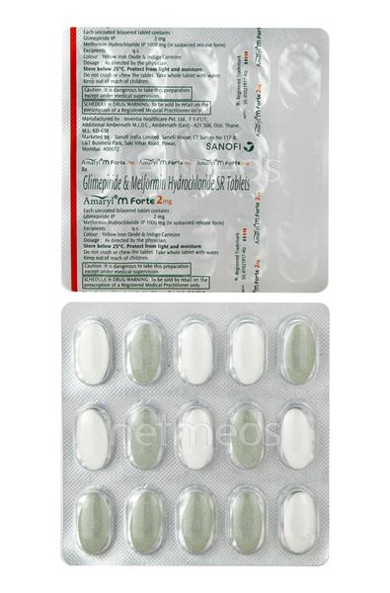

1. **Amaryl M Forte 1mg Tab 15`s :---**

**Description**

Amaryl M Forte 1mg Tablet PR belongs to a category of medicines known as anti-diabetic drugs. It is a combination of two medicines used to treat type 2 diabetes mellitus in adults. It helps control blood sugar levels in people with diabetes.  
  
Amaryl M Forte 1mg Tablet PR should be taken with food. Take it regularly at the same time each day to get the most benefit. Your doctor will decide what dose is best for you and this may change from time to time according to how it is working according to your blood sugar levels.  
  
Keep taking this medicine, even if you feel well or your blood sugar levels are controlled. If you stop it without consulting your doctor, your blood sugar levels could rise and put you at risk of kidney damage, blindness, nerve problems, and loss of limbs. Remember that it is only part of a treatment program that should also include a healthy diet, regular exercise, and weight reduction as advised by your doctor. Your lifestyle plays a big part in controlling diabetes.  
  
The most common side effect of Amaryl M Forte 1mg Tablet PR is low blood glucose levels (hypoglycemia). Make sure you recognize the signs of having low blood glucose levels, such as sweating, dizziness, headache, and shaking, and know how to deal with it. To prevent this, it's important to have regular meals and always carry a fast-acting source of glucose such as sugary food or fruit juice with you. Drinking alcohol can also increase your risk of low blood sugar levels and should be avoided. Other side effects that may be seen on taking this medicine include taste changes, nausea, diarrhea, stomach pain, headache, and upper respiratory tract infection. Some people may find that they put on weight with this medicine.  
  
You should not take it if you have type 1 diabetes mellitus, if you have diabetic ketoacidosis (high levels of acid in your blood), or if you have severe kidney or liver disease. Before taking this medicine, tell your doctor if you have ever had heart disease. It may not be suitable. Pregnant or breastfeeding women should also consult their doctor before taking it. Your blood sugar levels should be checked regularly and your doctor may also advise blood tests to monitor your blood cell counts and liver function.

**USES OF AMARYL M FORTE TABLET PR**

[Type 2 diabetes mellitus](https://www.1mg.com/diseases/type-2-diabetes-mellitus-105)

**BENEFITS OF AMARYL M FORTE TABLET PR**

In Type 2 diabetes mellitus

Amaryl M Forte 1mg Tablet PR is a combination medicine that increases the amount of insulin your body produces (in the pancreas). The insulin then works to lower your blood glucose level. It is usually taken once a day. You should keep taking it for as long as it is prescribed.  
Lowering blood glucose levels is an essential part of managing diabetes. If you can control the level you will reduce the risk of getting any of the serious complications of diabetes such as kidney damage, eye damage, nerve problems, and loss of limbs. Taking this medicine regularly along with proper diet and exercise will help you live a normal, healthy life.

**SIDE EFFECTS OF AMARYL M FORTE TABLET PR**

Most side effects do not require any medical attention and disappear as your body adjusts to the medicine. Consult your doctor if they persist or if you’re worried about them

Common side effects of Amaryl M Forte

* Hypoglycemia (low blood glucose level)
* Taste change
* Nausea
* Diarrhea
* Stomach pain
* Headache
* Upper respiratory tract infection

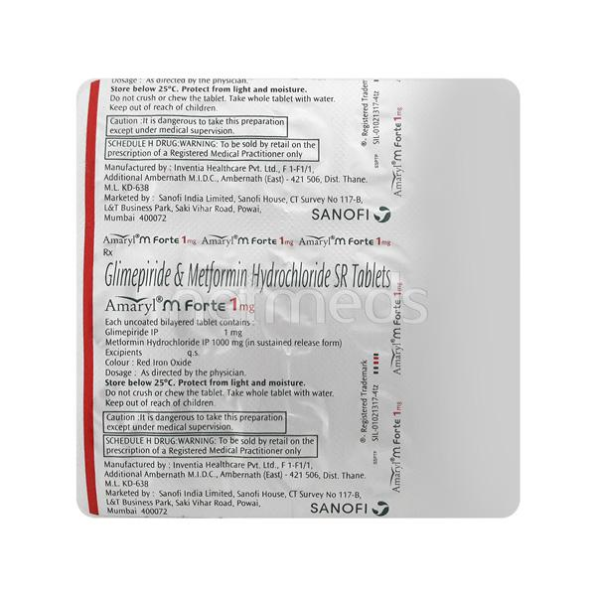

1. **Ambrican 5mg Tablet :--**

**Description**

Ambrican 5 Tablet is a prescription medicine used to treat pulmonary arterial hypertension (high pressure in the blood vessels that carry blood from the heart to the lungs). It even helps to improve your quality of life, exercising ability and delay in disease progression.  
  
Ambrican 5 Tablet may be taken with or without food but, it is better to take it in a dose and duration as advised by the doctor. In case, you have missed any dose than it is better to take another one as soon as you remember it.  
  
Dizziness may occur as its side effect, so do not drive or do anything that requires mental focus. You may also have other side effects like, headache, palpitations, breathlessness, runny nose, feeling sick, diarrhea or fatigue. Let your doctor know if any of these side effects bothers you or persists for a longer duration.

**USES OF AMBRICAN TABLET**

[Pulmonary arterial hypertension (PAH)](https://www.1mg.com/diseases/pulmonary-arterial-hypertension-pah-98)

**BENEFITS OF AMBRICAN TABLET**

In Pulmonary arterial hypertension (PAH)

Pulmonary arterial hypertension can cause shortness of breath, tiredness, dizziness, chest pain and swelling in your ankles and legs. It is caused by thickening of walls of the arteries that supply your lungs making it hard for blood to get through. Ambrican 5 Tablet relaxes the blood vessels and can help lower the blood pressure in the arteries of your lungs. You will be able to carry out your daily activities more easily and feel less tired or dizzy.

**SIDE EFFECTS OF AMBRICAN TABLET**

Most side effects do not require any medical attention and disappear as your body adjusts to the medicine. Consult your doctor if they persist or if you’re worried about them

Common side effects of Ambrican

* Headache
* Dizziness
* Palpitations
* Breathlessness
* Runny nose
* Feeling sick
* Diarrhea
* Fatigue

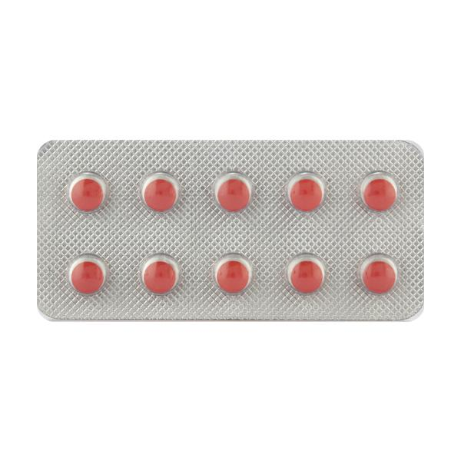

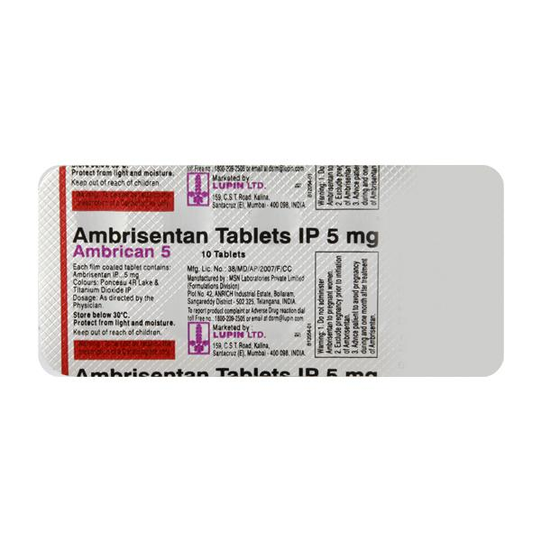

1. **Amlodac 5mg Strip Of 30 Tablets:---**

**Description**

Amlodac 5 Tablet belongs to a class of medicines known as calcium channel blockers. It is used to treat high blood pressure (hypertension) and prevent angina (heart-related chest pain). It lowers blood pressure and reduces the heart's workload, which helps prevent heart attacks and strokes.  
  
Amlodac 5 Tablet may be prescribed alone or along with other medicines. The dose depends on what you are taking it for and the severity of your condition. You can take it at any time of the day, with or without food, but it is best to take it at about the same time each day. You should take this medicine for as long as it is prescribed for you. Even if you feel well, do not stop this medicine on your own because high blood pressure often has no symptoms. If you stop taking it, your condition may get worse. Keeping yourself active with regular exercise, managing your weight, and eating a healthy diet will also help control your blood pressure.  
  
The most common side effects include headache, fatigue, nausea, abdominal pain, and sleepiness. Consult your doctor if any of these side effects bother you or do not go away. They may be able to suggest ways to prevent or reduce the side effects.  
  
Before taking it, let your doctor know if you have any liver, heart, or kidney problems. Pregnant or breastfeeding women should also consult their doctor before taking this medicine. You also need to tell your doctor about all the other medicines you are taking, especially those used to treat high blood pressure or heart conditions. You should have your blood pressure checked regularly to make sure that this medicine is working properly.

**USES OF AMLODAC TABLET**

[Hypertension (high blood pressure)](https://www.1mg.com/diseases/hypertension-high-blood-pressure-68)

Prevention of [Angina (heart-related chest pain)](https://www.1mg.com/diseases/angina-heart-related-chest-pain-65)

**BENEFITS OF AMLODAC TABLET**

In Hypertension (high blood pressure)

Amlodac 5 Tablet works by relaxing the blood vessels so that blood can flow more easily around your body. This lowers your blood pressure and reduces your risk of having a stroke, a heart attack, or kidney problems in the future. You do not usually feel any direct benefit from taking this medicine, but it works in the long term to keep you well. You should take it regularly as prescribed for this medicine to be most effective, even if you feel better.

In Prevention of Angina (heart-related chest pain)

* Amlodac 5 Tablet relaxes the blood vessels and improves blood flow around your body. This means that more oxygen gets to your heart and reduces the risk of getting chest pain (angina). This medicine should not be used to treat chest pain which is already happening. It is used to prevent or reduce the frequency of angina attacks. This medicine needs to be taken regularly as prescribed for it to work effectively. So, it is important to keep taking it even if you feel well and have no symptoms.

**SIDE EFFECTS OF AMLODAC TABLET**

Most side effects do not require any medical attention and disappear as your body adjusts to the medicine. Consult your doctor if they persist or if you’re worried about them

Common side effects of Amlodac

* Headache
* Fatigue
* Nausea
* Abdominal pain
* Sleepiness

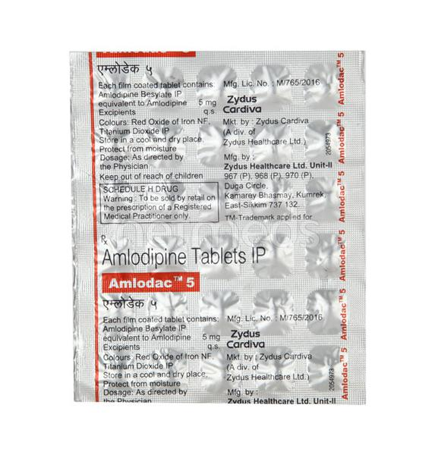

1. **Amlokind At 50mg Strip Of 10 Tablets :---**

**Description**

Amlokind-AT Tablet is used to treat hypertension (high blood pressure). This is a combination of two medicines that controls blood pressure when a single medication is not effective. It helps to lower high blood pressure and thus reduces the chances of future heart attack and stroke.  
  
You can take Amlokind-AT Tablet at any time of day, on empty stomach, but it is best to take it at the same time each day. Keep taking it for as long as advised by your doctor. Even if you feel well, do not stop this medicine on your own because high blood pressure often has no symptoms. If you stop taking it, your condition may get worse. Keeping active with regular exercise, reducing your weight and eating a healthy diet will also help control your blood pressure. Follow your doctor’s advice while taking this medicine.  
  
It may cause side effects like headache, ankle swelling, slow heart rate, and nausea. It may also cause dizziness, so do not drive or do anything that requires mental focus until you know how this medicine affects you. This might raise the level of potassium in the blood, hence avoid potassium rich food or supplements. You may be asked for regular monitoring of blood pressure, kidney function, and electrolytes level while on the treatment.  
  
Before taking it, let your doctor know if you have any liver or kidney problems. Pregnant or breastfeeding women should also consult their doctor for advice before taking this medicine. You also need to tell your doctor what other medicines you are taking especially those used to treat high blood pressure or heart conditions.

**USES OF AMLOKIND-AT TABLET**

[Hypertension (high blood pressure)](https://www.1mg.com/diseases/hypertension-high-blood-pressure-68)

**BENEFITS OF AMLOKIND-AT TABLET**

In Hypertension (high blood pressure)

Amlokind-AT Tablet is a combination medicine that contains two active ingredients, Amlodipine and Atenolol. Both of the medicines in this combination work to lower blood pressure but in different ways. Together they help to relax blood vessels, reduce heart rate and make it easier for your heart to pump blood around your body. This lowers blood pressure.  
  
If your blood pressure is controlled you are less at risk of having a heart attack, stroke or kidney problems. The medicine must be taken regularly as prescribed to be effective. You do not usually feel any direct benefit from taking this medicine, but it works in the long term to keep you well. You should also make appropriate lifestyle changes (such as eating healthy and staying active) to maximize the effectiveness of this medicine.

**SIDE EFFECTS OF AMLOKIND-AT TABLET**

Most side effects do not require any medical attention and disappear as your body adjusts to the medicine. Consult your doctor if they persist or if you’re worried about them

Common side effects of Amlokind-AT

* Sleepiness
* Headache
* Ankle swelling
* Flushing (sense of warmth in the face, ears, neck and trunk)
* Slow heart rate
* Palpitations
* Nausea
* Edema (swelling)
* Constipation
* Tiredness
* Cold extremities

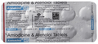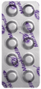

1. **Amlong 5mg Strip Of 15 Tablets:--**

**Description**

Amlong Tablet belongs to a class of medicines known as calcium channel blockers. It is used to treat high blood pressure (hypertension) and prevent angina (heart-related chest pain). It lowers blood pressure and reduces the heart's workload, which helps prevent heart attacks and strokes.  
  
Amlong Tablet may be prescribed alone or along with other medicines. The dose depends on what you are taking it for and the severity of your condition. You can take it at any time of the day, with or without food, but it is best to take it at about the same time each day. You should take this medicine for as long as it is prescribed for you. Even if you feel well, do not stop this medicine on your own because high blood pressure often has no symptoms. If you stop taking it, your condition may get worse. Keeping yourself active with regular exercise, managing your weight, and eating a healthy diet will also help control your blood pressure.  
  
The most common side effects include headache, fatigue, nausea, abdominal pain, and sleepiness. Consult your doctor if any of these side effects bother you or do not go away. They may be able to suggest ways to prevent or reduce the side effects.  
  
Before taking it, let your doctor know if you have any liver, heart, or kidney problems. Pregnant or breastfeeding women should also consult their doctor before taking this medicine. You also need to tell your doctor about all the other medicines you are taking, especially those used to treat high blood pressure or heart conditions. You should have your blood pressure checked regularly to make sure that this medicine is working properly.

**USES OF AMLONG TABLET**

[Hypertension (high blood pressure)](https://www.1mg.com/diseases/hypertension-high-blood-pressure-68)

Prevention of [Angina (heart-related chest pain)](https://www.1mg.com/diseases/angina-heart-related-chest-pain-65)

**BENEFITS OF AMLONG TABLET**

In Hypertension (high blood pressure)

Amlong Tablet works by relaxing the blood vessels so that blood can flow more easily around your body. This lowers your blood pressure and reduces your risk of having a stroke, a heart attack, or kidney problems in the future. You do not usually feel any direct benefit from taking this medicine, but it works in the long term to keep you well. You should take it regularly as prescribed for this medicine to be most effective, even if you feel better.

**Show More**

**SIDE EFFECTS OF AMLONG TABLET**

Most side effects do not require any medical attention and disappear as your body adjusts to the medicine. Consult your doctor if they persist or if you’re worried about them

Common side effects of Amlong

* Headache
* Fatigue
* Nausea
* Abdominal pain
* Sleepiness

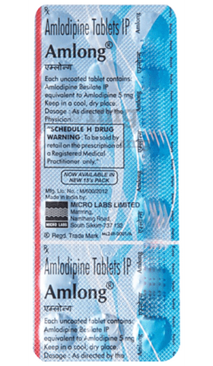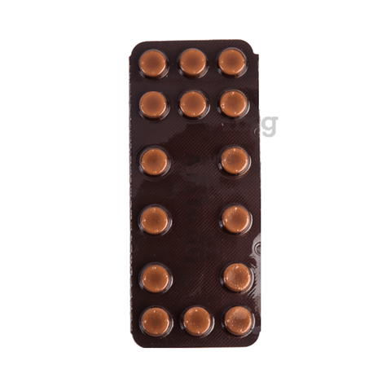

1. **Amlopin M 50mg Tablet:---**

**Description**

Amlopin-M Tablet PR contains two medicines, both of which help to control high blood pressure and heart rate. It is also used for heart-related chest pain, abnormal heart rhythms and chronic (long-term) heart failure.  
  
You can take Amlopin-M Tablet PR at any time of day, with or without food, but it is best to take it at the same time each day. Keep taking it for as long as advised by your doctor. Even if you feel well, do not stop this medicine on your own because high blood pressure often has no symptoms. If you stop taking it, your condition may get worse. Keeping active with regular exercise, reducing your weight and eating a healthy diet will also help control your blood pressure. Follow your doctor’s advice while taking this medicine.  
  
It may cause side effects like headache, ankle swelling, slow heart rate, and nausea. It may also cause dizziness, so do not drive or do anything that requires mental focus until you know how this medicine affects you. This might raise the level of potassium in the blood, hence avoid potassium rich food or supplements. You may be asked for regular monitoring of blood pressure, kidney function, and electrolytes level while on the treatment.  
  
Before taking it, let your doctor know if you have any liver or kidney problems. Pregnant or breastfeeding women should also consult their doctor for advice before taking this medicine. You also need to tell your doctor what other medicines you are taking especially those used to treat high blood pressure or heart conditions.

**USES OF AMLOPIN-M TABLET PR**

[Hypertension (high blood pressure)](https://www.1mg.com/diseases/hypertension-high-blood-pressure-68)

**BENEFITS OF AMLOPIN-M TABLET PR**

In Hypertension (high blood pressure)

Amlopin-M Tablet PR is a combination medicine that contains two active ingredients, Amlodipine and Metoprolol Succinate. Both of the medicines in this combination work to lower blood pressure but in different ways. Together they help to relax blood vessels, reduce heart rate and make it easier for your heart to pump blood around your body. This lowers blood pressure.  
If your blood pressure is controlled you are less at risk of having a heart attack, stroke or kidney problems. The medicine must be taken regularly as prescribed to be effective. You do not usually feel any direct benefit from taking this medicine, but it works in the long term to keep you well. You should also make appropriate lifestyle changes (such as eating healthy and staying active) to maximize the effectiveness of this medicine.

**SIDE EFFECTS OF AMLOPIN-M TABLET PR**

Most side effects do not require any medical attention and disappear as your body adjusts to the medicine. Consult your doctor if they persist or if you’re worried about them

Common side effects of Amlopin-M

* Depression
* Itching
* Nausea
* Rash
* Shortness of breath
* Slow heart rate
* Tiredness
* Abdominal pain
* Decreased blood pressure
* Diarrhea
* Dizziness
* Fatigue
* Sleepiness

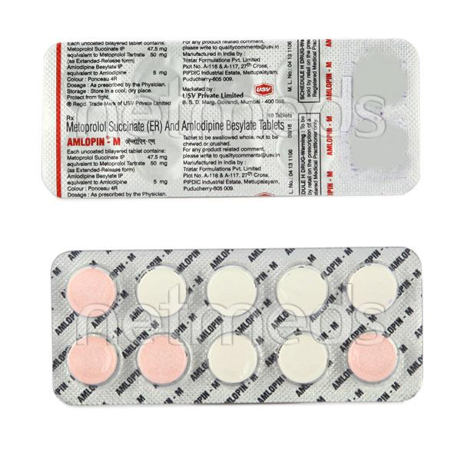

1. **Amlopin 5mg Strip Of 10 Tablets :--**

**Description**

Amlopin 5 Tablet belongs to a class of medicines known as calcium channel blockers. It is used to treat high blood pressure (hypertension) and prevent angina (heart-related chest pain). It lowers blood pressure and reduces the heart's workload, which helps prevent heart attacks and strokes.  
  
Amlopin 5 Tablet may be prescribed alone or along with other medicines. The dose depends on what you are taking it for and the severity of your condition. You can take it at any time of the day, with or without food, but it is best to take it at about the same time each day. You should take this medicine for as long as it is prescribed for you. Even if you feel well, do not stop this medicine on your own because high blood pressure often has no symptoms. If you stop taking it, your condition may get worse. Keeping yourself active with regular exercise, managing your weight, and eating a healthy diet will also help control your blood pressure.  
  
The most common side effects include headache, fatigue, nausea, abdominal pain, and sleepiness. Consult your doctor if any of these side effects bother you or do not go away. They may be able to suggest ways to prevent or reduce the side effects.  
  
Before taking it, let your doctor know if you have any liver, heart, or kidney problems. Pregnant or breastfeeding women should also consult their doctor before taking this medicine. You also need to tell your doctor about all the other medicines you are taking, especially those used to treat high blood pressure or heart conditions. You should have your blood pressure checked regularly to make sure that this medicine is working properly.

**USES OF AMLOPIN TABLET**

* [Hypertension (high blood pressure)](https://www.1mg.com/diseases/hypertension-high-blood-pressure-68)
* Prevention of [Angina (heart-related chest pain)](https://www.1mg.com/diseases/angina-heart-related-chest-pain-65)

**BENEFITS OF AMLOPIN TABLET**

In Hypertension (high blood pressure)

Amlopin 5 Tablet works by relaxing the blood vessels so that blood can flow more easily around your body. This lowers your blood pressure and reduces your risk of having a stroke, a heart attack, or kidney problems in the future. You do not usually feel any direct benefit from taking this medicine, but it works in the long term to keep you well. You should take it regularly as prescribed for this medicine to be most effective, even if you feel better.

In Prevention of Angina (heart-related chest pain)

Amlopin 5 Tablet relaxes the blood vessels and improves blood flow around your body. This means that more oxygen gets to your heart and reduces the risk of getting chest pain (angina). This medicine should not be used to treat chest pain which is already happening. It is used to prevent or reduce the frequency of angina attacks. This medicine needs to be taken regularly as prescribed for it to work effectively. So, it is important to keep taking it even if you feel well and have no symptoms.

**SIDE EFFECTS OF AMLOPIN TABLET**

Most side effects do not require any medical attention and disappear as your body adjusts to the medicine. Consult your doctor if they persist or if you’re worried about them

Common side effects of Amlopin

* Headache
* Fatigue
* Nausea
* Abdominal pain
* Sleepiness

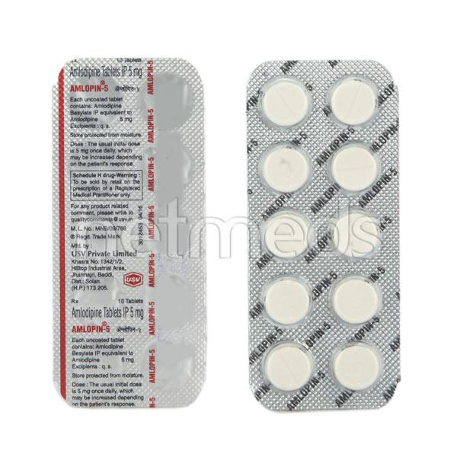

1. **Amlopres At 50mg Strip Of 15 Tablets :--**

**Description**

Amlopres-AT Tablet is used to treat hypertension (high blood pressure). This is a combination of two medicines that controls blood pressure when a single medication is not effective. It helps to lower high blood pressure and thus reduces the chances of future heart attack and stroke.  
  
You can take Amlopres-AT Tablet at any time of day, on empty stomach, but it is best to take it at the same time each day. Keep taking it for as long as advised by your doctor. Even if you feel well, do not stop this medicine on your own because high blood pressure often has no symptoms. If you stop taking it, your condition may get worse. Keeping active with regular exercise, reducing your weight and eating a healthy diet will also help control your blood pressure. Follow your doctor’s advice while taking this medicine.  
  
It may cause side effects like headache, ankle swelling, slow heart rate, and nausea. It may also cause dizziness, so do not drive or do anything that requires mental focus until you know how this medicine affects you. This might raise the level of potassium in the blood, hence avoid potassium rich food or supplements. You may be asked for regular monitoring of blood pressure, kidney function, and electrolytes level while on the treatment.  
  
Before taking it, let your doctor know if you have any liver or kidney problems. Pregnant or breastfeeding women should also consult their doctor for advice before taking this medicine. You also need to tell your doctor what other medicines you are taking especially those used to treat high blood pressure or heart conditions.

**USES OF AMLOPRES-AT TABLET**

[Hypertension (high blood pressure)](https://www.1mg.com/diseases/hypertension-high-blood-pressure-68)

**BENEFITS OF AMLOPRES-AT TABLET**

In Hypertension (high blood pressure)

Amlopres-AT Tablet is a combination medicine that contains two active ingredients, Amlodipine and Atenolol. Both of the medicines in this combination work to lower blood pressure but in different ways. Together they help to relax blood vessels, reduce heart rate and make it easier for your heart to pump blood around your body. This lowers blood pressure.  
  
If your blood pressure is controlled you are less at risk of having a heart attack, stroke or kidney problems. The medicine must be taken regularly as prescribed to be effective. You do not usually feel any direct benefit from taking this medicine, but it works in the long term to keep you well. You should also make appropriate lifestyle changes (such as eating healthy and staying active) to maximize the effectiveness of this medicine.

**SIDE EFFECTS OF AMLOPRES-AT TABLET**

Most side effects do not require any medical attention and disappear as your body adjusts to the medicine. Consult your doctor if they persist or if you’re worried about them

Common side effects of Amlopres-AT

* Sleepiness
* Headache
* Ankle swelling
* Flushing (sense of warmth in the face, ears, neck and trunk)
* Slow heart rate
* Palpitations
* Nausea
* Edema (swelling)
* Constipation
* Tiredness
* Cold extremities

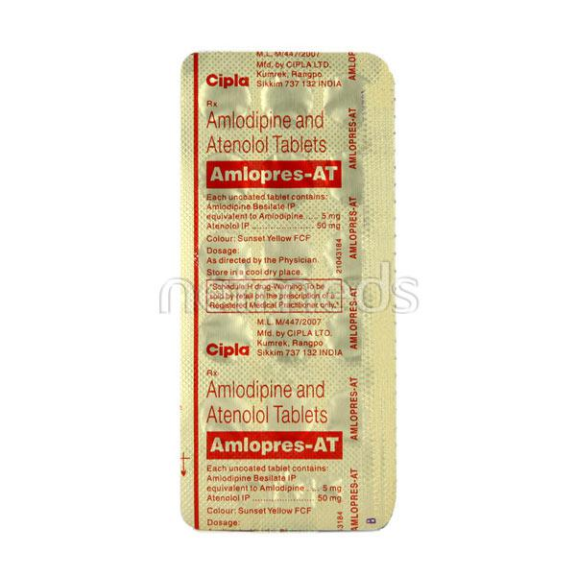

1. **Androanagen Tab :--**

**Description**

**Androanagen Tablet** is an effective remedy for hair loss. It helps in supporting the healthy growth of hair. It supports in treating hair problems such as hair loss, Alopecia and hair fall.  
  
**Key Ingredients:**

* Taurine
* Beta-Sitosterol
* Zinc Sulphate Monohydrate
* Green tea extract
* L-ornithine
* Copper
* Ferrous Fumarate

**Key Benefits:**

* It may help to prevent hardening of the hair shaft and the buildup of collagen around it
* It can be used by both men and women dealing with hereditary hair loss or androgenic alopecia
* Increases the circulation of blood to hair follicles which triggers an increase in hair growth

**Directions For Use**  
Take 1 tablet in a day or, as directed by the physician  
  
**Safety Information:**

* Read the label carefully before use
* Keep away from children
* Use under medical supervision
* Do not exceed the recommended dosage
* Store in a cool and dry place

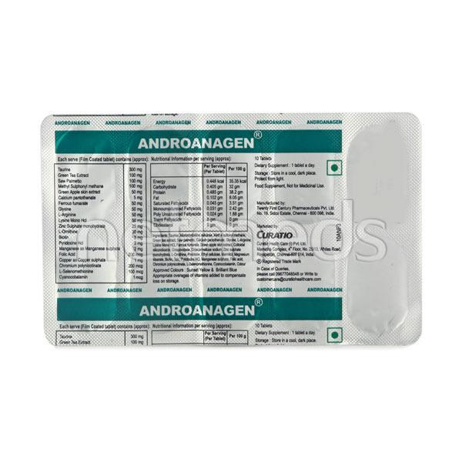

1. **Antoxipan Strip Of 15 Tablets :--**

**Description**

**Antoxipan Tablet** is a nutritional supplement that contains essential minerals and vitamins that helps to provide nourishment to the body. It helps in growth, good health and has good antioxidant properties.  
  
**Key Ingredients:**

* Beta-carotene
* Methionine
* Selenium
* Vitamin C
* Vitamin E

**Key Benefits:**

* Methionine is useful in migraine, trigeminal neuralgia, cardiac arrhythmias
* Selenium has potent anti oxidant properties and helps to protect the cells
* Useful in vitamin C deficiencies
* Protects the body from harmful effects of oxidation
* Promotes growth and good health

**Directions For Use:**

* Take Antoxipan Tablet as directed by the physician

**Safety Information:**

* A dietary nutritional supplement not for medicinal use
* Read the label carefully before use
* Do not exceed the recommended dose
* Keep out of the reach of children
* Store at a temperature below 25-degree Celsius and 40 % humidity in cool and dry place
* Should be protected from direct light

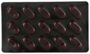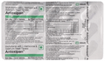

1. **Aplazar Strip Of 10 Tablets :---**

**Description**

Aplazar Tablet belongs to a class of drugs called nutritional supplements. It provides nutrition therapy in the patients of chronic kidney failure. This medicine prevents the unnecessary increase in urea levels in the blood.  
  
Aplazar Tablet is taken by mouth with or without food. But it is important to take it in a dose and duration as advised by doctor. It is best if taken along with a low-protein diet as it helps in delaying the progression of kidney diseases and dialysis initiation. Ensure that you maintain adequate calorie intake during the therapy. While you are taking this medicine, your doctor may advice for regular monitoring of serum calcium levels.  
  
It is usually well tolerated with little or no side effects.

**USES OF APLAZAR TABLET**

[Chronic kidney disease](https://www.1mg.com/diseases/chronic-kidney-disease-535)

**SIDE EFFECTS OF APLAZAR TABLET**

Most side effects do not require any medical attention and disappear as your body adjusts to the medicine. Consult your doctor if they persist or if you’re worried about them

Common side effects of Aplazar

* No common side effects seen

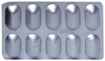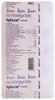

1. **Apresol Strip Of 10 Tablets :--**

## Description

Apresol Tablet belongs to a class of drugs known as vasodilators and is used for the treatment of hypertension (high blood pressure). It may also be used in combination with other medicines in the treatment of heart failure.  
  
Apresol Tablet works by relaxing and enlarging certain small blood vessels so that blood flows through them more easily. It may be taken with or without food, preferably at the same time, each day. You must follow your doctor’s instructions exactly, taking all the prescribed medicines, in the right amounts, each day.  
  
These medicines will help keep your blood pressure down. Do not skip any doses. If you forget a dose of Apresol Tablet, wait until it is time for your next dose, then continue with your regular schedule. Do not stop taking it, or any of your other high blood pressure medicines, without checking with your doctor.  
  
Apresol Tablet is generally safe and suitable for most people but has some potential side effects. The most common are headache, loss of appetite, nausea, vomiting, diarrhea, and increased heart rate. Talk to your doctor if you are bothered by side effects or they do not resolve.

**USES OF APRESOL TABLET**

* [Hypertension (high blood pressure)](https://www.1mg.com/diseases/hypertension-high-blood-pressure-68)
* Treatment of [Heart failure](https://www.1mg.com/diseases/heart-failure-75)

**BENEFITS OF APRESOL TABLET**

In Hypertension (high blood pressure)

Apresol Tablet is a medicine used to treat high blood pressure. It works by relaxing blood vessels which lower blood pressure and allow more blood and oxygen to reach the heart and other organs. If your blood pressure is controlled you are less at risk of having a heart attack, stroke, or kidney problems. It must be taken regularly as prescribed to be effective. You do not usually feel any direct benefit from taking this medicine, but it works in the long term to keep you well.

In Treatment of Heart failure

Heart failure means your heart is weak and cannot pump enough blood to your lungs and the rest of your body. The most common symptoms are breathlessness, tiredness, and swelling in your legs, ankles, abdomen and other parts of your body. Apresol Tablet makes it easier for your heart to pump blood around your body and is therefore an effective treatment for heart failure.  
  
This medicine will help relieve your symptoms, making you feel better and more energetic. You should make appropriate lifestyle changes (such as eating healthily and keeping active) to help this medicine be effective. Take it regularly and keep taking it even if you feel better.

**Show Less**

**SIDE EFFECTS OF APRESOL TABLET**

Most side effects do not require any medical attention and disappear as your body adjusts to the medicine. Consult your doctor if they persist or if you’re worried about them

Common side effects of Apresol

* Diarrhea
* Headache
* Increased heart rate
* Loss of appetite
* Nausea
* Palpitations
* Vomiting

1. **Aprezo 30mg Strip Of 10 Tablets:--**

**Description**

Aprezo Tablet is used in the treatment of moderate to severe plaque psoriasis which is a type of skin condition. This medicine is used when other conventional treatments cannot be used or if the patient is not responsive or intolerant to any of these treatments.  
  
Aprezo Tablet can be taken with or without food. Take it regularly and do not stop taking the medicine even if you get better until that doctor tells you it is alright to stop. You may need to monitor your weight regularly while taking the medicine as it may cause weight loss.  
  
Using this medicine may cause few common side effects such as nausea, diarrhea, and vomiting. If these side effects persist or get worse, let your doctor know. Your doctor may help with ways to reduce or prevent these symptoms by prescribing you an alternative medicine or by adjusting the dose.  
  
To make sure the medicine is safe for you, before taking this medicine, let your doctor know all the other medicines you are taking. If you are pregnant or breastfeeding, consult your doctor first before taking this medicine.

**USES OF APREZO TABLET**

Plaque psoriasis

**BENEFITS OF APREZO TABLET**

In Plaque psoriasis

Plaque psoriasis is the most common form of psoriasis, a condition where the skin cells in the body grow too quickly and form scales and dry patches. They can grow anywhere, but most appear on the scalp, elbows, knees, and lower back. Aprezo Tablet reduces the scaly, itchy patches which may develop on the different parts of the body. It may take several months to become fully effective. You should avoid drinking alcohol while having this treatment and drink plenty of water to stay hydrated.

**SIDE EFFECTS OF APREZO TABLET**

Most side effects do not require any medical attention and disappear as your body adjusts to the medicine. Consult your doctor if they persist or if you’re worried about them

Common side effects of Aprezo

* Diarrhea
* Nausea
* Vomiting

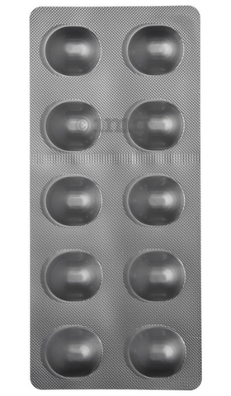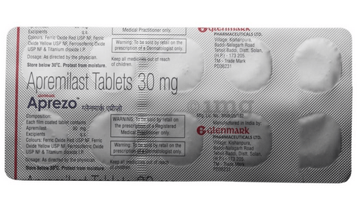

1. **Arimidex 1mg Tablet :--**

**Description**

Arimidex 1mg Tablet is used alone or with other treatments, such as surgery or radiation, to treat early breast cancer in postmenopausal women. It can also be used as the first line treatment of advanced breast cancer that has spread within the breast or to other areas of the body.  
  
Arimidex 1mg Tablet belong to a class of drug called aromatase inhibitors, which decreases the amount of estrogen in the body. It should be taken with or without food, but take it at the same time every day to get the most benefit. It should be taken as your doctor's advice. The dose and how often you take it depends on what you are taking it for. Your doctor will decide how much you need to improve your symptoms. Swallow the tablets whole with a drink of water. You should take this medicine for as long as it is prescribed for you.  
  
The most common side effects of the medicine include hot flushes, nausea, rashes, joint pain, osteoporosis, and weakness. If these bother you or appear serious, let your doctor know. There may be ways of reducing or preventing them.  
  
Before taking this medicine, tell your doctor if you are not gone through menopause and still having menstrual periods, or you have a problem with the liver or kidney. Your doctor should also know about all other medicines you are taking as many of these may make this medicine less effective or change the way it works. Tell your doctor if you are pregnant or breastfeeding. Your doctor may perform some blood tests to check for vitamin D level or bone density.

**USES OF ARIMIDEX TABLET**

[Breast cancer](https://www.1mg.com/diseases/breast-cancer-134)

**BENEFITS OF ARIMIDEX TABLET**

In Breast cancer

Arimidex 1mg Tablet relieves the symptoms of breast cancer such as breast lumps, bloody discharge from nipple or changes in the shape or texture of the breast. It works by altering the production of those hormones in the body that are essential for the growth and spread of breast cancer. It may also interact with other hormones or have a direct effect on the cancer to stop its growth.

**SIDE EFFECTS OF ARIMIDEX TABLET**

Most side effects do not require any medical attention and disappear as your body adjusts to the medicine. Consult your doctor if they persist or if you’re worried about them

Common side effects of Arimidex

* Hot flashes
* Nausea
* Osteoporosis
* Skin rash
* Weakness

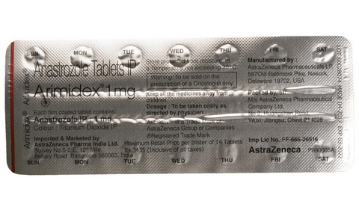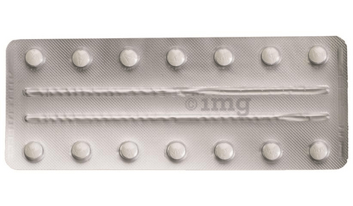

1. **Arkamin 100mcg Strip Of 30 Tablets :--**

**Description**

Arkamin Tablet is a medicine used in the treatment of hypertension (high blood pressure). It lowers the blood pressure by relaxing the blood vessels. Lowering the blood pressure helps to prevent future stroke and heart attack.  
  
Arkamin Tablet is also used to prevent migraine and hot flushes in women during menopause. This medicine can be taken with or without food but it is better to take it at the same time every day. You should always take this medicine as advised by the doctor and should never stop it without consulting the doctor. Most people with high blood pressure do not feel ill, but if you stop taking this medicine, your condition could get worse. This may lead to your blood pressure rising up again and increase your risk of heart disease and stroke. You should monitor your blood pressure regularly while taking this medicine.  
  
Common side effects of this medicine include dizziness, headache, nausea, fatigue, dry mouth, constipation, insomnia. Consult your doctor if these side effects bother you.  
  
Before taking this medicine, it is better to let your doctor know if you are suffering from any kidney or liver disease. Also, pregnant women and breastfeeding mothers should consult a doctor before taking it.

**USES OF ARKAMIN TABLET**

[Hypertension (high blood pressure)](https://www.1mg.com/diseases/hypertension-high-blood-pressure-68)

**BENEFITS OF ARKAMIN TABLET**

In Hypertension (high blood pressure)

Arkamin Tablet works by relaxing the blood vessels so that blood can flow more easily around your body. This lowers your blood pressure and reduces your risk of having a stroke, a heart attack, or kidney problems in the future. You do not usually feel any direct benefit from taking this medicine, but it works in the long term to keep you well. You should take it regularly as prescribed for this medicine to be most effective, even if you feel better.

**SIDE EFFECTS OF ARKAMIN TABLET**

Most side effects do not require any medical attention and disappear as your body adjusts to the medicine. Consult your doctor if they persist or if you’re worried about them

Common side effects of Arkamin

* Dizziness
* Dryness in mouth
* Constipation
* Headache
* Nausea
* Fatigue
* Insomnia (difficulty in sleeping)

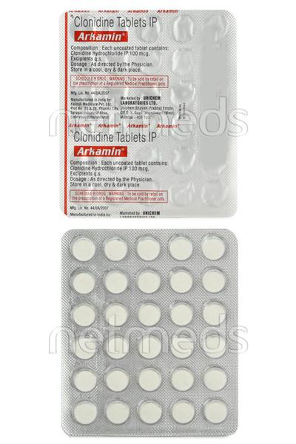

1. **Arvast 10mg Strip Of 15 Tablets :--**

**Description**

Arvast 15 Tablet belongs to a group of medicines called statins. It is used to lower cholesterol and to reduce the risk of heart disease. Cholesterol is a fatty substance that builds up in your blood vessels and causes narrowing, which may lead to a heart attack or stroke.  
  
Arvast 15 Tablet is a widely prescribed medicine and is regarded as safe for long-term use. It can be taken with a meal or on an empty stomach. You can take it at any time of the day but try to take it at the same time each day. Most people with high cholesterol do not feel ill, but stopping your medicine may increase your cholesterol levels, making your condition worse and increasing your risk of heart disease and stroke.  
  
It is important to have your cholesterol levels checked regularly. This medicine is only one part of the treatment program which should also include a healthy diet, regular exercise, smoking cessation, moderation of alcohol intake, and weight reduction. You can eat normally while taking this medicine, but try to avoid foods that are high in fat.  
  
Common side effects of this medicine include muscle pain, weakness, nausea, headache, and stomach pain. These are usually mild and disappear after a short time. Consult your doctor if they persist or if you notice any yellowing of your eyes or get repeated or unexplained muscle pains.  
  
This medicine should not be used in conditions such as liver disease. Also, pregnant women and breastfeeding mothers should not take this medicine as it may harm the developing baby. Diabetic patients should monitor their blood sugar levels while taking this medicine, as it may lead to an increase in blood sugar levels.

**USES OF ARVAST TABLET**

* [High cholesterol](https://www.1mg.com/diseases/high-cholesterol-108)
* Prevention of heart attack and stroke

**BENEFITS OF ARVAST TABLET**

In High cholesterol

Arvast 15 Tablet belongs to a group of medicines called statins. It works by reducing the amount of “bad” cholesterol (LDL) and raising the amount of “good” cholesterol (HDL) in your blood. Lowering the amount of cholesterol reduces the chances of heart diseases and helps you remain healthier for longer.  
  
Take it regularly and make appropriate lifestyle changes (such as eating healthy and staying active) to maximize the effectiveness of this medicine. Keep taking it even if you feel well.

In Prevention of heart attack and stroke

High levels of cholesterol can cause your blood vessels to narrow (atherosclerosis) and put you at risk of having a stroke or heart disease. Lowering the amount of this fat reduces the chances of this happening and helps you remain healthier for longer. Keep taking this medicine even if you feel well.

**SIDE EFFECTS OF ARVAST TABLET**

Most side effects do not require any medical attention and disappear as your body adjusts to the medicine. Consult your doctor if they persist or if you’re worried about them

Common side effects of Arvast

* Muscle pain
* Weakness
* Headache
* Abdominal pain
* Nausea

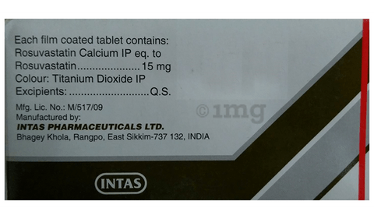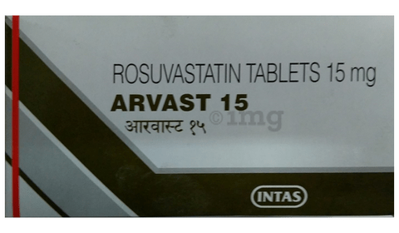

1. **Asomex 5mg Strip Of 15 Tablets :--**

**Description**

Asomex 5 Tablet is a medicine used to treat high blood pressure (hypertension) and to prevent angina (heart-related chest pain). It is a calcium channel blocker which helps to lower blood pressure and reduce the workload of the heart. This helps prevent heart attacks and strokes.  
  
Asomex 5 Tablet may be prescribed alone or along with other medicines. The dose depends on what you are taking it for and the severity of your condition. You can take it at any time of day, with or without food, but it is best to take it at the same time each day. Keep taking it for as long as advised by your doctor. Even if you feel well, do not stop this medicine on your own because high blood pressure often has no symptoms. If you stop taking it, your condition may get worse. Keeping active with regular exercise, reducing your weight and eating a healthy diet will also help control your blood pressure. Follow your doctor’s advice while taking this medicine.  
  
The most common side effects include fatigue, swelling in the feet or ankles, sleepiness, dizziness, flushing, and headache. Consult your doctor If any of these bother you, or get worse, or won't go away.  
  
Before taking it, let your doctor know if you have any liver or kidney problems. Pregnant or breastfeeding women should also consult their doctor for advice before taking this medicine. You also need to tell your doctor what other medicines you are taking – especially those used to treat high blood pressure or heart conditions. You should have your blood pressure checked regularly to make sure that this medicine is working properly.

**USES OF ASOMEX TABLET**

* Treatment of [Hypertension (high blood pressure)](https://www.1mg.com/diseases/hypertension-high-blood-pressure-68)
* Prevention of [Angina (heart-related chest pain)](https://www.1mg.com/diseases/angina-heart-related-chest-pain-65)
* Prevention of [Heart attack](https://www.1mg.com/diseases/heart-attack-67)
* Prevention of [Stroke](https://www.1mg.com/diseases/stroke-181)

**BENEFITS OF ASOMEX TABLET**

In Treatment of Hypertension (high blood pressure)

Asomex 5 Tablet is a calcium channel blocker. It works by relaxing the blood vessels so that blood can flow more easily around your body. This lowers your blood pressure and reduces your risk of having a stroke, a heart attack, or kidney problems in the future. You do not usually feel any direct benefit from taking this medicine, but it works in the long term to keep you well. Take regularly, as prescribed for this medicine to be most effective, even if you feel better.

In Prevention of Angina (heart-related chest pain)

Asomex 5 Tablet belongs to a class of medicines known as a calcium channel blockers. It works by relaxing blood vessels so that blood can flow more easily around your body. This means that more oxygen gets to your heart and reduces the risk of getting chest pain (angina). This medicine should not be used to treat chest pain which is already happening. It is used to prevent or reduce the frequency of angina attacks. This medicine needs to be taken regularly as prescribed for it to work effectively. So, it is important to keep taking it even if you feel well and have no symptoms.

In Prevention of Heart attack

Asomex 5 Tablet helps lower your blood pressure and make it easier for your heart to pump blood around your body. This reduces the chances of you having a heart attack. It can also reduce the risk of dying if it is given immediately after a heart attack. This medicine needs to be taken regularly to be effective, so keep taking it even if you feel well. Do not stop without talking to your doctor.

In Prevention of Stroke

Asomex 5 Tablet reduces the risk of future strokes. It helps lower your blood pressure and make it easier for your heart to pump blood around your body. This reduces the chances of you having a stroke. Take it as advised by the doctor to get the maximum benefit.

**SIDE EFFECTS OF ASOMEX TABLET**

Most side effects do not require any medical attention and disappear as your body adjusts to the medicine. Consult your doctor if they persist or if you’re worried about them

Common side effects of Asomex

* Dizziness
* Headache
* Palpitations
* Flushing (sense of warmth in the face, ears, neck and trunk)
* Fatigue

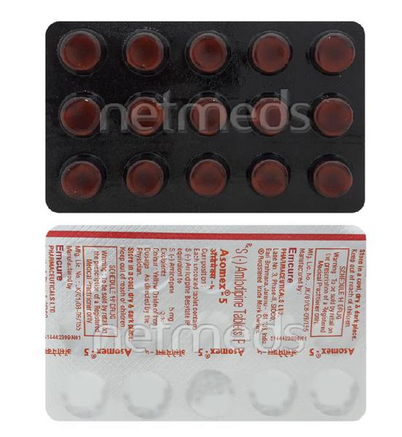

1. **Asomex 2.5mg Strip Of 15 Tablets :--**

**Description**

Asomex 2.5 Tablet is a medicine used to treat high blood pressure (hypertension) and to prevent angina (heart-related chest pain). It is a calcium channel blocker which helps to lower blood pressure and reduce the workload of the heart. This helps prevent heart attacks and strokes.  
  
Asomex 2.5 Tablet may be prescribed alone or along with other medicines. The dose depends on what you are taking it for and the severity of your condition. You can take it at any time of day, with or without food, but it is best to take it at the same time each day. Keep taking it for as long as advised by your doctor. Even if you feel well, do not stop this medicine on your own because high blood pressure often has no symptoms. If you stop taking it, your condition may get worse. Keeping active with regular exercise, reducing your weight and eating a healthy diet will also help control your blood pressure. Follow your doctor’s advice while taking this medicine.  
  
The most common side effects include fatigue, swelling in the feet or ankles, sleepiness, dizziness, flushing, and headache. Consult your doctor If any of these bother you, or get worse, or won't go away.  
  
Before taking it, let your doctor know if you have any liver or kidney problems. Pregnant or breastfeeding women should also consult their doctor for advice before taking this medicine. You also need to tell your doctor what other medicines you are taking – especially those used to treat high blood pressure or heart conditions. You should have your blood pressure checked regularly to make sure that this medicine is working properly.

**USES OF ASOMEX TABLET**

* Treatment of [Hypertension (high blood pressure)](https://www.1mg.com/diseases/hypertension-high-blood-pressure-68)
* Prevention of [Angina (heart-related chest pain)](https://www.1mg.com/diseases/angina-heart-related-chest-pain-65)
* Prevention of [Heart attack](https://www.1mg.com/diseases/heart-attack-67)
* Prevention of [Stroke](https://www.1mg.com/diseases/stroke-181)

**BENEFITS OF ASOMEX TABLET**

In Treatment of Hypertension (high blood pressure)

Asomex 2.5 Tablet is a calcium channel blocker. It works by relaxing the blood vessels so that blood can flow more easily around your body. This lowers your blood pressure and reduces your risk of having a stroke, a heart attack, or kidney problems in the future. You do not usually feel any direct benefit from taking this medicine, but it works in the long term to keep you well. Take regularly, as prescribed for this medicine to be most effective, even if you feel better.

In Prevention of Angina (heart-related chest pain)

Asomex 2.5 Tablet belongs to a class of medicines known as a calcium channel blockers. It works by relaxing blood vessels so that blood can flow more easily around your body. This means that more oxygen gets to your heart and reduces the risk of getting chest pain (angina). This medicine should not be used to treat chest pain which is already happening. It is used to prevent or reduce the frequency of angina attacks. This medicine needs to be taken regularly as prescribed for it to work effectively. So, it is important to keep taking it even if you feel well and have no symptoms.

In Prevention of Heart attack

Asomex 2.5 Tablet helps lower your blood pressure and make it easier for your heart to pump blood around your body. This reduces the chances of you having a heart attack. It can also reduce the risk of dying if it is given immediately after a heart attack. This medicine needs to be taken regularly to be effective, so keep taking it even if you feel well. Do not stop without talking to your doctor.

In Prevention of Stroke

Asomex 2.5 Tablet reduces the risk of future strokes. It helps lower your blood pressure and make it easier for your heart to pump blood around your body. This reduces the chances of you having a stroke. Take it as advised by the doctor to get the maximum benefit.

**SIDE EFFECTS OF ASOMEX TABLET**

Most side effects do not require any medical attention and disappear as your body adjusts to the medicine. Consult your doctor if they persist or if you’re worried about them

Common side effects of Asomex

* Dizziness
* Headache
* Palpitations
* Flushing (sense of warmth in the face, ears, neck and trunk)
* Fatigue

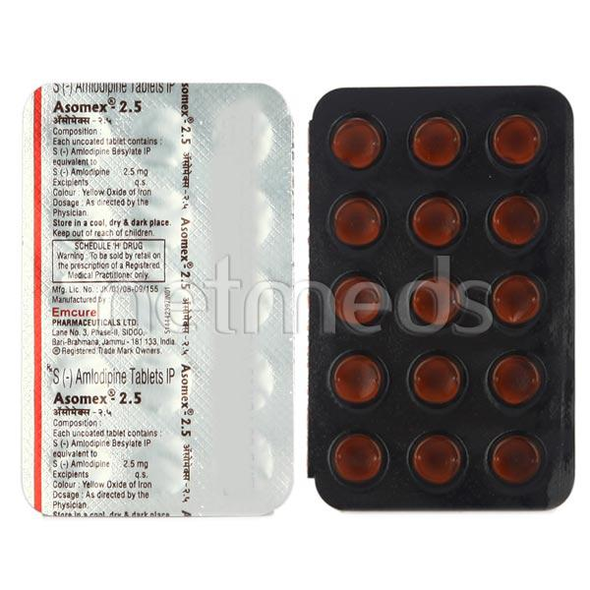

1. **Atocor 40mg Strip Of 14 Tablets :--**

**Description**

Atocor 40 Tablet belongs to a group of medicines called statins. It is used to lower cholesterol and to reduce the risk of heart diseases. Cholesterol is a fatty substance that builds up in your blood vessels and causes narrowing, which may lead to a heart attack or stroke.  
  
Atocor 40 Tablet is a widely prescribed medicine and is regarded as safe for long-term use when taken as per the doctor's advice. It can be taken with a meal or on an empty stomach. You can take it at any time of the day but try to take it at about the same time each day. Most people with high cholesterol do not feel ill, but stopping your medicine may increase your cholesterol levels thereby increasing your risk of heart disease and stroke.  
  
It is important to have your cholesterol levels checked regularly. This medicine is only one part of the treatment program which should also include a healthy diet, regular exercise, smoking cessation, moderation of alcohol intake, and weight reduction. You can eat normally while taking this medicine, but try to avoid foods that are high in fat.   
  
Common side effects of this medicine include constipation, flatulence, dyspepsia, and abdominal pain. These are usually mild and disappear after a short time. Consult your doctor if they persist or if you notice any yellowing of your eyes or get repeated or unexplained muscle pains.   
  
This medicine should not be used in some conditions such as liver disease. Also, pregnant women and breastfeeding mothers should not take this medicine as it may harm the developing baby. Diabetic patients should monitor their blood sugar levels while taking this medicine, as it may lead to an increase in blood sugar levels. Your doctor may check your liver function before starting the treatment and monitor it regularly thereafter.

**USES OF ATOCOR TABLET**

* [High cholesterol](https://www.1mg.com/diseases/high-cholesterol-108)
* Prevention of [Heart attack](https://www.1mg.com/diseases/heart-attack-67)

**BENEFITS OF ATOCOR TABLET**

In High cholesterol

Atocor 40 Tablet belongs to a group of medicines called statins. It works by reducing the amount of “bad” cholesterol (LDL) and raising the amount of “good” cholesterol (HDL) in your blood. Lowering the amount of cholesterol reduces the chances of heart diseases and helps you remain healthier for longer.  
Take it regularly and make appropriate lifestyle changes (such as eating healthy and staying active) to maximize the effectiveness of this medicine. Keep taking it even if you feel well.

In Prevention of Heart attack

High levels of cholesterol can cause your blood vessels to narrow (atherosclerosis) and put you at risk of having a stroke or heart disease. Lowering the amount of this fat reduces the chances of this happening and helps you remain healthier for longer. Keep taking this medicine even if you feel well.

**Show Less**

**SIDE EFFECTS OF ATOCOR TABLET**

Most side effects do not require any medical attention and disappear as your body adjusts to the medicine. Consult your doctor if they persist or if you’re worried about them

Common side effects of Atocor

* Constipation
* Flatulence
* Dyspepsia
* Abdominal pain

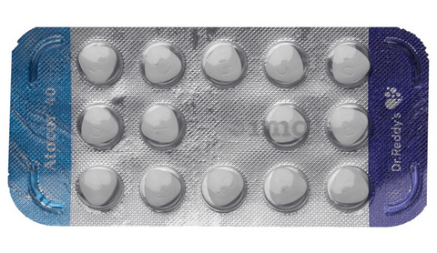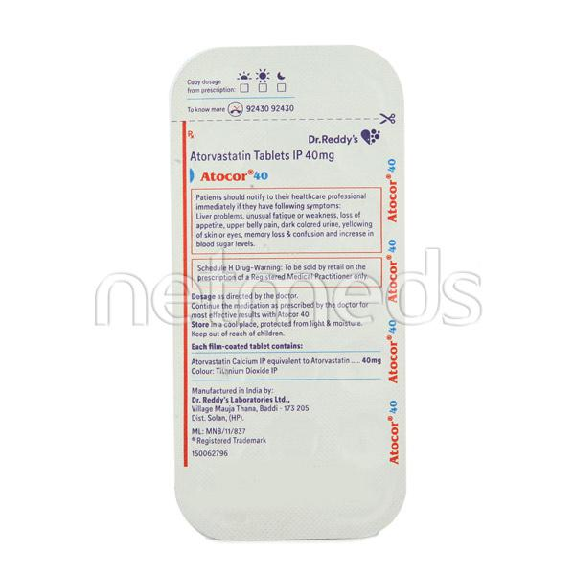

1. **Atorlip F 10mg Strip Of 15 Tablets :--**

**Description**

Atorlip-F Tablet is a combination of two lipids (fat) lowering medicines. It is used to lower the levels of lipids known as cholesterol and triglycerides in the blood when lifestyle changes (eg. low-fat diet) on their own have failed. This medicine helps to reduce the risk of heart disease.  
  
Atorlip-F Tablet can be taken with a meal or on an empty stomach. You can take it at any time of the day but try to take it at the same time each day. This will help you remember to take it. Your doctor will prescribe the right dose depending on your lipid levels and how you respond to this medicine. Most people with high cholesterol and triglyceride do not feel ill, but stopping your medicine may increase your lipid levels, making your condition worse and increasing your risk of heart disease and stroke.  
  
It is important to have your cholesterol and triglyceride levels (lipid profile) checked regularly. This medicine is only one part of a treatment program which should also include a healthy low-fat diet, regular exercise, smoking cessation, moderation of alcohol intake, and weight reduction. You can eat normally while taking this medicine, but try to avoid foods that are high in fat.  
  
Nausea, stomach pain, constipation, headache, flatulence (excessive gas), and muscle pain are some of the common side effects of this medicine. These are usually mild and disappear after a short time. Consult your doctor if they persist or if you notice any yellowing of your eyes, unusual bleeding or bruising, or get repeated, severe, or unexplained muscle pains. You may be advised to get your liver function tested periodically while taking this medicine.  
  
This medicine should not be used in conditions such as liver disease (eg. abnormal blood tests for liver function, persistent yellowness of eyes, etc.). Before taking it, let your doctor know if you have any kidney-related problems or if you are pregnant, planning a pregnancy, or breastfeeding. Diabetic patients should monitor their blood sugar levels while taking this medicine, as it may lead to an increase in blood sugar levels.

## USES OF ATORLIP-F TABLET

* Treatment of [High cholesterol](https://www.1mg.com/diseases/high-cholesterol-108)
* Prevention of [Heart attack](https://www.1mg.com/diseases/heart-attack-67)

## BENEFITS OF ATORLIP-F TABLET

### In Treatment of High cholesterol

Atorlip-F Tablet is a combination of two medicines that work by reducing the amount of “bad” cholesterol (LDL) and raising the amount of “good” cholesterol (HDL) in your blood. Lowering the amount of cholesterol reduces the chances of heart diseases and helps you remain healthier for longer.  
  
Take it regularly and make appropriate lifestyle changes (such as eating healthy and staying active) to maximize the effectiveness of this medicine. Keep taking it even if you feel well.

### In Prevention of Heart attack

High levels of cholesterol can cause your blood vessels to narrow (atherosclerosis) and put you at risk of having a stroke or heart disease. Lowering the amount of this fat reduces the chances of this happening and helps you remain healthier for longer. Keep taking this medicine even if you feel well.

## SIDE EFFECTS OF ATORLIP-F TABLET

Most side effects do not require any medical attention and disappear as your body adjusts to the medicine. Consult your doctor if they persist or if you’re worried about them

### Common side effects of Atorlip-F

* Nausea
* Stomach pain
* Constipation
* Flatulence
* Headache
* Muscle pain
* Increased liver enzymes
* Increased glucose level in blood

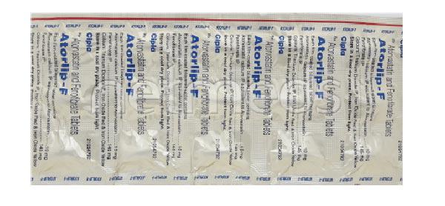

1. **Atorlip 20mg Strip Of 15 Tablets :--**

**Description**

Atorlip 20 Tablet belongs to a group of medicines called statins. It is used to lower cholesterol and to reduce the risk of heart diseases. Cholesterol is a fatty substance that builds up in your blood vessels and causes narrowing, which may lead to a heart attack or stroke.  
  
Atorlip 20 Tablet is a widely prescribed medicine and is regarded as safe for long-term use when taken as per the doctor's advice. It can be taken with a meal or on an empty stomach. You can take it at any time of the day but try to take it at about the same time each day. Most people with high cholesterol do not feel ill, but stopping your medicine may increase your cholesterol levels thereby increasing your risk of heart disease and stroke.  
  
It is important to have your cholesterol levels checked regularly. This medicine is only one part of the treatment program which should also include a healthy diet, regular exercise, smoking cessation, moderation of alcohol intake, and weight reduction. You can eat normally while taking this medicine, but try to avoid foods that are high in fat.   
  
Common side effects of this medicine include constipation, flatulence, dyspepsia, and abdominal pain. These are usually mild and disappear after a short time. Consult your doctor if they persist or if you notice any yellowing of your eyes or get repeated or unexplained muscle pains.   
  
This medicine should not be used in some conditions such as liver disease. Also, pregnant women and breastfeeding mothers should not take this medicine as it may harm the developing baby. Diabetic patients should monitor their blood sugar levels while taking this medicine, as it may lead to an increase in blood sugar levels. Your doctor may check your liver function before starting the treatment and monitor it regularly thereafter.

## USES OF ATORLIP TABLET

* [High cholesterol](https://www.1mg.com/diseases/high-cholesterol-108)
* Prevention of [Heart attack](https://www.1mg.com/diseases/heart-attack-67)

## BENEFITS OF ATORLIP TABLET

### In High cholesterol

Atorlip 20 Tablet belongs to a group of medicines called statins. It works by reducing the amount of “bad” cholesterol (LDL) and raising the amount of “good” cholesterol (HDL) in your blood. Lowering the amount of cholesterol reduces the chances of heart diseases and helps you remain healthier for longer.  
Take it regularly and make appropriate lifestyle changes (such as eating healthy and staying active) to maximize the effectiveness of this medicine. Keep taking it even if you feel well.

### In Prevention of Heart attack

High levels of cholesterol can cause your blood vessels to narrow (atherosclerosis) and put you at risk of having a stroke or heart disease. Lowering the amount of this fat reduces the chances of this happening and helps you remain healthier for longer. Keep taking this medicine even if you feel well.

## SIDE EFFECTS OF ATORLIP TABLET

Most side effects do not require any medical attention and disappear as your body adjusts to the medicine. Consult your doctor if they persist or if you’re worried about them

### Common side effects of Atorlip

* Constipation
* Flatulence
* Dyspepsia
* Abdominal pain

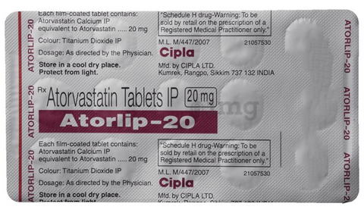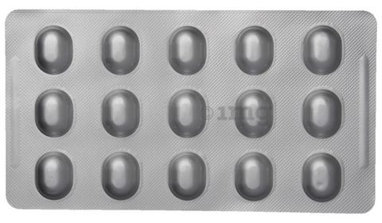

1. **Atorva 80mg Tablet :--**

**Description**

Atorvan 80mg Tablet belongs to a group of medicines called statins. It is used to lower cholesterol and to reduce the risk of heart diseases. Cholesterol is a fatty substance that builds up in your blood vessels and causes narrowing, which may lead to a heart attack or stroke.  
  
Atorvan 80mg Tablet is a widely prescribed medicine and is regarded as safe for long-term use when taken as per the doctor's advice. It can be taken with a meal or on an empty stomach. You can take it at any time of the day but try to take it at about the same time each day. Most people with high cholesterol do not feel ill, but stopping your medicine may increase your cholesterol levels thereby increasing your risk of heart disease and stroke.  
  
It is important to have your cholesterol levels checked regularly. This medicine is only one part of the treatment program which should also include a healthy diet, regular exercise, smoking cessation, moderation of alcohol intake, and weight reduction. You can eat normally while taking this medicine, but try to avoid foods that are high in fat.   
  
Common side effects of this medicine include constipation, flatulence, dyspepsia, and abdominal pain. These are usually mild and disappear after a short time. Consult your doctor if they persist or if you notice any yellowing of your eyes or get repeated or unexplained muscle pains.   
  
This medicine should not be used in some conditions such as liver disease. Also, pregnant women and breastfeeding mothers should not take this medicine as it may harm the developing baby. Diabetic patients should monitor their blood sugar levels while taking this medicine, as it may lead to an increase in blood sugar levels. Your doctor may check your liver function before starting the treatment and monitor it regularly thereafter.

## USES OF ATORVAN TABLET

* [High cholesterol](https://www.1mg.com/diseases/high-cholesterol-108)
* Prevention of [Heart attack](https://www.1mg.com/diseases/heart-attack-67)

## BENEFITS OF ATORVAN TABLET

### In High cholesterol

Atorvan 80mg Tablet belongs to a group of medicines called statins. It works by reducing the amount of “bad” cholesterol (LDL) and raising the amount of “good” cholesterol (HDL) in your blood. Lowering the amount of cholesterol reduces the chances of heart diseases and helps you remain healthier for longer.  
Take it regularly and make appropriate lifestyle changes (such as eating healthy and staying active) to maximize the effectiveness of this medicine. Keep taking it even if you feel well.

### In Prevention of Heart attack

High levels of cholesterol can cause your blood vessels to narrow (atherosclerosis) and put you at risk of having a stroke or heart disease. Lowering the amount of this fat reduces the chances of this happening and helps you remain healthier for longer. Keep taking this medicine even if you feel well.

## SIDE EFFECTS OF ATORVAN TABLET

Most side effects do not require any medical attention and disappear as your body adjusts to the medicine. Consult your doctor if they persist or if you’re worried about them

### Common side effects of Atorvan

* Constipation
* Flatulence
* Dyspepsia
* Abdominal pain

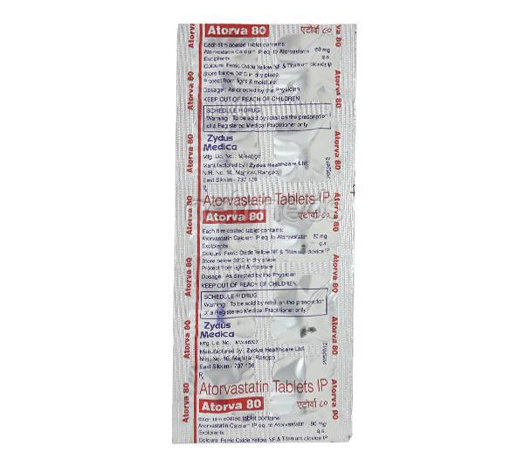

1. **Atorva 40mg Strip Of 10 Tablets :--**

**Description**

Atorva 40 Tablet belongs to a group of medicines called statins. It is used to lower cholesterol and to reduce the risk of heart diseases. Cholesterol is a fatty substance that builds up in your blood vessels and causes narrowing, which may lead to a heart attack or stroke.  
  
Atorva 40 Tablet is a widely prescribed medicine and is regarded as safe for long-term use when taken as per the doctor's advice. It can be taken with a meal or on an empty stomach. You can take it at any time of the day but try to take it at about the same time each day. Most people with high cholesterol do not feel ill, but stopping your medicine may increase your cholesterol levels thereby increasing your risk of heart disease and stroke.  
  
It is important to have your cholesterol levels checked regularly. This medicine is only one part of the treatment program which should also include a healthy diet, regular exercise, smoking cessation, moderation of alcohol intake, and weight reduction. You can eat normally while taking this medicine, but try to avoid foods that are high in fat.   
  
Common side effects of this medicine include constipation, flatulence, dyspepsia, and abdominal pain. These are usually mild and disappear after a short time. Consult your doctor if they persist or if you notice any yellowing of your eyes or get repeated or unexplained muscle pains.   
  
This medicine should not be used in some conditions such as liver disease. Also, pregnant women and breastfeeding mothers should not take this medicine as it may harm the developing baby. Diabetic patients should monitor their blood sugar levels while taking this medicine, as it may lead to an increase in blood sugar levels. Your doctor may check your liver function before starting the treatment and monitor it regularly thereafter.

## USES OF ATORVA TABLET

* [High cholesterol](https://www.1mg.com/diseases/high-cholesterol-108)
* Prevention of [Heart attack](https://www.1mg.com/diseases/heart-attack-67)

## BENEFITS OF ATORVA TABLET

### In High cholesterol

Atorva 40 Tablet belongs to a group of medicines called statins. It works by reducing the amount of “bad” cholesterol (LDL) and raising the amount of “good” cholesterol (HDL) in your blood. Lowering the amount of cholesterol reduces the chances of heart diseases and helps you remain healthier for longer.  
Take it regularly and make appropriate lifestyle changes (such as eating healthy and staying active) to maximize the effectiveness of this medicine. Keep taking it even if you feel well.

### In Prevention of Heart attack

High levels of cholesterol can cause your blood vessels to narrow (atherosclerosis) and put you at risk of having a stroke or heart disease. Lowering the amount of this fat reduces the chances of this happening and helps you remain healthier for longer. Keep taking this medicine even if you feel well.

## SIDE EFFECTS OF ATORVA TABLET

Most side effects do not require any medical attention and disappear as your body adjusts to the medicine. Consult your doctor if they persist or if you’re worried about them

### Common side effects of Atorva

* Constipation
* Flatulence
* Dyspepsia
* Abdominal pain

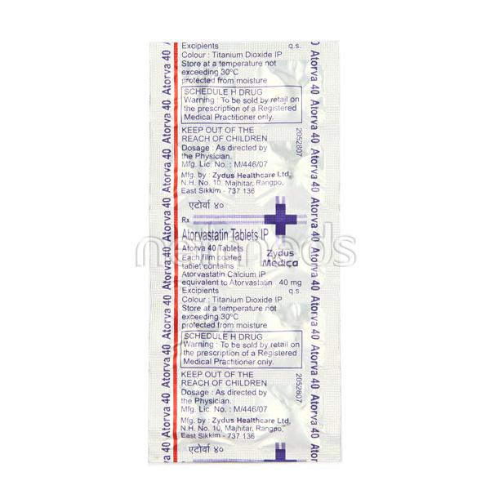

1. **Atorva 10mg Strip Of 10 Tablets :--**

**Description**

Atorva Tablet belongs to a group of medicines called statins. It is used to lower cholesterol and to reduce the risk of heart diseases. Cholesterol is a fatty substance that builds up in your blood vessels and causes narrowing, which may lead to a heart attack or stroke.  
  
Atorva Tablet is a widely prescribed medicine and is regarded as safe for long-term use when taken as per the doctor's advice. It can be taken with a meal or on an empty stomach. You can take it at any time of the day but try to take it at about the same time each day. Most people with high cholesterol do not feel ill, but stopping your medicine may increase your cholesterol levels thereby increasing your risk of heart disease and stroke.  
  
It is important to have your cholesterol levels checked regularly. This medicine is only one part of the treatment program which should also include a healthy diet, regular exercise, smoking cessation, moderation of alcohol intake, and weight reduction. You can eat normally while taking this medicine, but try to avoid foods that are high in fat.   
  
Common side effects of this medicine include constipation, flatulence, dyspepsia, and abdominal pain. These are usually mild and disappear after a short time. Consult your doctor if they persist or if you notice any yellowing of your eyes or get repeated or unexplained muscle pains.   
  
This medicine should not be used in some conditions such as liver disease. Also, pregnant women and breastfeeding mothers should not take this medicine as it may harm the developing baby. Diabetic patients should monitor their blood sugar levels while taking this medicine, as it may lead to an increase in blood sugar levels. Your doctor may check your liver function before starting the treatment and monitor it regularly thereafter.

## USES OF ATORVA TABLET

* [High cholesterol](https://www.1mg.com/diseases/high-cholesterol-108)
* Prevention of [Heart attack](https://www.1mg.com/diseases/heart-attack-67)

## BENEFITS OF ATORVA TABLET

### In High cholesterol

Atorva Tablet belongs to a group of medicines called statins. It works by reducing the amount of “bad” cholesterol (LDL) and raising the amount of “good” cholesterol (HDL) in your blood. Lowering the amount of cholesterol reduces the chances of heart diseases and helps you remain healthier for longer.  
Take it regularly and make appropriate lifestyle changes (such as eating healthy and staying active) to maximize the effectiveness of this medicine. Keep taking it even if you feel well.

### In Prevention of Heart attack

High levels of cholesterol can cause your blood vessels to narrow (atherosclerosis) and put you at risk of having a stroke or heart disease. Lowering the amount of this fat reduces the chances of this happening and helps you remain healthier for longer. Keep taking this medicine even if you feel well.

## SIDE EFFECTS OF ATORVA TABLET

Most side effects do not require any medical attention and disappear as your body adjusts to the medicine. Consult your doctor if they persist or if you’re worried about them

### Common side effects of Atorva

* Constipation
* Flatulence
* Dyspepsia
* Abdominal pain

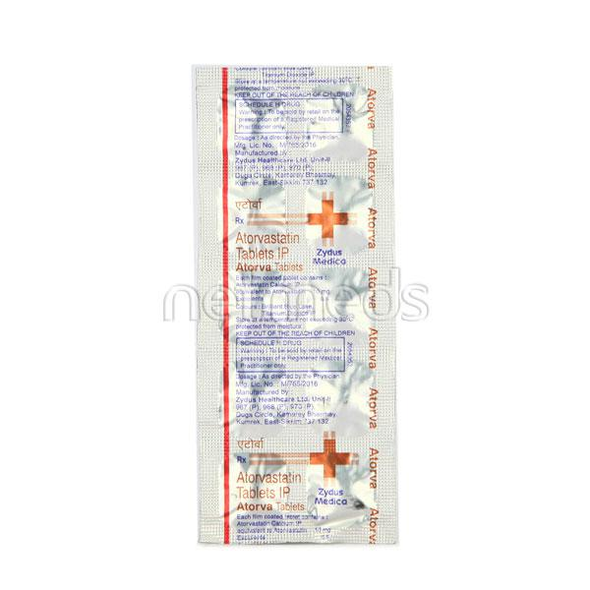

1. **Atorva 20mg Tab 15's :--**

**Description**

Atorva 20 Tablet belongs to a group of medicines called statins. It is used to lower cholesterol and to reduce the risk of heart diseases. Cholesterol is a fatty substance that builds up in your blood vessels and causes narrowing, which may lead to a heart attack or stroke.  
  
Atorva 20 Tablet is a widely prescribed medicine and is regarded as safe for long-term use when taken as per the doctor's advice. It can be taken with a meal or on an empty stomach. You can take it at any time of the day but try to take it at about the same time each day. Most people with high cholesterol do not feel ill, but stopping your medicine may increase your cholesterol levels thereby increasing your risk of heart disease and stroke.  
  
It is important to have your cholesterol levels checked regularly. This medicine is only one part of the treatment program which should also include a healthy diet, regular exercise, smoking cessation, moderation of alcohol intake, and weight reduction. You can eat normally while taking this medicine, but try to avoid foods that are high in fat.   
  
Common side effects of this medicine include constipation, flatulence, dyspepsia, and abdominal pain. These are usually mild and disappear after a short time. Consult your doctor if they persist or if you notice any yellowing of your eyes or get repeated or unexplained muscle pains.   
  
This medicine should not be used in some conditions such as liver disease. Also, pregnant women and breastfeeding mothers should not take this medicine as it may harm the developing baby. Diabetic patients should monitor their blood sugar levels while taking this medicine, as it may lead to an increase in blood sugar levels. Your doctor may check your liver function before starting the treatment and monitor it regularly thereafter.

## USES OF ATORVA TABLET

* [High cholesterol](https://www.1mg.com/diseases/high-cholesterol-108)
* Prevention of [Heart attack](https://www.1mg.com/diseases/heart-attack-67)

## BENEFITS OF ATORVA TABLET

### In High cholesterol

Atorva 20 Tablet belongs to a group of medicines called statins. It works by reducing the amount of “bad” cholesterol (LDL) and raising the amount of “good” cholesterol (HDL) in your blood. Lowering the amount of cholesterol reduces the chances of heart diseases and helps you remain healthier for longer.  
Take it regularly and make appropriate lifestyle changes (such as eating healthy and staying active) to maximize the effectiveness of this medicine. Keep taking it even if you feel well.

### In Prevention of Heart attack

High levels of cholesterol can cause your blood vessels to narrow (atherosclerosis) and put you at risk of having a stroke or heart disease. Lowering the amount of this fat reduces the chances of this happening and helps you remain healthier for longer. Keep taking this medicine even if you feel well.

## SIDE EFFECTS OF ATORVA TABLET

Most side effects do not require any medical attention and disappear as your body adjusts to the medicine. Consult your doctor if they persist or if you’re worried about them

### Common side effects of Atorva

* Constipation
* Flatulence
* Dyspepsia
* Abdominal pain

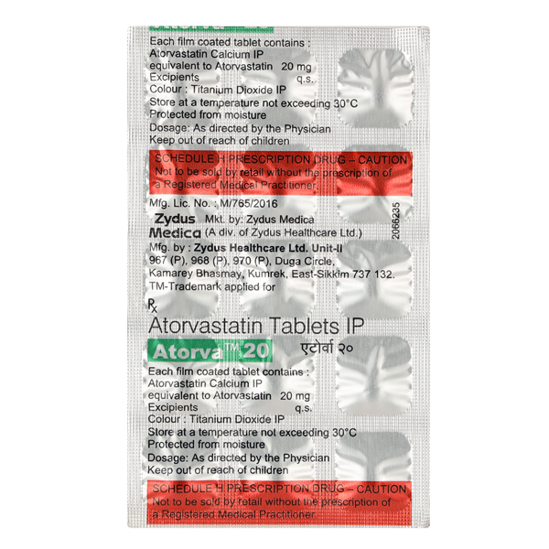

1. **Augmentin Duo 625mg Strip Of 10 Tablets :--**

**Description**

Augmentin 625 Duo Tablet is a penicillin-type of antibiotic that helps your body fight infections caused by bacteria. It is used to treat infections of the lungs (e.g., pneumonia), ear, nasal sinus, urinary tract, skin, and soft tissue. It will not work for viral infections such as the common cold.  
  
Augmentin 625 Duo Tablet is best taken with a meal to reduce the chance of a stomach upset. You should take it regularly at evenly spaced intervals as per the schedule prescribed by your doctor. Taking it at the same time every day will help you to remember to take it. The dose will depend on what you are being treated for, but you should always complete a full course of this antibiotic as prescribed by your doctor. Do not stop taking it until you have finished, even when you feel better. If you stop taking it early, some bacteria may survive and the infection may come back or worsen.  
  
The most common side effects of this medicine include vomiting, nausea, and diarrhea. These are usually mild but let your doctor know if they bother you or will not go away.  
  
Before taking it, let your doctor know if you are allergic to any antibiotics or have any kidney or liver problems. You should also let your healthcare team know about all other medicines you are taking as they may affect, or be affected by, this medicine. This medicine is generally regarded as safe to use during pregnancy and breastfeeding if prescribed by a doctor.

## USES OF AUGMENTIN TABLET

Treatment of [Bacterial infections](https://www.1mg.com/diseases/bacterial-infections-248)

## BENEFITS OF AUGMENTIN TABLET

### In Treatment of Bacterial infections

Augmentin 625 Duo Tablet contains two different medicines, Amoxycillin and Clavulanic Acid, that work together to kill the bacteria that cause infections. Amoxycillin works by stopping the growth of bacteria. Clavulanic Acid reduces resistance and enhances the activity of Amoxycillin against bacteria.  
  
This combination medicine can be used to treat many different bacterial infections such as ear, sinus, throat, lung, urinary tract, skin, teeth, joints, and bones. It usually makes you feel better within a few days, but you should continue taking it as prescribed even when you feel better to make sure that all bacteria are killed and do not become resistant.

## SIDE EFFECTS OF AUGMENTIN TABLET

Most side effects do not require any medical attention and disappear as your body adjusts to the medicine. Consult your doctor if they persist or if you’re worried about them

### Common side effects of Augmentin

* Vomiting
* Nausea
* Diarrhea



1. **Axcer 90mg Tabs 14's**

**Description**

Axcer 90mg Tablet belongs to a group of medicines called antiplatelets or blood thinners. It reduces the formation of harmful blood clots in blood vessels. This helps to prevent a heart attack or stroke in people with heart disease.  
  
Axcer 90mg Tablet is also used to treat people with a recent heart attack or severe heart-related chest pain (unstable angina), who have undergone stenting of the heart. It helps to prevent serious heart-related problems like having another heart attack, stroke, or formation of blood clots in stents in such people.  
  
Your doctor will also prescribe aspirin, another antiplatelet medicine, along with this medicine. Axcer 90mg Tablet may be taken with or without food and should be taken regularly at the same time each day. It is important to keep taking it even if you feel well. If you stop taking this medicine, it may increase your chances of having another heart attack or stroke.  
  
The most common side effect seen with this medicine is bleeding. If you cut or injure yourself, it may take longer than usual for the bleeding to stop. Such episodes of bleeding are usually mild and resolve on their own. Some people may develop mild breathlessness after taking this medicine, however, this usually resolves on its own with continued treatment. Let your doctor know if bleeding persists or if the breathlessness worsens or does not go away.  
  
Axcer 90mg Tablet is not suitable for some people. Do not take it if you are bleeding from anywhere in the body such as a stomach ulcer or bleeding within the brain. It is also not recommended for people with liver diseases. Before using the medicine, inform your doctor if you have any such problems.

**USES OF AXCER TABLET**

Prevention of heart attack and stroke

**BENEFITS OF AXCER TABLET**

In Prevention of heart attack and stroke

Axcer 90mg Tablet is an antiplatelet medicine or blood thinner. It prevents blood from clotting inside the veins and arteries. This helps the blood flow freely around your body thereby preventing a heart attack or stroke (or deep vein thrombosis or pulmonary embolism). Take this medicine regularly and make appropriate lifestyle changes to achieve maximum benefits. It is often prescribed along with a low dose of aspirin which also helps to prevent blood from clotting.

**SIDE EFFECTS OF AXCER TABLET**

Most side effects do not require any medical attention and disappear as your body adjusts to the medicine. Consult your doctor if they persist or if you’re worried about them

Common side effects of Axcer

* Bleeding
* Breathlessness

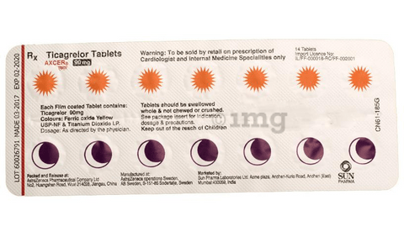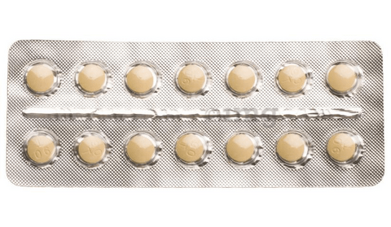

1. **Azmarda 50mg Strip Of 14 Tablets :--**

**Description**

Azmarda 50mg Tablet is a combination medicine used to treat heart failure. It reduces the risk of hospitalization and death due to long-lasting (chronic) heart failure.  
  
Azmarda 50mg Tablet can be taken with or without food but is best taken at the same time(s) each day. Swallow it as a whole with water. Your dose, and how often you take it, will be decided by your doctor and may change depending on how well you respond to the medicine. Keep taking the tablets regularly, as they have been prescribed, and try not to miss doses to get the most benefit. Do not stop taking them, even if you are feeling well. These tablets are preventing future harm.  
  
Some of the common side effects include cough, dizziness, and feeling lightheaded. To reduce the risk of dizziness, try getting up slowly from a sitting or lying position. If these or other side effects are severe or do not go away, tell your doctor. Serious side effects are rare.  
  
Before taking this medicine, tell your doctor if you are taking any other medicines for blood pressure or heart conditions or if you have kidney or liver disease. Also let your doctor know all other medications you are using as they may affect, or be affected by, this medicine. This medicine should not be taken during pregnancy and is not recommended while breastfeeding. While using it your blood pressure will need to be checked often and your kidney function may also need to be tested.

## USES OF AZMARDA TABLET

Treatment of [Heart failure](https://www.1mg.com/diseases/heart-failure-75)

## BENEFITS OF AZMARDA TABLET

### In Treatment of Heart failure

Heart failure means your heart is weak and cannot pump enough blood to your lungs and the rest of your body. The most common symptoms are breathlessness, tiredness, and swelling in your legs, ankles, abdomen, and other parts of your body. Azmarda 50mg Tablet is a combination of two medicine namely valsartan and sacubitril. Both of these medicines work in different ways to lower blood pressure. This makes it easier for your heart to pump blood around your body and is therefore an effective treatment for heart failure.  
  
This medicine will help relieve your symptoms, making you feel better and more energetic. You should make appropriate lifestyle changes (such as eating healthily and keeping active) to help this medicine be effective. Take it regularly and keep taking it even if you feel better.

## SIDE EFFECTS OF AZMARDA TABLET

Most side effects do not require any medical attention and disappear as your body adjusts to the medicine. Consult your doctor if they persist or if you’re worried about them

### Common side effects of Azmarda

* Cough
* Dizziness
* Orthostatic hypotension (sudden lowering of blood pressure on standing)
* Altered levels of potassium in blood
* Decreased red blood cell count
* Decreased blood pressure
* Hypoglycemia (low blood glucose level)
* Diarrhea
* Fainting
* Headache
* Nausea
* Stomach pain
* Vertigo
* Weakness

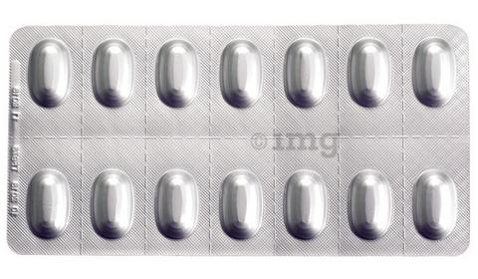

1. **Azmarda 100 Strip Of 14 Tablets:--**

**Description**

Azmarda 100mg Tablet is a combination medicine used to treat heart failure. It reduces the risk of hospitalization and death due to long-lasting (chronic) heart failure.  
  
Azmarda 100mg Tablet can be taken with or without food but is best taken at the same time(s) each day. Swallow it as a whole with water. Your dose, and how often you take it, will be decided by your doctor and may change depending on how well you respond to the medicine. Keep taking the tablets regularly, as they have been prescribed, and try not to miss doses to get the most benefit. Do not stop taking them, even if you are feeling well. These tablets are preventing future harm.  
  
Some of the common side effects include cough, dizziness, and feeling lightheaded. To reduce the risk of dizziness, try getting up slowly from a sitting or lying position. If these or other side effects are severe or do not go away, tell your doctor. Serious side effects are rare.  
  
Before taking this medicine, tell your doctor if you are taking any other medicines for blood pressure or heart conditions or if you have kidney or liver disease. Also let your doctor know all other medications you are using as they may affect, or be affected by, this medicine. This medicine should not be taken during pregnancy and is not recommended while breastfeeding. While using it your blood pressure will need to be checked often and your kidney function may also need to be tested.

## USES OF AZMARDA TABLET

Treatment of [Heart failure](https://www.1mg.com/diseases/heart-failure-75)

## BENEFITS OF AZMARDA TABLET

### In Treatment of Heart failure

Heart failure means your heart is weak and cannot pump enough blood to your lungs and the rest of your body. The most common symptoms are breathlessness, tiredness, and swelling in your legs, ankles, abdomen, and other parts of your body. Azmarda 100mg Tablet is a combination of two medicine namely valsartan and sacubitril. Both of these medicines work in different ways to lower blood pressure. This makes it easier for your heart to pump blood around your body and is therefore an effective treatment for heart failure.  
  
This medicine will help relieve your symptoms, making you feel better and more energetic. You should make appropriate lifestyle changes (such as eating healthily and keeping active) to help this medicine be effective. Take it regularly and keep taking it even if you feel better.

## SIDE EFFECTS OF AZMARDA TABLET

Most side effects do not require any medical attention and disappear as your body adjusts to the medicine. Consult your doctor if they persist or if you’re worried about them

### Common side effects of Azmarda

* Cough
* Dizziness
* Orthostatic hypotension (sudden lowering of blood pressure on standing)
* Altered levels of potassium in blood
* Decreased red blood cell count
* Decreased blood pressure
* Hypoglycemia (low blood glucose level)
* Diarrhea
* Fainting
* Headache
* Nausea
* Stomach pain
* Vertigo
* Weakness

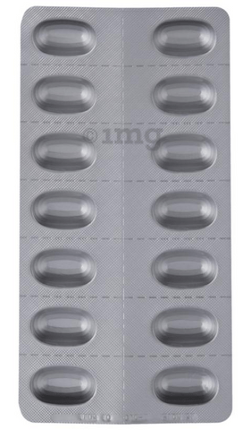

1. **Azmarda 200 Strip Of 7 Tablets :--**

**Description**

Azmarda 200mg Tablet is a combination medicine used to treat heart failure. It reduces the risk of hospitalization and death due to long-lasting (chronic) heart failure.  
  
Azmarda 200mg Tablet can be taken with or without food but is best taken at the same time(s) each day. Swallow it as a whole with water. Your dose, and how often you take it, will be decided by your doctor and may change depending on how well you respond to the medicine. Keep taking the tablets regularly, as they have been prescribed, and try not to miss doses to get the most benefit. Do not stop taking them, even if you are feeling well. These tablets are preventing future harm.  
  
Some of the common side effects include cough, dizziness, and feeling lightheaded. To reduce the risk of dizziness, try getting up slowly from a sitting or lying position. If these or other side effects are severe or do not go away, tell your doctor. Serious side effects are rare.  
  
Before taking this medicine, tell your doctor if you are taking any other medicines for blood pressure or heart conditions or if you have kidney or liver disease. Also let your doctor know all other medications you are using as they may affect, or be affected by, this medicine. This medicine should not be taken during pregnancy and is not recommended while breastfeeding. While using it your blood pressure will need to be checked often and your kidney function may also need to be tested.

## USES OF AZMARDA TABLET

Treatment of [Heart failure](https://www.1mg.com/diseases/heart-failure-75)

## BENEFITS OF AZMARDA TABLET

### In Treatment of Heart failure

Heart failure means your heart is weak and cannot pump enough blood to your lungs and the rest of your body. The most common symptoms are breathlessness, tiredness, and swelling in your legs, ankles, abdomen, and other parts of your body. Azmarda 200mg Tablet is a combination of two medicine namely valsartan and sacubitril. Both of these medicines work in different ways to lower blood pressure. This makes it easier for your heart to pump blood around your body and is therefore an effective treatment for heart failure.  
  
This medicine will help relieve your symptoms, making you feel better and more energetic. You should make appropriate lifestyle changes (such as eating healthily and keeping active) to help this medicine be effective. Take it regularly and keep taking it even if you feel better.

## SIDE EFFECTS OF AZMARDA TABLET

Most side effects do not require any medical attention and disappear as your body adjusts to the medicine. Consult your doctor if they persist or if you’re worried about them

### Common side effects of Azmarda

* Cough
* Dizziness
* Orthostatic hypotension (sudden lowering of blood pressure on standing)
* Altered levels of potassium in blood
* Decreased red blood cell count
* Decreased blood pressure
* Hypoglycemia (low blood glucose level)
* Diarrhea
* Fainting
* Headache
* Nausea
* Stomach pain
* Vertigo
* Weakness

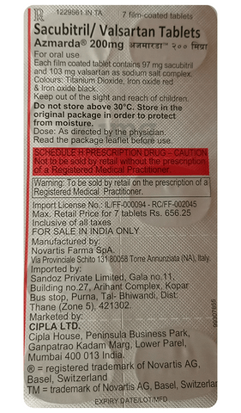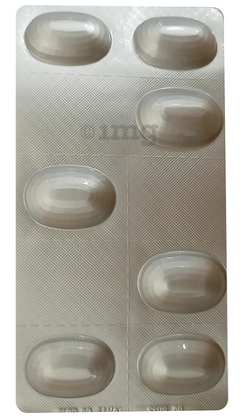

1. **Azoran 50mg Strip Of 10 Tablets :--**

**Description**

Azoran Tablet belongs to a group of medicines called immunosuppressants. It is used with other medicines to prevent your body from rejecting an organ (such as a kidney, heart, or liver) after a transplant. It is also used in the treatment of rheumatoid arthritis.  
  
Azoran Tablet works by weakening the body’s immune system, so it does not attack the new organ. The amount of medicine to be taken and how often you need to take it will depend on the type of transplant you have. Follow your doctor’s instructions on this. You should take it along with food. Take the medicine regularly to get the most benefit and keep taking it even if you feel well. If you stop taking it, you may increase the chances of rejecting your transplanted organ.  
  
It has many potential side effects. The most common are loss of appetite, nausea, and increased risk of bleeding. Because it suppresses your immune system, you may catch infections easily. There’s also an increased risk of developing some cancers for this reason. You should ask your doctor about side effects that may need urgent medical attention.  
  
Azoran Tablet can cause birth defects and miscarriages so do not take it if you are pregnant, planning to become pregnant, or breastfeeding. You should talk to your doctor before taking this medicine if you have any signs of infection or if you have any unexpected bruising or bleeding. Your doctor also needs to know what other medicines you are taking as there are many which interact with this medicine and affect the way it works. You will have regular tests to check for any changes in the number of your blood cells.

## USES OF AZORAN TABLET

* [Prevention of organ rejection in transplant patients](https://www.1mg.com/diseases/prevention-of-organ-rejection-in-transplant-patients-233)
* [Rheumatoid arthritis](https://www.1mg.com/diseases/rheumatoid-arthritis-213)

## BENEFITS OF AZORAN TABLET

### In Prevention of organ rejection in transplant patients

Azoran Tablet is an immunosuppressive agent that lowers your immune response and reduces the chance of your body attacking the transplanted organ. Organ rejection happens when your immune system treats the new organ as an invader and attacks it. This medicine may be used in combination with other medicines to suppress the immune system and help your body accept the new organ.

### In Rheumatoid arthritis

Azoran Tablet works by blocking the action of some chemicals which cause inflammation. It can help reduce pain, stiffness, and swelling in your joints and slow down the progression of bone and joint damage. This will help you do normal daily activities more easily and thus improve your quality of life. This medicine should be taken at the same time each day to get maximum benefits. Keep taking it even if you feel well because it is preventing future harm as well as improving your symptoms.

## SIDE EFFECTS OF AZORAN TABLET

Most side effects do not require any medical attention and disappear as your body adjusts to the medicine. Consult your doctor if they persist or if you’re worried about them

### Common side effects of Azoran

* Decreased white blood cell count
* Increased bleeding tendency
* Nausea
* Infection
* Loss of appetite

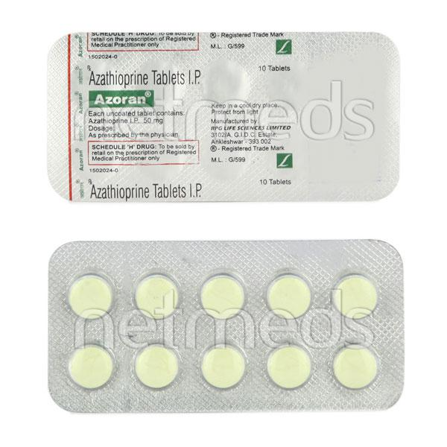

1. **Aztolet 10mg Tablet:---**

**Description**

Aztolet 10 Tablet is a combination of two medicines used to prevent heart attack and stroke. This medicine reduces the "bad" cholesterol (LDL) and triglycerides (fats) levels. Moreover, it also decreases the formation of blood clots.  
  
Aztolet 10 Tablet should be taken with food to avoid stomach upset. You should take it regularly at evenly spaced intervals as per the schedule prescribed by your doctor. Taking it at the same time every day will help you remember to take it. The dose and duration of treatment will depend on what you are being treated for. Do not stop taking it until you have finished the complete course, even when you feel better. Lifestyle changes like low-fat diet, exercise and not smoking may help this medicine to work better.  
  
Nausea, abdominal pain, headache, and constipation are some common side effects of this medicine. This medicine increases your risk of bleeding, so it is important to be careful while shaving, cutting nails, using sharp objects, or engaging in contact sports (e.g., football, wrestling). Let your doctor know if you notice yellowing of the skin, muscle pain or dark urine.  
  
Before taking this medicine, tell your doctor if you have liver or kidney disease or you are suffering from bleeding disorder. You must tell your doctor if you are pregnant, planning pregnancy or breastfeeding. You should also let your healthcare team know all other medicines you are taking as they may affect, or be affected by this medicine.

## USES OF AZTOLET TABLET

[Heart attack prevention and high cholesterol](https://www.1mg.com/diseases/heart-attack-prevention-and-high-cholesterol-706)

## BENEFITS OF AZTOLET TABLET

### In Heart attack prevention and high cholesterol

Aztolet 10 Tablet is a combination medicine that is used to prevent heart attack. It contains Atorvastatin that works by reducing the amount of “bad” cholesterol (LDL) and raising the amount of “good” cholesterol (HDL) in your blood. High levels of cholesterol can cause your blood vessels to narrow (atherosclerosis). Lowering the amount of cholesterol reduces the chances of heart diseases and helps you remain healthier for longer.  
Besides, it also contains a blood thinner, Clopidogrel, that prevents the formation of blood clots and also prevents the existing ones from growing bigger in size. Take it regularly and make appropriate lifestyle changes (such as eating healthy and staying active) to maximize the effectiveness of this medicine. Keep taking it even if you feel well.

## SIDE EFFECTS OF AZTOLET TABLET

Most side effects do not require any medical attention and disappear as your body adjusts to the medicine. Consult your doctor if they persist or if you’re worried about them

### Common side effects of Aztolet

* Stomach pain
* Diarrhea
* Indigestion
* Constipation
* Headache
* Dizziness
* Muscle pain
* Weakness
* Increased glucose level in blood
* Increased liver enzymes

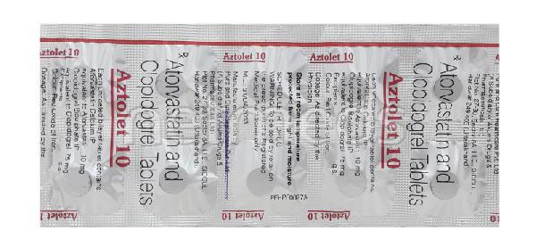

1. **Aztor 10mg Strip Of 15 Tablets:--**

**Description**

Aztor 10 Tablet belongs to a group of medicines called statins. It is used to lower cholesterol and to reduce the risk of heart diseases. Cholesterol is a fatty substance that builds up in your blood vessels and causes narrowing, which may lead to a heart attack or stroke.  
  
Aztor 10 Tablet is a widely prescribed medicine and is regarded as safe for long-term use when taken as per the doctor's advice. It can be taken with a meal or on an empty stomach. You can take it at any time of the day but try to take it at about the same time each day. Most people with high cholesterol do not feel ill, but stopping your medicine may increase your cholesterol levels thereby increasing your risk of heart disease and stroke.  
  
It is important to have your cholesterol levels checked regularly. This medicine is only one part of the treatment program which should also include a healthy diet, regular exercise, smoking cessation, moderation of alcohol intake, and weight reduction. You can eat normally while taking this medicine, but try to avoid foods that are high in fat.   
  
Common side effects of this medicine include constipation, flatulence, dyspepsia, and abdominal pain. These are usually mild and disappear after a short time. Consult your doctor if they persist or if you notice any yellowing of your eyes or get repeated or unexplained muscle pains.   
  
This medicine should not be used in some conditions such as liver disease. Also, pregnant women and breastfeeding mothers should not take this medicine as it may harm the developing baby. Diabetic patients should monitor their blood sugar levels while taking this medicine, as it may lead to an increase in blood sugar levels. Your doctor may check your liver function before starting the treatment and monitor it regularly thereafter.

## USES OF AZTOR TABLET

* [High cholesterol](https://www.1mg.com/diseases/high-cholesterol-108)
* Prevention of [Heart attack](https://www.1mg.com/diseases/heart-attack-67)

## BENEFITS OF AZTOR TABLET

### In High cholesterol

Aztor 10 Tablet belongs to a group of medicines called statins. It works by reducing the amount of “bad” cholesterol (LDL) and raising the amount of “good” cholesterol (HDL) in your blood. Lowering the amount of cholesterol reduces the chances of heart diseases and helps you remain healthier for longer.  
Take it regularly and make appropriate lifestyle changes (such as eating healthy and staying active) to maximize the effectiveness of this medicine. Keep taking it even if you feel well.

### In Prevention of Heart attack

High levels of cholesterol can cause your blood vessels to narrow (atherosclerosis) and put you at risk of having a stroke or heart disease. Lowering the amount of this fat reduces the chances of this happening and helps you remain healthier for longer. Keep taking this medicine even if you feel well.

## SIDE EFFECTS OF AZTOR TABLET

Most side effects do not require any medical attention and disappear as your body adjusts to the medicine. Consult your doctor if they persist or if you’re worried about them

### Common side effects of Aztor

* Constipation
* Flatulence
* Dyspepsia
* Abdominal pain

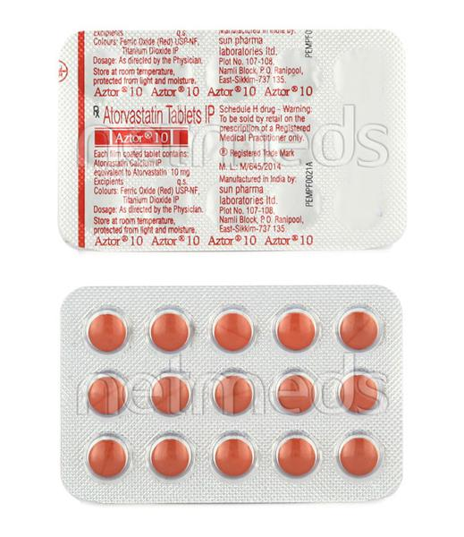

1. **Aztor 80mg Tab 15's :--**

**Description**

Aztor 80 Tablet belongs to a group of medicines called statins. It is used to lower cholesterol and to reduce the risk of heart diseases. Cholesterol is a fatty substance that builds up in your blood vessels and causes narrowing, which may lead to a heart attack or stroke.  
  
Aztor 80 Tablet is a widely prescribed medicine and is regarded as safe for long-term use when taken as per the doctor's advice. It can be taken with a meal or on an empty stomach. You can take it at any time of the day but try to take it at about the same time each day. Most people with high cholesterol do not feel ill, but stopping your medicine may increase your cholesterol levels thereby increasing your risk of heart disease and stroke.  
  
It is important to have your cholesterol levels checked regularly. This medicine is only one part of the treatment program which should also include a healthy diet, regular exercise, smoking cessation, moderation of alcohol intake, and weight reduction. You can eat normally while taking this medicine, but try to avoid foods that are high in fat.   
  
Common side effects of this medicine include constipation, flatulence, dyspepsia, and abdominal pain. These are usually mild and disappear after a short time. Consult your doctor if they persist or if you notice any yellowing of your eyes or get repeated or unexplained muscle pains.   
  
This medicine should not be used in some conditions such as liver disease. Also, pregnant women and breastfeeding mothers should not take this medicine as it may harm the developing baby. Diabetic patients should monitor their blood sugar levels while taking this medicine, as it may lead to an increase in blood sugar levels. Your doctor may check your liver function before starting the treatment and monitor it regularly thereafter.

## USES OF AZTOR TABLET

* [High cholesterol](https://www.1mg.com/diseases/high-cholesterol-108)
* Prevention of [Heart attack](https://www.1mg.com/diseases/heart-attack-67)

## BENEFITS OF AZTOR TABLET

### In High cholesterol

Aztor 80 Tablet belongs to a group of medicines called statins. It works by reducing the amount of “bad” cholesterol (LDL) and raising the amount of “good” cholesterol (HDL) in your blood. Lowering the amount of cholesterol reduces the chances of heart diseases and helps you remain healthier for longer.  
Take it regularly and make appropriate lifestyle changes (such as eating healthy and staying active) to maximize the effectiveness of this medicine. Keep taking it even if you feel well.

### In Prevention of Heart attack

High levels of cholesterol can cause your blood vessels to narrow (atherosclerosis) and put you at risk of having a stroke or heart disease. Lowering the amount of this fat reduces the chances of this happening and helps you remain healthier for longer. Keep taking this medicine even if you feel well.

## SIDE EFFECTS OF AZTOR TABLET

Most side effects do not require any medical attention and disappear as your body adjusts to the medicine. Consult your doctor if they persist or if you’re worried about them

### Common side effects of Aztor

* Constipation
* Flatulence
* Dyspepsia
* Abdominal pain

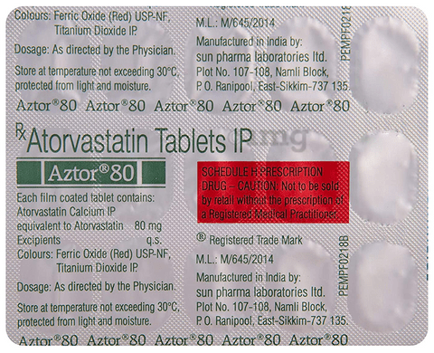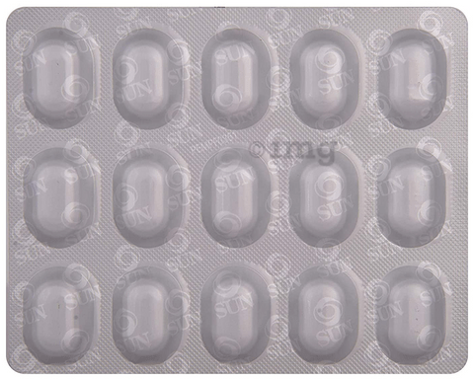

1. **Aztor 20mg Strip Of 15 Tablets:--**

**Description**

Aztor 20 Tablet belongs to a group of medicines called statins. It is used to lower cholesterol and to reduce the risk of heart diseases. Cholesterol is a fatty substance that builds up in your blood vessels and causes narrowing, which may lead to a heart attack or stroke.  
  
Aztor 20 Tablet is a widely prescribed medicine and is regarded as safe for long-term use when taken as per the doctor's advice. It can be taken with a meal or on an empty stomach. You can take it at any time of the day but try to take it at about the same time each day. Most people with high cholesterol do not feel ill, but stopping your medicine may increase your cholesterol levels thereby increasing your risk of heart disease and stroke.  
  
It is important to have your cholesterol levels checked regularly. This medicine is only one part of the treatment program which should also include a healthy diet, regular exercise, smoking cessation, moderation of alcohol intake, and weight reduction. You can eat normally while taking this medicine, but try to avoid foods that are high in fat.   
  
Common side effects of this medicine include constipation, flatulence, dyspepsia, and abdominal pain. These are usually mild and disappear after a short time. Consult your doctor if they persist or if you notice any yellowing of your eyes or get repeated or unexplained muscle pains.   
  
This medicine should not be used in some conditions such as liver disease. Also, pregnant women and breastfeeding mothers should not take this medicine as it may harm the developing baby. Diabetic patients should monitor their blood sugar levels while taking this medicine, as it may lead to an increase in blood sugar levels. Your doctor may check your liver function before starting the treatment and monitor it regularly thereafter.

## USES OF AZTOR TABLET

* [High cholesterol](https://www.1mg.com/diseases/high-cholesterol-108)
* Prevention of [Heart attack](https://www.1mg.com/diseases/heart-attack-67)

## BENEFITS OF AZTOR TABLET

### In High cholesterol

Aztor 20 Tablet belongs to a group of medicines called statins. It works by reducing the amount of “bad” cholesterol (LDL) and raising the amount of “good” cholesterol (HDL) in your blood. Lowering the amount of cholesterol reduces the chances of heart diseases and helps you remain healthier for longer.  
Take it regularly and make appropriate lifestyle changes (such as eating healthy and staying active) to maximize the effectiveness of this medicine. Keep taking it even if you feel well.

### In Prevention of Heart attack

High levels of cholesterol can cause your blood vessels to narrow (atherosclerosis) and put you at risk of having a stroke or heart disease. Lowering the amount of this fat reduces the chances of this happening and helps you remain healthier for longer. Keep taking this medicine even if you feel well.

## SIDE EFFECTS OF AZTOR TABLET

Most side effects do not require any medical attention and disappear as your body adjusts to the medicine. Consult your doctor if they persist or if you’re worried about them

### Common side effects of Aztor

* Constipation
* Flatulence
* Dyspepsia
* Abdominal pain

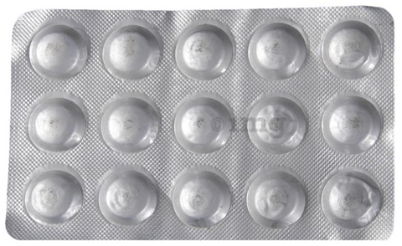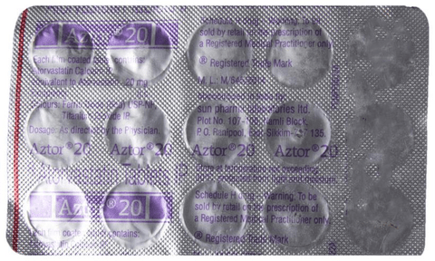

1. **Aztor 40mg Strip Of 15 Tablets:--**

**Description**

Aztor 40 Tablet belongs to a group of medicines called statins. It is used to lower cholesterol and to reduce the risk of heart diseases. Cholesterol is a fatty substance that builds up in your blood vessels and causes narrowing, which may lead to a heart attack or stroke.  
  
Aztor 40 Tablet is a widely prescribed medicine and is regarded as safe for long-term use when taken as per the doctor's advice. It can be taken with a meal or on an empty stomach. You can take it at any time of the day but try to take it at about the same time each day. Most people with high cholesterol do not feel ill, but stopping your medicine may increase your cholesterol levels thereby increasing your risk of heart disease and stroke.  
  
It is important to have your cholesterol levels checked regularly. This medicine is only one part of the treatment program which should also include a healthy diet, regular exercise, smoking cessation, moderation of alcohol intake, and weight reduction. You can eat normally while taking this medicine, but try to avoid foods that are high in fat.   
  
Common side effects of this medicine include constipation, flatulence, dyspepsia, and abdominal pain. These are usually mild and disappear after a short time. Consult your doctor if they persist or if you notice any yellowing of your eyes or get repeated or unexplained muscle pains.   
  
This medicine should not be used in some conditions such as liver disease. Also, pregnant women and breastfeeding mothers should not take this medicine as it may harm the developing baby. Diabetic patients should monitor their blood sugar levels while taking this medicine, as it may lead to an increase in blood sugar levels. Your doctor may check your liver function before starting the treatment and monitor it regularly thereafter.

## USES OF AZTOR TABLET

* [High cholesterol](https://www.1mg.com/diseases/high-cholesterol-108)
* Prevention of [Heart attack](https://www.1mg.com/diseases/heart-attack-67)

## BENEFITS OF AZTOR TABLET

### In High cholesterol

Aztor 40 Tablet belongs to a group of medicines called statins. It works by reducing the amount of “bad” cholesterol (LDL) and raising the amount of “good” cholesterol (HDL) in your blood. Lowering the amount of cholesterol reduces the chances of heart diseases and helps you remain healthier for longer.  
Take it regularly and make appropriate lifestyle changes (such as eating healthy and staying active) to maximize the effectiveness of this medicine. Keep taking it even if you feel well.

### In Prevention of Heart attack

High levels of cholesterol can cause your blood vessels to narrow (atherosclerosis) and put you at risk of having a stroke or heart disease. Lowering the amount of this fat reduces the chances of this happening and helps you remain healthier for longer. Keep taking this medicine even if you feel well.

## SIDE EFFECTS OF AZTOR TABLET

Most side effects do not require any medical attention and disappear as your body adjusts to the medicine. Consult your doctor if they persist or if you’re worried about them

### Common side effects of Aztor

* Constipation
* Flatulence
* Dyspepsia
* Abdominal pain

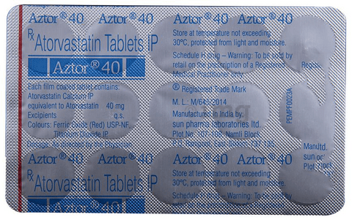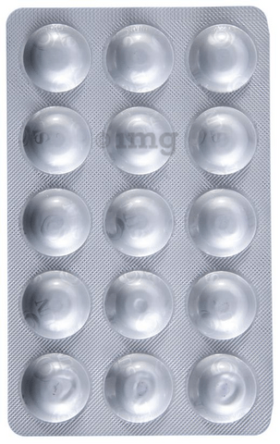

1. **Azulix Mf 2mg Strip Of 15 Tablets:--**

**Description**

Azulix 2 MF Tablet PR belongs to a category of medicines known as anti-diabetic drugs. It is a combination of two medicines used to treat type 2 diabetes mellitus in adults. It helps control blood sugar levels in people with diabetes.  
  
Azulix 2 MF Tablet PR should be taken with food. Take it regularly at the same time each day to get the most benefit. Your doctor will decide what dose is best for you and this may change from time to time according to how it is working according to your blood sugar levels.  
  
Keep taking this medicine, even if you feel well or your blood sugar levels are controlled. If you stop it without consulting your doctor, your blood sugar levels could rise and put you at risk of kidney damage, blindness, nerve problems, and loss of limbs. Remember that it is only part of a treatment program that should also include a healthy diet, regular exercise, and weight reduction as advised by your doctor. Your lifestyle plays a big part in controlling diabetes.  
  
The most common side effect of Azulix 2 MF Tablet PR is low blood glucose levels (hypoglycemia). Make sure you recognize the signs of having low blood glucose levels, such as sweating, dizziness, headache, and shaking, and know how to deal with it. To prevent this, it's important to have regular meals and always carry a fast-acting source of glucose such as sugary food or fruit juice with you. Drinking alcohol can also increase your risk of low blood sugar levels and should be avoided. Other side effects that may be seen on taking this medicine include taste changes, nausea, diarrhea, stomach pain, headache, and upper respiratory tract infection. Some people may find that they put on weight with this medicine.  
  
You should not take it if you have type 1 diabetes mellitus, if you have diabetic ketoacidosis (high levels of acid in your blood), or if you have severe kidney or liver disease. Before taking this medicine, tell your doctor if you have ever had heart disease. It may not be suitable. Pregnant or breastfeeding women should also consult their doctor before taking it. Your blood sugar levels should be checked regularly and your doctor may also advise blood tests to monitor your blood cell counts and liver function.

## USES OF AZULIX MF TABLET PR

[Type 2 diabetes mellitus](https://www.1mg.com/diseases/type-2-diabetes-mellitus-105)

## BENEFITS OF AZULIX MF TABLET PR

### In Type 2 diabetes mellitus

Azulix 2 MF Tablet PR is a combination medicine that increases the amount of insulin your body produces (in the pancreas). The insulin then works to lower your blood glucose level. It is usually taken once a day. You should keep taking it for as long as it is prescribed.  
Lowering blood glucose levels is an essential part of managing diabetes. If you can control the level you will reduce the risk of getting any of the serious complications of diabetes such as kidney damage, eye damage, nerve problems, and loss of limbs. Taking this medicine regularly along with proper diet and exercise will help you live a normal, healthy life.

## SIDE EFFECTS OF AZULIX MF TABLET PR

Most side effects do not require any medical attention and disappear as your body adjusts to the medicine. Consult your doctor if they persist or if you’re worried about them

### Common side effects of Azulix MF

* Hypoglycemia (low blood glucose level)
* Taste change
* Nausea
* Diarrhea
* Stomach pain
* Headache
* Upper respiratory tract infection

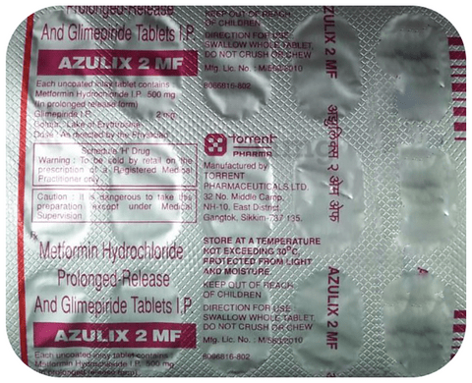

1. **Azulix Mf 1mg Strip Of 15 Tablets:--**

**Description**

Azulix 1 MF Tablet PR belongs to a category of medicines known as anti-diabetic drugs. It is a combination of two medicines used to treat type 2 diabetes mellitus in adults. It helps control blood sugar levels in people with diabetes.  
  
Azulix 1 MF Tablet PR should be taken with food. Take it regularly at the same time each day to get the most benefit. Your doctor will decide what dose is best for you and this may change from time to time according to how it is working according to your blood sugar levels.  
  
Keep taking this medicine, even if you feel well or your blood sugar levels are controlled. If you stop it without consulting your doctor, your blood sugar levels could rise and put you at risk of kidney damage, blindness, nerve problems, and loss of limbs. Remember that it is only part of a treatment program that should also include a healthy diet, regular exercise, and weight reduction as advised by your doctor. Your lifestyle plays a big part in controlling diabetes.  
  
The most common side effect of Azulix 1 MF Tablet PR is low blood glucose levels (hypoglycemia). Make sure you recognize the signs of having low blood glucose levels, such as sweating, dizziness, headache, and shaking, and know how to deal with it. To prevent this, it's important to have regular meals and always carry a fast-acting source of glucose such as sugary food or fruit juice with you. Drinking alcohol can also increase your risk of low blood sugar levels and should be avoided. Other side effects that may be seen on taking this medicine include taste changes, nausea, diarrhea, stomach pain, headache, and upper respiratory tract infection. Some people may find that they put on weight with this medicine.  
  
You should not take it if you have type 1 diabetes mellitus, if you have diabetic ketoacidosis (high levels of acid in your blood), or if you have severe kidney or liver disease. Before taking this medicine, tell your doctor if you have ever had heart disease. It may not be suitable. Pregnant or breastfeeding women should also consult their doctor before taking it. Your blood sugar levels should be checked regularly and your doctor may also advise blood tests to monitor your blood cell counts and liver function.

## USES OF AZULIX MF TABLET PR

[Type 2 diabetes mellitus](https://www.1mg.com/diseases/type-2-diabetes-mellitus-105)

## BENEFITS OF AZULIX MF TABLET PR

### In Type 2 diabetes mellitus

Azulix 1 MF Tablet PR is a combination medicine that increases the amount of insulin your body produces (in the pancreas). The insulin then works to lower your blood glucose level. It is usually taken once a day. You should keep taking it for as long as it is prescribed.  
Lowering blood glucose levels is an essential part of managing diabetes. If you can control the level you will reduce the risk of getting any of the serious complications of diabetes such as kidney damage, eye damage, nerve problems, and loss of limbs. Taking this medicine regularly along with proper diet and exercise will help you live a normal, healthy life.

## SIDE EFFECTS OF AZULIX MF TABLET PR

Most side effects do not require any medical attention and disappear as your body adjusts to the medicine. Consult your doctor if they persist or if you’re worried about them

### Common side effects of Azulix MF

* Hypoglycemia (low blood glucose level)
* Taste change
* Nausea
* Diarrhea
* Stomach pain
* Headache
* Upper respiratory tract infection

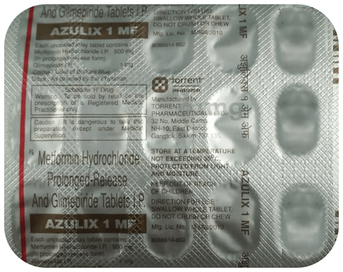

1. **Azulix Mf Forte 2mg Tab 15's:--**

**Description**

Azulix 2 MF Forte Tablet PR belongs to a category of medicines known as anti-diabetic drugs. It is a combination of two medicines used to treat type 2 diabetes mellitus in adults. It helps control blood sugar levels in people with diabetes.  
  
Azulix 2 MF Forte Tablet PR should be taken with food. Take it regularly at the same time each day to get the most benefit. Your doctor will decide what dose is best for you and this may change from time to time according to how it is working according to your blood sugar levels.  
  
Keep taking this medicine, even if you feel well or your blood sugar levels are controlled. If you stop it without consulting your doctor, your blood sugar levels could rise and put you at risk of kidney damage, blindness, nerve problems, and loss of limbs. Remember that it is only part of a treatment program that should also include a healthy diet, regular exercise, and weight reduction as advised by your doctor. Your lifestyle plays a big part in controlling diabetes.  
  
The most common side effect of Azulix 2 MF Forte Tablet PR is low blood glucose levels (hypoglycemia). Make sure you recognize the signs of having low blood glucose levels, such as sweating, dizziness, headache, and shaking, and know how to deal with it. To prevent this, it's important to have regular meals and always carry a fast-acting source of glucose such as sugary food or fruit juice with you. Drinking alcohol can also increase your risk of low blood sugar levels and should be avoided. Other side effects that may be seen on taking this medicine include taste changes, nausea, diarrhea, stomach pain, headache, and upper respiratory tract infection. Some people may find that they put on weight with this medicine.  
  
You should not take it if you have type 1 diabetes mellitus, if you have diabetic ketoacidosis (high levels of acid in your blood), or if you have severe kidney or liver disease. Before taking this medicine, tell your doctor if you have ever had heart disease. It may not be suitable. Pregnant or breastfeeding women should also consult their doctor before taking it. Your blood sugar levels should be checked regularly and your doctor may also advise blood tests to monitor your blood cell counts and liver function.

## USES OF AZULIX MF TABLET PR

[Type 2 diabetes mellitus](https://www.1mg.com/diseases/type-2-diabetes-mellitus-105)

## BENEFITS OF AZULIX MF TABLET PR

### In Type 2 diabetes mellitus

Azulix 2 MF Forte Tablet PR is a combination medicine that increases the amount of insulin your body produces (in the pancreas). The insulin then works to lower your blood glucose level. It is usually taken once a day. You should keep taking it for as long as it is prescribed.  
Lowering blood glucose levels is an essential part of managing diabetes. If you can control the level you will reduce the risk of getting any of the serious complications of diabetes such as kidney damage, eye damage, nerve problems, and loss of limbs. Taking this medicine regularly along with proper diet and exercise will help you live a normal, healthy life.

## SIDE EFFECTS OF AZULIX MF TABLET PR

Most side effects do not require any medical attention and disappear as your body adjusts to the medicine. Consult your doctor if they persist or if you’re worried about them

### Common side effects of Azulix MF

* Hypoglycemia (low blood glucose level)
* Taste change
* Nausea
* Diarrhea
* Stomach pain
* Headache
* Upper respiratory tract infection

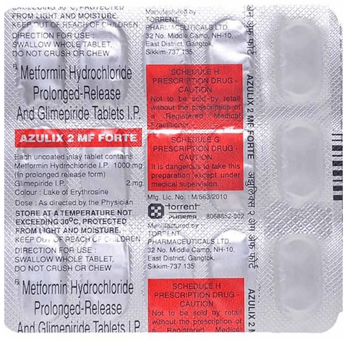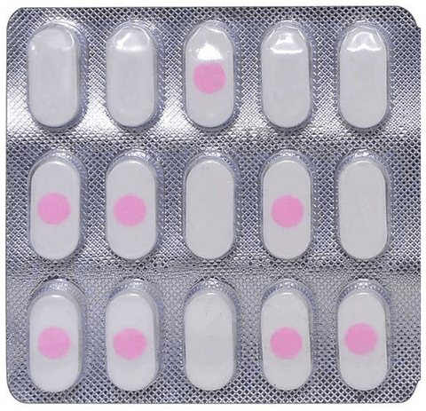

1. **A & D Tab:--**

**NOT FOUND**

1. **A 2 12mg Tab :--**

**NOT FOUND**

1. **A 24 250mg Tab:--**

**Description**

A24 250mg Tablet is an antibiotic used to treat various types of bacterial infections of the respiratory tract, ear, nose, throat, lungs, skin, and eye in adults and children. It is also effective in typhoid fever and some sexually transmitted diseases like gonorrhea.  
  
A24 250mg Tablet is taken orally, preferably one hour before or 2 hours after a meal. It should be used regularly at evenly spaced time intervals as prescribed by your doctor. Do not skip any doses and finish the full course of treatment even if you feel better. Stopping the medicine too early may lead to the return or worsening of the infection.  
  
Commonly seen side effects seen with this medicine include vomiting, nausea, stomach pain, and diarrhea. These are usually temporary and subside with the completion of treatment. Consult your doctor if you find these side effects worry you or persist for a longer duration.  
  
Inform your doctor if you have any previous history of allergy or heart problems before taking this medicine. Pregnant or breastfeeding women should consult their doctor before using this medicine.

## USES OF A24 TABLET

[Bacterial infections](https://www.1mg.com/diseases/bacterial-infections-248)

## BENEFITS OF A24 TABLET

### In Bacterial infections

A24 250mg Tablet is an antibiotic medicine that can be used to treat many different infections caused by bacteria. These include infections of the blood, brain, lungs, bones, joints, urinary tract, stomach, and intestines. It can also be used to treat sexually transmitted diseases. It stops the growth of the bacteria causing the infection and clears the infection. Take it for as long as prescribed by the doctor and avoid skipping doses. This will make sure that all bacteria are killed and they do not become resistant.

## SIDE EFFECTS OF A24 TABLET

Most side effects do not require any medical attention and disappear as your body adjusts to the medicine. Consult your doctor if they persist or if you’re worried about them

### Common side effects of A24

* Vomiting
* Nausea
* Abdominal pain
* Diarrhea

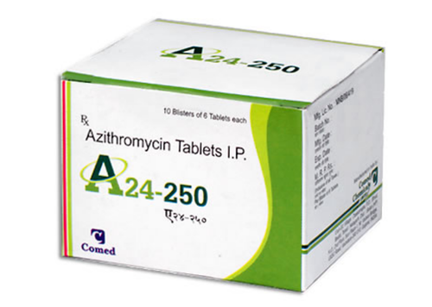

1. **A 24 500mg Tab:--**

**Description**

A24 500mg Tablet is an antibiotic used to treat various types of bacterial infections of the respiratory tract, ear, nose, throat, lungs, skin, and eye in adults and children. It is also effective in typhoid fever and some sexually transmitted diseases like gonorrhea.  
  
A24 500mg Tablet is taken orally, preferably one hour before or 2 hours after a meal. It should be used regularly at evenly spaced time intervals as prescribed by your doctor. Do not skip any doses and finish the full course of treatment even if you feel better. Stopping the medicine too early may lead to the return or worsening of the infection.  
  
Commonly seen side effects seen with this medicine include vomiting, nausea, stomach pain, and diarrhea. These are usually temporary and subside with the completion of treatment. Consult your doctor if you find these side effects worry you or persist for a longer duration.  
  
Inform your doctor if you have any previous history of allergy or heart problems before taking this medicine. Pregnant or breastfeeding women should consult their doctor before using this medicine.

## USES OF A24 TABLET

[Bacterial infections](https://www.1mg.com/diseases/bacterial-infections-248)

## BENEFITS OF A24 TABLET

### In Bacterial infections

A24 500mg Tablet is an antibiotic medicine that can be used to treat many different infections caused by bacteria. These include infections of the blood, brain, lungs, bones, joints, urinary tract, stomach, and intestines. It can also be used to treat sexually transmitted diseases. It stops the growth of the bacteria causing the infection and clears the infection. Take it for as long as prescribed by the doctor and avoid skipping doses. This will make sure that all bacteria are killed and they do not become resistant.

## SIDE EFFECTS OF A24 TABLET

Most side effects do not require any medical attention and disappear as your body adjusts to the medicine. Consult your doctor if they persist or if you’re worried about them

### Common side effects of A24

* Vomiting
* Nausea
* Abdominal pain
* Diarrhea

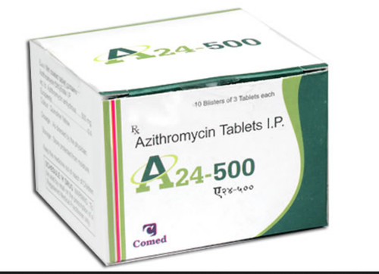

1. **A 24 500mg Tab 5’s:--**

**Description**

A 24 500MG contain Azithromycin which belongs to a group of medicine called macrolide antibiotics. It is used to treat infections caused by micro-organisms such as bacteria including chest, throat or nasal infection, ear infections, skin and soft tissue infections, sexually transmitted diseases and infection of the tube that carries urine from the bladder (urethra) or the neck of the womb (cervix).

A 24 500MG is a broad-spectrum type of antibiotic. It is effective in killing many types of gram-positive bacteria, some types of gram-negative bacteria and other microorganisms. This medicine is not recommended for use in children and adolescents under 45 kg. Before taking this medicine tell your doctor if you have ever had kidney disease, heart disease, liver problems. Pregnant and breastfeeding women should consult their doctor before taking this medicine.

USES OF A 24 500MG

* Treat bacterial infections such as
* Chest, throat, or nasal infections (such as bronchitis, pneumonia, tonsillitis, sore throat and sinusitis)
* Ear infections
* Skin and soft tissue infections (such as abscess or boil)
* Sexually transmitted diseases caused by Chlamydia trachomatis and Neisseria gonorrhoea
* Infection of the tube that carries urine from the bladder (urethra) or the neck of the womb (cervix) caused by Chlamidia trachomatis

HOW A 24 500MG WORKS

A 24 500MG inhibits the synthesis of essential protein required by bacteria to grow and multiply and thus prevents the infection from spreading.

DIRECTIONS FOR USE

Always take A 24 500MG exactly as your doctor has told you. It must be taken with or without food. Try to take this medicine at the same time each day. It should be swallowed whole with water. Do not crush or chew the medicine.

SIDE EFFECTS OF A 24 500MG

SERIOUS

* Allergic reaction which may cause sudden wheeziness, difficulty in breathing, swelling of eyelids, face or lips, rash, or itching
* Severe skin rashes or reactions
* Rapid or irregular heartbeat
* Low blood pressure
* Liver problems (symptoms such as yellowing of the skin or whites of the eyes)
* Inflammation of the pancreas
* Increased or reduced urine output or trace of blood in your urine
* Serious bowel inflammation
* Unusual bruising or bleeding

COMMON

* Stomach pain or cramps, diarrhoea, wind, indigestion
* Dizziness, headache
* Numbness or pins and needles
* Nausea, vomiting
* Loss of appetite
* Taste disturbance
* Visual disturbances
* Deafness
* Joint pain
* Change in white blood cells
* Low blood bicarbonate level
* RARE
* Feeling agitated
* Vertigo

Allergic skin reaction such as being sensitive to sunlight

HOW TO MANAGE SIDE EFFECTS

**Diarrhoea:**

Drink lots of fluids, such as water or juice, to avoid dehydration. Do not take any medicines without speaking to a doctor.

**Stomach pain:**

Try to rest and relax. Eat and drink slowly and smaller and frequent meals. Applying a heat pad or covered hot water bottle on your stomach may also help. If still pain persists, speak to your doctor.

**Nausea and Vomiting:**

Try taking this medicine with, or just after meal. Stick to simple meals. Do not eat rich or spicy food.

**Headache:**

Apply hot or cold-water bag on your head. Take rest in a quiet and dark room. Drink tea or coffee.

**Dizziness:**

Get up and move around to feel awake, take small naps to edge off the sleepiness. Give your eyes a break to avoid fatigue and eat a healthy food to boost energy.

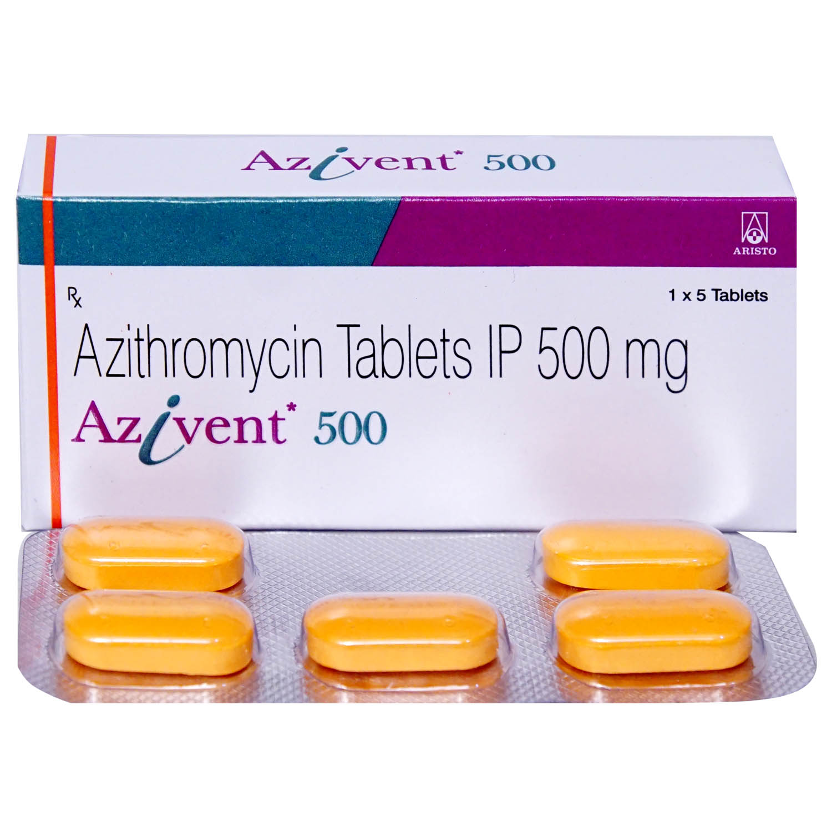

1. **A 3 100/500 Mg Tablet 10:--**

**Description**

A 3 100 mg/500 mg Tablet is a combination medicine that helps in relieving pain. It is used to relieve pain and inflammation in conditions like rheumatoid arthritis, ankylosing spondylitis, and osteoarthritis. It is also used to relieve fever, muscle pain, back pain, toothache, or pain in the ear and throat.  
  
A 3 100 mg/500 mg Tablet should be taken with food. This will prevent you from getting an upset stomach. The dose will depend on what you are taking it for and how well it helps your symptoms. You should take it as advised by your doctor. Do not take more or use it for a longer duration than recommended by the doctor.  
  
The most common side effects of this medicine include nausea, vomiting, diarrhea, and increased liver enzymes. If any of these side effects bother you or get worse, you should speak to your doctor. Your doctor may be able to suggest ways of preventing or reducing the side effects.  
  
Before taking it, you should let your doctor know if you have a history of ulcer or bleeding in your stomach, high blood pressure, or have any trouble with your heart, kidneys, or liver. Let your doctor also know about all the other medicines you are taking because they may affect, or be affected by, this medicine.  
  
Pregnant or breastfeeding women should consult their doctor before starting treatment. You should also avoid drinking alcohol while you are taking this medicine, as alcohol can cause excessive drowsiness.

## USES OF A 3 TABLET

[Pain relief](https://www.1mg.com/diseases/pain-relief-168)

## BENEFITS OF A 3 TABLET

### In Pain relief

A 3 100 mg/500 mg Tablet is a combination of two medicines that belong to a group of medicines called nonsteroidal anti-inflammatory drugs (NSAIDs). It is used for short term relief of pain, inflammation, and swelling in conditions that affect joints and muscles. It works by blocking chemical messengers in the brain that tell us we have pain. It can help relieve pain in conditions like rheumatoid arthritis and osteoarthritis.  
  
Take it as it is prescribed to get the most benefit. Do not take more or for longer than needed as that can be dangerous. In general, you should take the lowest dose that works, for the shortest possible time. This will help you to go about your daily activities more easily and have a better, more active, quality of life.

## SIDE EFFECTS OF A 3 TABLET

Most side effects do not require any medical attention and disappear as your body adjusts to the medicine. Consult your doctor if they persist or if you’re worried about them

### Common side effects of A 3

* Nausea
* Vomiting
* Diarrhea
* Increased liver enzymes

1. **A Arti L Tab:--**

**Not Found**

1. **A Calcy Tab:--**

**Description**

A Calcy Tab contains calcium. It is one of the most essential mineral required the body for optimal health.

Uses of A Calcy Tab

For treatment of calcium deficiency.

As an adjuvent for the treatment and prevention of osteoporosis and bone disorders.

As a supplement when calcium requirement of body is high such as in elderly, after surgery, during pregnancy and lactation.



Precautions and Warnings of A Calcy Tab



Other General Warnings

Talk to your doctor if

If you have any existing medical condition like diabetes, hypertension, kidney or liver problem

If you are on other medications, supplements or following any complementary or integrative health approaches

If you should not take this supplement if you are allergic to any of the component of this supplement

If you have any planned surgery or operation. You may be asked to stop taking these products at least 2-3 weeks ahead of the procedure

Dietary supplements are intended to supplement the diets of some people and should not be a substitute for a well-balanced, varied diet and a healthy lifestyle

Warnings:

Pregnancy: CONSULT YOUR DOCTOR - Artemether+Lumefantrine may be unsafe to use during pregnancy. However, the benefits from use in pregnant women may be acceptable despite the risk. Please consult your doctor.

Lactation: SAFE IF PRESCRIBED - Artemether+Lumefantrine is probably safe to use during lactation.

Alcohol: CONSULT YOUR DOCTOR - Interaction with alcohol is not known. Please consult your doctor.

Driving: UNSAFE - Artemether+Lumefantrine may make you feel dizzy, sleepy, tired, or decrease alertness. If this happens, do not drive.

Liver Warning: CAUTION - Artemether+Lumefantrine should be used with caution in patients with severe liver disease. Please consult your doctor.

Kidney Warning: CAUTION - Artemether+Lumefantrine should be used with caution in patients with severe kidney disease. Please consult your doctor.

Availability: Prescription required

Addiction: Not known to be addictive

Side Effects:

* Headache
* Loss of appetite
* Dizziness
* Weakness
* Joint pain
* Muscle pain

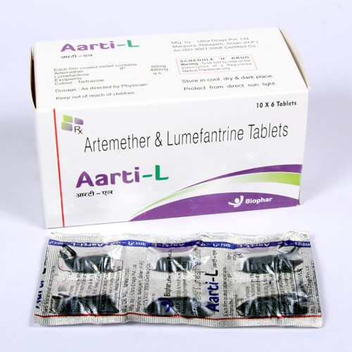

1. **A Card 50mg Tablet:--**

**Description**

A-Card 50mg Tablet belongs to a group of medicines called beta-blockers. It is used to treat high blood pressure (hypertension), angina (heart-related chest pain), irregular heart rhythms (arrhythmia). It also helps to prevent future heart attacks and stroke and migraines.  
  
A-Card 50mg Tablet is also used to relieve the symptoms caused by an overactive thyroid gland. It may be prescribed alone or together with other medications. The dose and frequency depend on what you are taking it for and the severity of your condition. It may be taken empty stomach or with a meal, but take it regularly at the same time each day to get the most benefit. It may take several weeks before you get the full benefit of this medicine and you may need to take it for the rest of your life. However, it is important to continue taking it even if you feel well. Most people with high blood pressure do not feel ill and if you stop taking it, your condition may worsen.  
  
The main side effects of this medicine are fatigue, slow heart rate,  feeling dizzy, diarrhea, and nausea. These are usually mild and short-lived. It may also cause shortness of breath or low blood pressure in some people. To reduce the risk of side effects your doctor will probably start the medicine at a low dose and gradually increase it. Consult your doctor if the side effects bother you or do not go away.  
  
Before taking it, let your doctor know if you have any liver problems. It may also not be suitable for people who have a slow heart rate, severe circulation problems, severe heart failure, or low blood pressure. Pregnant or breastfeeding mothers should also consult their doctor before taking it. You must talk to your doctor to find out whether this medicine is suitable for you to use. You should have your blood pressure checked regularly to make sure that this medicine is working properly. Avoid drinking alcohol as it may increase certain side effects.

## USES OF A-CARD TABLET

* Treatment of [Hypertension (high blood pressure)](https://www.1mg.com/diseases/hypertension-high-blood-pressure-68)
* Treatment of [Angina (heart-related chest pain)](https://www.1mg.com/diseases/angina-heart-related-chest-pain-65)
* Treatment of [Arrhythmia](https://www.1mg.com/diseases/arrhythmia-66)
* Prevention of [Heart attack](https://www.1mg.com/diseases/heart-attack-67)
* Prevention of [Migraine](https://www.1mg.com/diseases/migraine-158)

## BENEFITS OF A-CARD TABLET

### In Treatment of Hypertension (high blood pressure)

A-Card 50mg Tablet works by blocking the effects of some chemicals on your heart and blood vessels. It slows down your heart rate and helps the heartbeat with less force. This lowers your blood pressure and helps in reducing your risk of having a stroke, a heart attack, other heart problems, or kidney problems in the future. This medicine needs to be taken regularly to be effective, so keep taking it even if you feel well. Do not stop without talking to your doctor.

### In Treatment of Angina (heart-related chest pain)

A-Card 50mg Tablet relaxes the blood vessels so that blood can flow more easily around your body and makes sure that your heart is getting a good supply of oxygen. This makes it less likely that you will suffer chest pain caused by angina. This medicine can help increase your ability to exercise and go about your daily life more easily by reducing the frequency of angina attacks. You should take it regularly and as long as it is prescribed for it to work effectively.

### In Treatment of Arrhythmia

A-Card 50mg Tablet is used to stabilize heart rhythms (particularly atrial fibrillation). It helps in normalizing an abnormal heart rhythm, preventing it occurring in the first place or slowing down the heart rate during an episode.

### In Prevention of Heart attack

A-Card 50mg Tablet helps lower your blood pressure and make it easier for your heart to pump blood around your body. This reduces the chances of you having a heart attack. It can also reduce the risk of dying if it is given immediately after a heart attack. This medicine needs to be taken regularly to be effective, so keep taking it even if you feel well. Do not stop without talking to your doctor

### In Prevention of Migraine

A-Card 50mg Tablet helps change electrical activity in the brain, reduce the flow of blood in your brain or increase activity in a region of the brain associated with migraines. By preventing and reducing the frequency of migraine attacks, the medicine can help you carry out your daily activities and improve your quality of life.

## SIDE EFFECTS OF A-CARD TABLET

Most side effects do not require any medical attention and disappear as your body adjusts to the medicine. Consult your doctor if they persist or if you’re worried about them

### Common side effects of A-Card

* Cold extremities
* Fatigue
* Slow heart rate
* Nausea
* Diarrhea
* Dizziness

1. **A Card Am Tab:--**

**Description**

Cardace AM 10 Tablet is used to treat hypertension (high blood pressure). This is a combination of two medicines that controls blood pressure when a single medication is not effective. It helps to lower high blood pressure and thus reduces the chances of future heart attack and stroke.  
  
You can take Cardace AM 10 Tablet at any time of day, with or without food, but it is best to take it at the same time each day. Keep taking it for as long as advised by your doctor. Even if you feel well, do not stop this medicine on your own because high blood pressure often has no symptoms. If you stop taking it, your condition may get worse. Keeping active with regular exercise, reducing your weight and eating a healthy diet will also help control your blood pressure. Follow your doctor’s advice while taking this medicine.  
  
It may cause side effects like taste change, ankle swelling, headache, cough, and stomach upset. It may also cause dizziness, so do not drive or do anything that requires mental focus until you know how this medicine affects you. This might raise the level of potassium in the blood, hence avoid potassium rich food or supplements. You may be asked for regular monitoring of blood pressure, kidney function, and electrolytes level while on the treatment.  
  
Before taking it, let your doctor know if you have any liver or kidney problems. Pregnant or breastfeeding women should also consult their doctor for advice before taking this medicine. You also need to tell your doctor what other medicines you are taking especially those used to treat high blood pressure or heart conditions.

## USES OF CARDACE AM TABLET

[Hypertension (high blood pressure)](https://www.1mg.com/diseases/hypertension-high-blood-pressure-68)

## BENEFITS OF CARDACE AM TABLET

### In Hypertension (high blood pressure)

Cardace AM 10 Tablet relaxes the blood vessels so that blood can flow more easily around your body. This lowers your blood pressure and reduces your risk of having a stroke, a heart attack, or kidney problems in the future. You do not usually feel any direct benefit from taking this medicine, but it works in the long term to keep you well. You should take it regularly as prescribed for this medicine to be most effective, even if you feel better.

## SIDE EFFECTS OF CARDACE AM TABLET

Most side effects do not require any medical attention and disappear as your body adjusts to the medicine. Consult your doctor if they persist or if you’re worried about them

### Common side effects of Cardace AM

* Decreased blood pressure
* Sleepiness
* Taste change
* Headache
* Ankle swelling
* Flushing (sense of warmth in the face, ears, neck and trunk)
* Tiredness
* Palpitations
* Increased potassium level in blood
* Cough
* Upset stomach

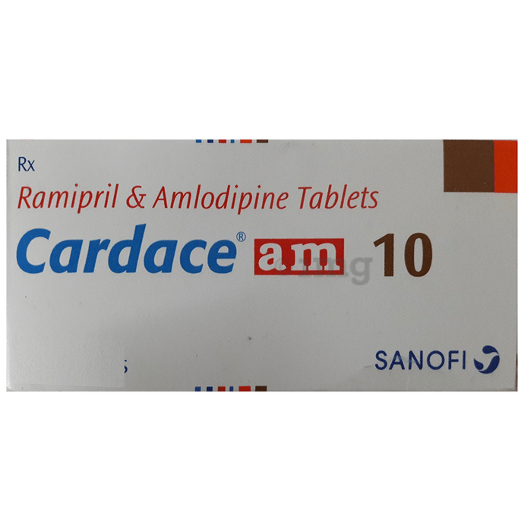

1. **A Cet 10mg Tab:--**

**Description**

A-Cet 10mg Tablet belongs to a group of medicines called antihistamines. It is used to treat various allergic conditions such as hay fever, conjunctivitis and some skin reactions, and reactions to bites and stings. It relieves watery eyes, runny nose, sneezing, and itching.  
  
A-Cet 10mg Tablet can be taken with or without food. The dose required for you may vary depending on what you are taking it for. This medicine is usually taken in the evening but follow the advice of your doctor on how to take it. You may need this medicine only on days you have symptoms, but if you are taking it to prevent symptoms you should take it regularly. If you miss doses or stop taking it earlier than advised, your symptoms may come back.  
  
This medicine is generally very safe. The most common side effects include feeling sleepy or dizzy. These are usually mild and go away after a couple of days as your body adjusts. Consult your doctor if any of the side effects persist or worry you. You should avoid alcohol while taking this medicine.  
  
Before taking it, tell your doctor if you have any kidney problems or epilepsy. Your dose may need to be modified or this medicine may not be suitable. Some other medicines can interact with this medicine so let your healthcare team know what else you are taking. You should also talk to your doctor before using this medicine if you are pregnant or breastfeeding, although it is not thought to be harmful.

## USES OF A-CET TABLET

[Allergic conditions](https://www.1mg.com/diseases/allergic-conditions-10)

## BENEFITS OF A-CET TABLET

### In Allergic conditions

A-Cet 10mg Tablet provides relief from symptoms such as blocked or runny nose, sneezing, and itchy or watery eyes. This will make it easier for you to go about your daily activities. It can also give relief from allergic reactions after insect bites and symptoms of hives and eczema such as rash, swelling, itching, and irritation. This will improve the appearance of your skin and you may find that your mood and self-confidence improve as well. It rarely has any serious side effects and you may only need to take it on days you have symptoms. If you are taking it to prevent getting symptoms you should use it regularly to get the most benefit.

## SIDE EFFECTS OF A-CET TABLET

Most side effects do not require any medical attention and disappear as your body adjusts to the medicine. Consult your doctor if they persist or if you’re worried about them

### Common side effects of A-Cet

* Sleepiness
* Dizziness



1. **A Clo P Tab:--**

**Description**

Aclo-P Tablet is a pain-relieving medicine. It is used to reduce pain and inflammation in conditions like rheumatoid arthritis, ankylosing spondylitis, and osteoarthritis. It may also be used to relieve muscle pain, back pain, toothache, or pain in the ear and throat.  
  
Aclo-P Tablet should be taken with or without food. You should take it regularly as advised by your doctor. Your doctor may change the dose and time between doses according to your pain level and your needs. Do not take more or use it for a longer duration than recommended by your doctor.  
  
Some of the common side effects of this medicine include nausea, vomiting, stomach pain, loss of appetite, heartburn, and diarrhea. If any of these side effects bother you or do not go away with time, you should let your doctor know. Your doctor may help you with ways to reduce or prevent these side effects by prescribing an alternative medicine or adjusting the dose.  
  
The medicine may not be suitable for everybody. Before taking it, let your doctor know if you have any problems with your heart, kidneys, liver, or have stomach ulcers. To make sure it is safe for you, let your doctor know about all the other medicines you are taking. Pregnant and breastfeeding mothers should first consult their doctors before using this medicine.

## USES OF ACLO-P TABLET

[Pain relief](https://www.1mg.com/diseases/pain-relief-168)

## BENEFITS OF ACLO-P TABLET

### In Pain relief

Aclo-P Tablet is used for short-term relief of pain, inflammation, and swelling in conditions that affect joints and muscles. Some of the conditions in which Aclo-P Tablet is used are rheumatoid arthritis, osteoarthritis, muscle pain, back pain, toothache, or pain in the ear and throat. Take it as it is prescribed to get the most benefit. Do not take more or longer than needed as that can be dangerous. In general, you should take the lowest dose that works, for the shortest possible time. This will help you to go about your daily activities more easily and have a better, more active, quality of life.

## SIDE EFFECTS OF ACLO-P TABLET

Most side effects do not require any medical attention and disappear as your body adjusts to the medicine. Consult your doctor if they persist or if you’re worried about them

### Common side effects of Aclo-P

* Nausea
* Vomiting
* Stomach pain/epigastric pain
* Loss of appetite
* Heartburn
* Diarrhea

1. **A Clo SP Tab:--**

**Description**

A Clo SP Tablet is a combination medicine used to relieve pain and swelling in various conditions like muscle pain, joint pain, and postoperative pain. Thus, it effectively alleviates pain and inflammation in conditions like rheumatoid arthritis, ankylosing spondylitis, and osteoarthritis.  
  
A Clo SP Tablet should be taken in the dose and duration as advised by your doctor. It should be taken with food or milk to prevent stomach upset. Taking the medicine regularly at the right times increases its effectiveness. It is important to keep taking the medicine regularly until your doctor tells you it is safe to stop.  
  
Nausea, vomiting, stomach pain, indigestion, heartburn, loss of appetite, and diarrhea are some of the common side effects that might be observed on taking this medicine. Your doctor may regularly monitor your kidney function, liver function, and levels of blood components if you are taking this medicine for long-term treatment. Long-term use may lead to serious complications such as stomach bleeding and kidney problems. A Clo SP Tablet is not recommended if you are pregnant or breastfeeding.

## USES OF A CLO SP TABLET

[Pain relief](https://www.1mg.com/diseases/pain-relief-168)

## BENEFITS OF A CLO SP TABLET

### In Pain relief

A Clo SP Tablet is a combination medicine used for short-term relief of pain, inflammation, and swelling in conditions affecting joints and muscles. It works by blocking chemical messengers in the brain that tell us we have pain. It can help relieve pain in conditions like rheumatoid arthritis and osteoarthritis. Along with painkillers, this medicine also contains an active ingredient called Serratiopeptidase, which is an enzyme that promotes the overall healing process and speeds up recovery.  
  
Take it as it is prescribed to get the most benefit. Do not take more or longer than needed as that can be dangerous. In general, you should take the lowest dose that works, for the shortest possible time. This will help you to go about your daily activities more easily and have a better, more active, quality of life.

## SIDE EFFECTS OF A CLO SP TABLET

Most side effects do not require any medical attention and disappear as your body adjusts to the medicine. Consult your doctor if they persist or if you’re worried about them

### Common side effects of A Clo SP

* Nausea
* Vomiting
* Stomach pain
* Indigestion
* Heartburn
* Loss of appetite
* Diarrhea

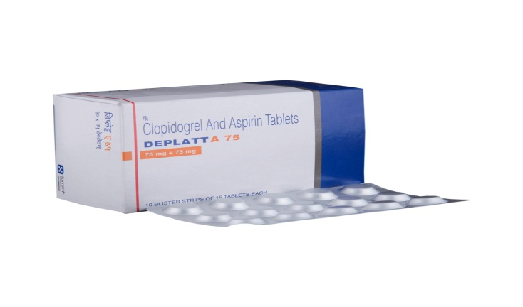

1. **A Clo 100mg Tab:--**

**Description**

Aclo 100mg Tablet is a pain-relieving medicine. It alleviates pain and inflammation in conditions like rheumatoid arthritis, ankylosing spondylitis, and osteoarthritis.  
  
Aclo 100mg Tablet should be taken in the dose and duration as advised by your doctor. It should be taken with food or milk to prevent stomach upset. Taking the medicine regularly at the right times increases its effectiveness. It is important to keep taking the medicine regularly until your doctor tells you it is safe to stop.  
  
Vomiting, stomach pain, nausea, and indigestion are some of the common side effects of taking this medicine. It may also cause dizziness, drowsiness, or visual disturbances. Your doctor may regularly monitor your kidney function, liver function, and levels of blood components if you are taking this medicine for long-term treatment. Long-term use may lead to serious complications such as stomach bleeding and kidney problems. Aclo 100mg Tablet is not recommended if you are pregnant or breastfeeding.

## USES OF ACLO TABLET

[Pain relief](https://www.1mg.com/diseases/pain-relief-168)

## BENEFITS OF ACLO TABLET

### In Pain relief

Aclo 100mg Tablet belongs to a group of medicines called nonsteroidal anti-inflammatory drugs (NSAIDs). It is used for short-term relief of pain, inflammation, and swelling in conditions that affect joints and muscles. It works by blocking chemical messengers in the brain that tell us we have pain. It can help relieve pain in conditions like rheumatoid arthritis and osteoarthritis.  
  
Take it as it is prescribed to get the most benefit. Do not take more or longer than needed as that can be dangerous. In general, you should take the lowest dose that works, for the shortest possible time. This will help you to go about your daily activities more easily and have a better, more active, quality of life.

## SIDE EFFECTS OF ACLO TABLET

Most side effects do not require any medical attention and disappear as your body adjusts to the medicine. Consult your doctor if they persist or if you’re worried about them

### Common side effects of Aclo

* Vomiting
* Stomach pain/epigastric pain
* Nausea
* Indigestion
* Diarrhea
* Heartburn
* Loss of appetite

1. **A Clo Sr 200mg Tablet:--**

**Description**

A Clo 200mg Tablet SR is a pain-relieving medicine. It effectively alleviates pain and inflammation in conditions like rheumatoid arthritis, ankylosing spondylitis, and osteoarthritis.  
  
A Clo 200mg Tablet SR should be taken in the dose and duration as advised by your doctor. It should be taken with food or milk to prevent stomach upset.  
  
Common side effects of this medicine include dizziness, indigestion, nausea, diarrhea, abdominal pain, and increased liver enzymes. Your doctor may regularly monitor your kidney function, liver function, and levels of blood components if you are taking this medicine for long-term treatment. Long-term use may lead to serious complications such as stomach bleeding and kidney problems.

## USES OF A CLO TABLET SR

[Pain relief](https://www.1mg.com/diseases/pain-relief-168)

## BENEFITS OF A CLO TABLET SR

### In Pain relief

A Clo 200mg Tablet SR belongs to a group of medicines called nonsteroidal anti-inflammatory drugs (NSAIDs). It is used for short-term relief of pain, inflammation, and swelling in conditions that affect joints and muscles. It works by blocking chemical messengers in the brain that tell us we have pain. It can help relieve pain in conditions like rheumatoid arthritis and osteoarthritis.  
  
Take it as it is prescribed to get the most benefit. Do not take more or longer than needed as that can be dangerous. In general, you should take the lowest dose that works, for the shortest possible time. This will help you to go about your daily activities more easily and have a better, more active, quality of life.

## SIDE EFFECTS OF A CLO TABLET SR

Most side effects do not require any medical attention and disappear as your body adjusts to the medicine. Consult your doctor if they persist or if you’re worried about them

### Common side effects of A Clo

* Dizziness
* Indigestion
* Nausea
* Abdominal pain
* Increased liver enzymes

1. **A Cold Plus Tab:--**

**Description**

Av Cold Plus Tablet is used to treat common cold symptoms. It provides temporary relief from stuffiness in the nose. It also helps to relieve allergy symptoms like runny nose and watery eyes.  
  
Av Cold Plus Tablet is taken with or without food in a dose and duration as advised by the doctor. It is better to take it with food to avoid stomach upset. The dose you are given will depend on your condition and how you respond to the medicine. You should keep taking this medicine for as long as your doctor recommends. If you stop treatment too early your symptoms may come back and your condition may worsen. Let your doctor know about all other medications you are taking as some may affect, or be affected by this medicine.  
  
The most common side effects are nausea, vomiting, stomach pain, insomnia, restlessness, coordination impaired, and headache. Most of these are temporary and usually resolve with time. Contact your doctor straight away if you are at all concerned about any of these side effects. It can also cause dizziness and sleepiness, so do not drive or do anything that requires mental focus until you know how this medicine affects you. Avoid drinking alcohol while taking this medicine as it can make dizziness worse.  
  
Before taking it, you should tell your doctor if you have any kidney or liver diseases so that your doctor can prescribe a suitable dose for you. Also tell your doctor if you are pregnant, planning pregnancy or breastfeeding.

## USES OF AV COLD PLUS TABLET

Treatment of [Common cold symptoms](https://www.1mg.com/diseases/common-cold-symptoms-589)

## BENEFITS OF AV COLD PLUS TABLET

### In Treatment of Common cold symptoms

Av Cold Plus Tablet is a combination of medicines that effectively relieves symptoms of common cold such as blocked nose, runny nose, watery eyes, sneezing, and congestion or stuffiness. It helps to loosen thick mucus, making it easier to cough out. This makes it easier for air to move in and out. It shrinks the blood vessels and provides rapid relief that lasts for several hours.

## SIDE EFFECTS OF AV COLD PLUS TABLET

Most side effects do not require any medical attention and disappear as your body adjusts to the medicine. Consult your doctor if they persist or if you’re worried about them

### Common side effects of Av Cold Plus

* Nausea
* Vomiting
* Stomach pain/epigastric pain
* Insomnia (difficulty in sleeping)
* Restlessness
* Allergic reaction
* Sleepiness
* Dizziness
* Impaired coordination
* Thickened respiratory tract secretions
* Headache

1. **A Heal Tab:--**

**Description**

A-Heal Tablet is a pain-relieving medicine. It is used in the treatment of various conditions such as fever, headache, arthritis-related pain, menstrual cramps, and toothache.  
  
A-Heal Tablet should be taken with or without food. The dose and duration will depend on what you are using it for and how well it helps your symptoms. Use it regularly and do not discontinue using it until the doctor tells you it is alright to stop.  
  
The medicine is generally safe with little or no side effects. However, if you experience any symptoms which you believe are caused by the use of this medicine, let your doctor know. Your doctor may be able to suggest ways of preventing or reducing the side effects. In general, you should try to use the smallest amount necessary to control your symptoms.  
  
Before using the medicine, you should tell your doctor if you have any other medical conditions or disorders. To make sure it is safe for you, you should also tell your doctor all the other medicines you are taking. Before using the medicine, let your doctor also know if you have any problems with your liver or kidneys. Pregnant and breastfeeding women should consult their doctors first before using the medicine.

## USES OF A-HEAL TABLET

[Pain relief](https://www.1mg.com/diseases/pain-relief-168)

## BENEFITS OF A-HEAL TABLET

### In Pain relief

A-Heal Tablet is a combination of medicines used for relief of pain, inflammation, and swelling in conditions that may occur due to trauma, surgery or everyday life. It may also be used to provide relief in degenerative and inflammatory conditions that affect muscles and joints such as rheumatoid arthritis and osteoarthritis. It promotes speedy recovery due to its anti-inflammatory and antioxidant properties. Take it as it is prescribed to get the most benefit. This will help you to go about your daily activities more easily and have a better, more active, quality of life.

## SIDE EFFECTS OF A-HEAL TABLET

Most side effects do not require any medical attention and disappear as your body adjusts to the medicine. Consult your doctor if they persist or if you’re worried about them

### Common side effects of A-Heal

* No common side effects seen

1. **A Keftal 50mg Tab:--**

**Description**

## Uses of A Keftal Products

Artesunate is used in the treatment of [malaria](https://www.1mg.com/diseases/malaria-260). It is not used to prevent malaria or to treat severe malaria (where it has affected the brain, lungs or kidneys).

## A Keftal Products side effects

Common

Side Effects of A Keftal are Headache, Dizziness, Loss of appetite, Weakness.

1. **A Lith 300mg Tab:--**

**Description**

A Lith 300mg Tablet is used in the treatment of bipolar disorder and mania in adults. It is sometimes used to treat other behavioral disorders as well. It reduces the frequency of manic episodes and decreases the intensity of those episodes that might occur.  
  
A Lith 300mg Tablet should be taken with food. However, it is advised to take it at the same time each day as this helps to maintain a consistent level of medicine in the body. Do not skip any doses and finish the full course of treatment even if you feel better. If you have missed a dose, take it as soon as you remember it. You should continue to take this medicine for as long as the doctor advises and do not stop taking it suddenly as it may result in harmful effects.  
  
Side effects associated with the use of this medicine include tremors, slurred speech, uncoordinated body movements, nausea, acne, increased white blood cell count, and memory impairment. It may also cause hair loss, enlarged thyroid gland, skin rash, and increased thirst. This medicine may also cause weight gain and to control it, you should have a balanced diet and exercise regularly. If you have been taking this medicine for a long time then regular monitoring of thyroid and kidney function may be required.

## USES OF A LITH TABLET

* [Mania](https://www.1mg.com/diseases/mania-157)
* [Bipolar disorder](https://www.1mg.com/diseases/bipolar-disorder-529)

## BENEFITS OF A LITH TABLET

### In Mania

Mania means extremely excited or elevated mood. A Lith 300mg Tablet helps calm the mood and relax the nerves. This stabilises the mood and prevents the symptoms of mania from recurring again. Taking A Lith 300mg Tablet will ensure that you have a better social life and are able to do daily activities more comfortably.

### In Bipolar disorder

A Lith 300mg Tablet works to restore the normal balance of nerve activity in your brain. It can help prevent extreme changes in mood and help you feel less agitated. You may experience fewer episodes of low mood. It can take several weeks for this medicine to work and you may still feel low during this time. It is likely that you will take this medicine for at least six months but possibly much longer. It needs to be taken regularly to work effectively. Do not stop taking it unless your doctor advises you to. You should continue to eat well and keep fit to reduce symptoms of bipolar disorder.

## SIDE EFFECTS OF A LITH TABLET

Most side effects do not require any medical attention and disappear as your body adjusts to the medicine. Consult your doctor if they persist or if you’re worried about them

### Common side effects of A Lith

* Tremor
* Slurred speech
* Uncoordinated body movements
* Nausea
* Acne
* Increased white blood cell count
* Memory impairment
* Hair loss
* Goiter (enlarged thyroid gland)
* Skin rash
* Increased thirst
* Weight gain
* Polyuria
* Diarrhea